Household chores
Look and label the pictures with an expression from the box.
A
make the bed set the table do the laundry
do the dusting make dinner do the washing up

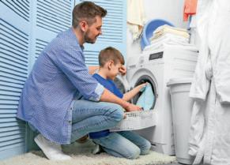 | 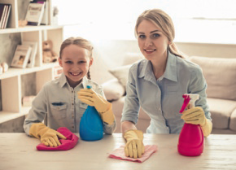 | 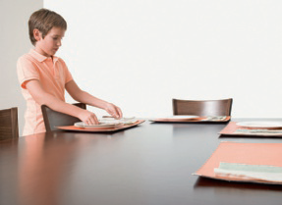
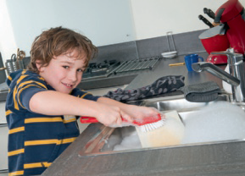 | 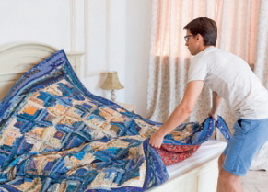 | 
Circle the correct verb.
B
- I usually do / make the housework.
- I often do / make breakfast for myself.
- I sometimes do / make the ironing.
- I never do / make my brother’s bed.
- I always do / make the shopping.
- I often do / make the vacuuming.
Write about you. Which chores do you usually do at home?
C

