Public places
Find the places you see in the pictures in the wordsearch. Then, label the pictures.
A
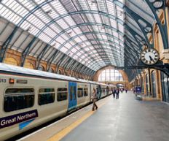 |  |  | 
  N | O | S | C | J | S | I | G | O | H | R | C | P | G | K
  R | O | B | V | U | F | E | Y | Y | D | A | F | Q | P | I
  R | K | I | W | O | E | M | O | O | Z | G | T | G | I | S
  P | I | V | T | H | G | Z | Z | U | G | F | D | T | S | F
  S | K | C | L | A | Z | G | H | N | H | R | W | A | E | T
  X | M | C | H | L | T | Z | M | I | T | D | V | L | C | N
  K | M | U | K | U | G | S | R | E | K | B | M | X | I | A
  V | R | X | S | S | R | T | Y | F | P | R | A | L | N | R
  G | C | A | Q | E | R | C | J | A | U | V | A | L | E | U
  C | S | X | T | O | U | H | H | M | W | T | P | W | M | A
  T | J | D | P | J | B | M | M | D | I | L | Y | B | A | T
  K | M | R | C | Q | F | C | J | P | K | O | I | S | P | S
  H | I | L | I | V | B | P | S | R | L | T | N | A | U | E
  A | F | Y | X | S | Z | O | M | Q | J | P | Y | G | R | R
  B | Y | N | H | Z | H | I | T | F | M | H | E | L | Y | R
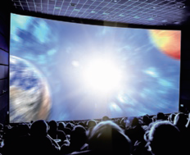 |  |  | 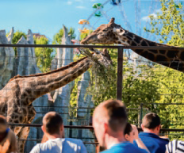
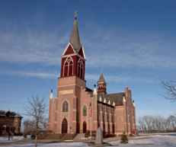 | 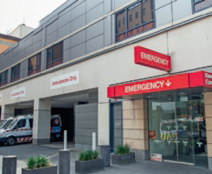 | 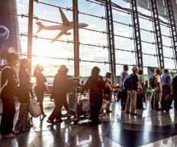 | 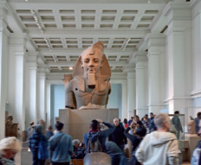
Read the clues and write the words (public places) in the boxes.
B

post office |  | hotel |  | theatre |  | library |  | shopping centre

- A place with lots of shops.
- A place where tourists and travellers sleep.
- A place where you can watch a play or a performance.
- A place where you can post and collect mail.
- A place where you can read and borrow books.

