Means of transport
Read, look and match.
A
- bicycle | a. 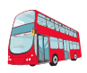 |  | b. 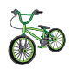 |  | c. 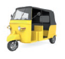 |  | d. 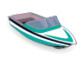
- boat
- bus
- car
- plane |  | e.  |  | f. 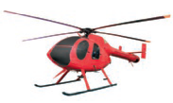 |  | g. 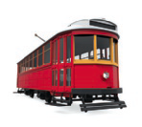
- helicopter
- lorry
- motorbike |  | h. 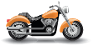 |  | i. 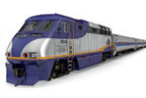 |  | j. 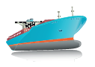
- ship
- taxi
- train
- tram | k. 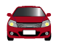 |  | l. 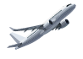 |  | m. 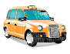 |  | n. 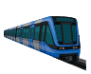
- underground
- tuk tuk
Write about you.
B

- Have you got a bicycle?

- How do you usually go to school?

