Shops
Read and complete with the words below.
A
baker's bookshop chemist's florist's butcher's
supermarket newsagent's fishmonger's shoe shop
clothes shop jeweller's sports shop
You can buy…
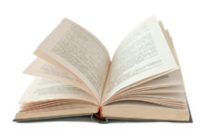 | 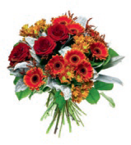 | 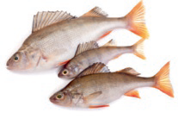 | 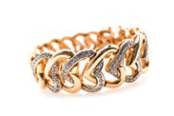
- … a book at the | - … flowers at the | - … fish at the | - … a bracelet at the
 | 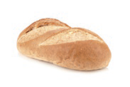 | 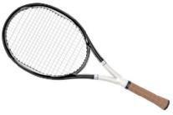 | 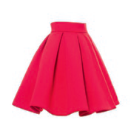
- … a newspaper at the | - … bread at the | - … a tennis racket at  the | - … a skirt at the
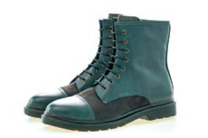 |  | 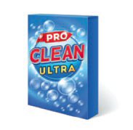 | 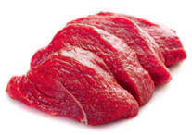
- … boots at the | - … pills at the | - … detergent at the | - … meat at the
Write about you. What are your favourite shops?
B

