Water parks
Look at the pictures and complete the expressions.
A
 | 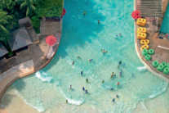
  S |  |  |  |  | I | N |  | T |  |  |  | W |  |  |  |  | P
 | 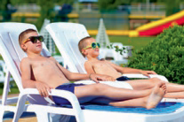
  S |  |  |  |  |  |  | E
 | 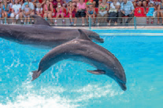
  V |  |  |  |  |  | T |  |  |  | D |  |  |  |  |  |  |  | A
 | 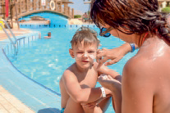
  P |  |  |  | O | N |  | S
 | 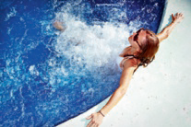
  R |  |  |  |  |  | I | N |  | T |  |  |  | P
 | 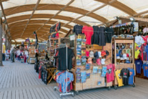
  B |  |  |  | A |  | S
 | 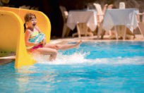
  G |  |  | O |  |  | T |  |  |  | S
Write about you.
B
- Do you like water parks? Why?

- What is your favourite amusement at the waterpark?

