Theme park
Look at the pictures. Find out the missing words. Then, complete the crossword. There is one example.
A
 |  | 
   |  |  |  |  |  |  |  | 7
   |  | 4
   | 1
  3
  2
   |  |  |  |  |  | F
   |  | 6 |  |  |  | I
   |  |  |  |  |  | L
   |  |  |  |  |  | M
   |  |  |  | 5
Watch a 3D film. |  | - Watch a .
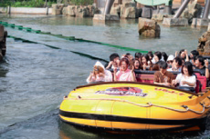 |  | 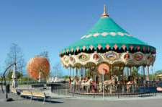
- Go on a  ride. |  | - Go on a .
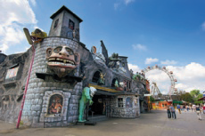 |  | 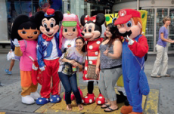
- Visit a house. |  | - Take a  photo.
 |  | 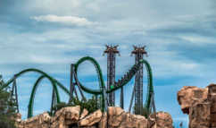
- Watch a . |  | - Go on a .
Write about you.
B
Write one thing you like doing at a theme park and one you don’t.
I like
I don’t like

