Grammar worksheets

Worksheet 1: To be – Present Simple (p. 3)
A. 1. is 2. is 3. are 4. is 5. am 6. are
B. 1. d 2. e 3. c 4. a 5. b
C.
1. am 2. is 3. is 4. Are 5. am 6. are 7. am 8. are 9. am 10. am 11. is 12. isn’t 13. is

Worksheet 2: There to be – Present Simple (p. 4)
A.
1. There are 2. There are 3. there are 4. there are 5. There is 6. there is 7. There is 8. There is
B.
1. There are 2. there are 3. There is 4. Are there 5. there are 6. Are there 7. there are 8. Is there 9. there isn’t 10. Is there 11. there is 12. Is there 13. there is

Worksheet 3: Have got / To be – Present Simple (p. 5)

A. 1. has got 2. hasn’t got 3. have got 4. Have 5. has got 6. Has
B.

1. have got 2. hasn’t got 3. Have… got; haven’t 4. have got 5. Has… got; has 6. has got 7. haven’t got
C.
1. am; have got 2. is 3. are 4. have got 5. is 6. is 7. is; has got 8. have got
D. Personal answers

Worksheet 4: Present Simple – Aﬃrmative (p. 6)
A.
-s: helps, plays, likes, dances, sings
-es: kisses, watches, finishes, fixes, brushes, does
-ies: tries, tidies, flies, studies
B. 1. loves 2. go 3. likes 4. play 5. goes 6. wake
C.
1. brush; go 2. play 3. have 4. get up 5. watches 6. leave 7. rides 8. helps

Worksheet 5: Present Simple – Negative (p. 7)
A. 1. don’t 2. doesn’t 3. doesn’t 4. don’t 5. doesn’t 6. don’t 7. don’t
B.
1. don’t watch 2. doesn’t speak 3. don’t like 4. doesn’t wake up 5. don’t have 6. don’t surf 7. doesn’t read 8. don’t go
C.
1. I don’t help my mother in the kitchen.
2. My sister doesn’t make her bed every morning.
3. Mark doesn’t talk a lot during classes.
4. They don’t play sports after school.
5. She doesn’t eat a snack at 5 o’clock.
6. I don’t wash my hands before meals.

Worksheet 6: Present Simple – Interrogative / Short answers (p. 8)

A. 1. Do 2. does 3. Does 4. do 5. Does
B.
1. Do… wake up; don’t 2. Does… watch; doesn’t 3. Do… study; do 4. Does… drink; does 5. Do… do; do
C.
1. Do you like chatty people? 2. Do they have dinner at home? 3. Does Jane brush her hair every morning? 4. Does Nick play basketball on Saturdays? 5. Does she listen to music after dinner? 6. Do we catch the bus at 7:30? 7. Does your dog sleep in your bedroom?

Worksheet 7: Present Continuous – Aﬃrmative (p. 9)
A.
1. dancing 2. swimming 3. helping 4. having 5. sitting 6. learning 7. getting up 8. working 9. seeing 10. going 11. drinking 12. beginning 13. running 14. visiting 15. travelling 16. waiting 17. studying 18. singing 19. washing
B. 1. is 2. are 3. is 4. am 5. are 6. is 7. is 8. are
C. 1. am doing 2. are studying 3. is writing 4. is speaking 5. are reading 6. is painting 7. are waiting 8. is riding 9. is talking

Worksheet 8: Present Continuous – Negative (p. 10)
A.
1. Mr Smith isn’t reading now. 2. I’m not running at the moment. 3. They aren’t going to bed now. 4. Mike isn’t listening to music at the moment.

B.
1. They aren’t walking the dog. They are playing football.
2. They aren’t having lessons. They are talking in the playground.
3. She isn’t eating an apple. She is drinking water.

Worksheet 9: Present Continuous – Interrogative (p. 11)
A.
1. Are they playing computer games? 2. Is Michael doing his homework? 3. Are you having breakfast? 4. Is Susan staying with her best friend? 5. Is he saying goodbye? 6. Are we speaking loudly?

B.
1. is 2. doing 3. Is 4. studying 5. isn’t 6. is watching 7. are 8. doing 9. Are 10. working 11. are 12. relaxing am playing 14. Are 15. playing 16. am cooking

Worksheet 10: Reflexive pronouns (p. 12)
A. 1. yourself 2. herself 3. ourselves 4. yourselves

B.

1. herself 2. itself 3. ourselves 4. yourself 5. myself 6. themselves
C. 1. themselves 2. herself 3. myself

Worksheet 11: The comparative (p. 13)
A.
1. bigger 2. better 3. nicer 4. easier 5. fatter 6. smaller 7. older 8. worse 9. taller 10. thinner

B.
1. Your pencil case is more beautiful than my pencil case.
2. English is easier than maths.
3. Holidays are better than schooldays.
4. A car is more comfortable than a bus.
5. The drama club is more exciting than the chess club.
6. Grace is friendlier than Lucy.

Worksheet 12: The superlative (p. 14)
A.
1. the thinnest 2. the richest 3. the most comfortable 4. the ugliest 5. the fattest 6. the most beautiful 7. the oldest 8. the worst 9. the luckiest 10. the shortest

B.
1. the best 2. the tallest 3. the easiest 4. the prettiest 5. the youngest 6. the most important
C. 1. the most expensive 2. the smallest 3. the biggest

Worksheet 13: To be – Past Simple (p. 15)
A. 1. was 2. was; were 3. were 4. were 5. was

B.
1. Last summer it wasn’t very hot. Was it very hot last summer?
2. The family barbecue wasn’t fun. Was the family barbecue fun?
3. My cousin’s baptism wasn’t last week. Was my cousin’s baptism last week?
4. Last month you weren’t at your grandmother’s birthday party. Were you at your grandmother’s birthday party last month?
C. Personal answers

Worksheet 14: There to be – Past Simple (p. 16)
A.
1. There were 2. There were 3. there was 4. There were 5. there were 6. There was 7. There were 8. There were 9. There was

B.
1. there was 2. Was there; there was 3. Was there; there wasn’t 4. Were there; there were 5. Was there; there was 6. Were there; there weren’t 7. Were there; there were 8. Were there; there weren’t 9. Was there; there wasn’t 10. Were there; there were

Worksheet 15: Regular verbs – Past Simple (aﬃrmative) (p. 17)
A.
-d: arrived, danced, liked, decided
-ed: enjoyed, played, watched, visited, stayed
-ied: cried, tried, studied

B.
1. planned 2. invited 3. started 4. received 5. chatted 6. thanked 7. loved
C. Personal answers

Worksheet 16: Regular verbs – Past Simple (negative) (p. 18)
A.
1. didn’t phone 2. didn’t help 3. didn’t travel 4. didn’t like 5. didn’t visit
B. 1. didn’t listen 2. didn’t talk 3. didn’t cry 4. didn’t answer

C.
1. We didn’t listen to cool music. 2. I didn’t dance with Tom at the party. 3. I didn’t like my birthday cake. 4. I didn’t laugh a lot at Fred’s jokes. 5. We didn’t play the piano. 6. My party didn’t finish at 4 o’clock. 7. We didn’t arrive home late.

Worksheet 17: Regular verbs – Past Simple (interrogative / short answers) (p. 19)
A.
1. Did 2. enjoy 3. did 4. stayed 5. Did 6. visit 7. visited 8. loved 9. did 10. do 11. helped 12. cooked

B.
1. Did you try the local food? No, I didn’t.
2. Did you stay at a hotel? Yes, I did.

C.
1. Did you watch a film yesterday?
2. Did Peter and Tim arrive early?

Worksheet 18: Prepositions of movement (p. 20)
A.
1. up 2. across 3. through 4. down 5. into / onto 6. into 7. along 8. towards 9. onto

Worksheet 19: Irregular verbs – Past Simple (p. 21)
A.
1. came 2. had 3. went 4. bought 5. drank 6. saw 7. made 8. did 9. gave 10. spent 11. said 12. found
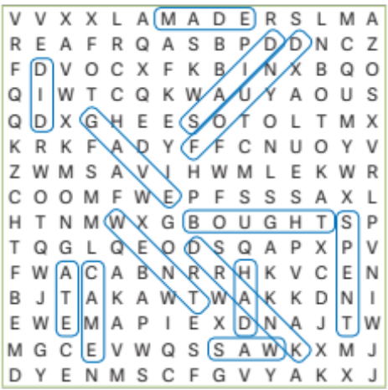

B.
1. went 2. met 3. ate 4. drank 5. bought 6. spent 7. spoke 8. saw 9. had

Worksheet 20: Be going to – Aﬃrmative (p. 22)
A. 1. a 2. b 3. c

B.
1. am going to watch 2. are going to travel 3. is going to spend 4. is going to visit 5. are going to miss

C.
1. Lily is going to get married next weekend. 2. Nick and Daisy are going to play tennis tomorrow. 3. Harry is going to take lots of photos at the party tonight.

Worksheet 21: Be going to – Negative (p. 23)
A.
1. is not going to brush 2. am not going to travel 3. are not going to do

B.
1. They aren’t going to swim in the wave pool next summer. 2. Tom isn’t going to visit the horror house. 3. I am not going to make lots of videos.

C.
1. They are not going to go sailing. They are going to go canoeing.
2. She is not going to buy a snack. She is going to relax in the pool.
3. They are not going to cut the grass. They are going to pick fruit.

Worksheet 22: Be going to – Interrogative (p. 24)
A.
1. Are they going to swim in the wave pool next summer?
2. Are Tom and Pat going to spend their holiday at a campsite?
3. Are you going to make lots of videos? 4. Is Sally going to swim with the dolphins?

B.
1. Is she going to travel by plane? 2. Are they going to take photos? 3. Is he going to watch a musical? 4. Are you going to buy a souvenir?

C.
1. Is Jill going to buy a pair of boots? No, she isn’t. 2. Are they going to visit a museum? Yes, they are.

Worksheet 23: Connectors (p. 25)
A. 1. then 2. Later 3. after that

B.
1. He bought tickets. Then he went on the rollercoaster. Later he took some photographs and after that he ate an ice cream.
2. He went to a farm. Then he fed the animals. Later he did a
baking workshop and after that he went horse riding.
3. He went sightseeing. Then he visited a museum. Later he had lunch and after that he went back home.

Worksheet 24: Should / Shouldn’t (p. 26)
A.
1. should 2. shouldn’t 3. should 4. should 5. should 6. shouldn’t 7. should 8. should 9. should 10. shouldn’t; should 11. should 12. shouldn’t 13. shouldn’t 14. shouldn’t 15. should 16. should 17. should 18. shouldn’t 19. should 20. should

Worksheet 25: Adverbs of manner (p. 27)
A.
1. strangely 2. lately 3. lazily 4. slowly 5. quickly 6. fast 7. politely 8. well 9. nervously 10. badly 11. rudely

B.
1. loudly 2. quietly 3. angrily 4. safely 5. easily 6. quickly 7. carefully 8. slowly 9. wonderfully 10. happily 11. extremely 12. fast 13. beautifully

Worksheet 26: Possessive pronouns (p. 28)
A. yours, his, hers, its, ours, yours, theirs

B.
1. his 2. mine 3. theirs 4. ours 5. hers 6. his 7. yours 8. hers 9. its 10. hers 11. ours 12. mine 13. his 14. theirs 15. ours 16. Hers

Worksheet 27: Prepositions of time (p. 29)
A.
in: June, 2015, spring, the morning
on: Monday, 5th September, my birthday
at: the moment, half past eleven, Christmas
B. 1. in 2. in 3. at 4. on 5. on 6. at
C. 1. On 2. at 3. at 4. in 5. on 6. in 7. on 8. In 9. on 10. at

Vocabulary worksheets

Worksheet 1: Clothes (p. 30)
A. 1. b 2. f 3. e 4. g 5. h 6. d 7. a 8. j 9. m 10. c 11. k 12. l 13. i
B. 1. scarf 2. belt 3. cap 4. tie

Worksheet 2: Telling the time (p. 31)

A. 1. b 2. c 3. a

B.
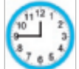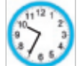
1. What time is it? 3. What time is it?
It’s a quarter to twelve. It’s twenty-five to ten.

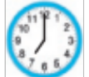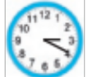
2. What time is it? 4. What time is it?
It’s seven o’clock. It’s twenty past three.

Worksheet 3: Nationalities (p. 32)

A.
1. India 2. France 3. Spain 4. The USA 5. Switzerland 6. Australia 7. The United Kingdom 8. China 9. Mexico 10. Portugal 11. Italy 12. Russia 13. Japan 14. Brazil 15. Germany 16. England

B.
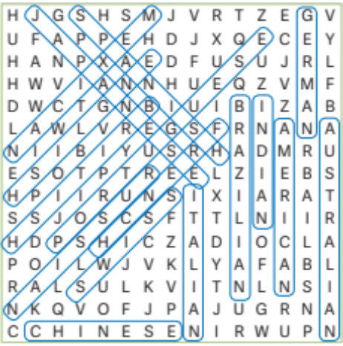

Worksheet 4: Physical features (p. 33)
A.
Appearance: ugly, attractive, pretty
Age: middle-aged, old
Height: tall, medium-height, short
Weight: chubby, thin, fat, slim
Hair: long, wavy, curly, medium-length, straight, short
Eyes: round, small
Face: long, round, small, oval
B. 1. Jack 2. Mary 3. Mike
C. Personal answer

Worksheet 5: Personality traits (p. 34)
A.
1. funny 2. patient 3. kind 4. lazy 5. chatty 6. shy 7. grumpy 8. clever
B. a. 7 b. 3 c. 1 d. 6 e. 4 f. 8 g. 5 h. 2

Worksheet 6: School subjects (p. 35)
A.
1. information technology (IT) 2. Portuguese 3. geography 4. physics and chemistry 5. science 6. music 7. English 8. mathematics / maths 9. French 10. art 11. physical education (PE) 12. Spanish
B. Personal answers
Worksheet 7: School supplies (p. 36)

A.

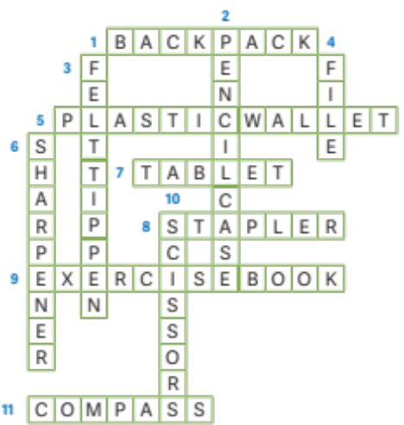

1. backpack 2. pencil case 3. felt tip pen 4. file 5. plastic wallet 6. sharpener 7. tablet 8. stapler 9. exercise book 10. scissors 11. Compass

B. Personal answer

Worksheet 8: Places at school (p. 37)
A.
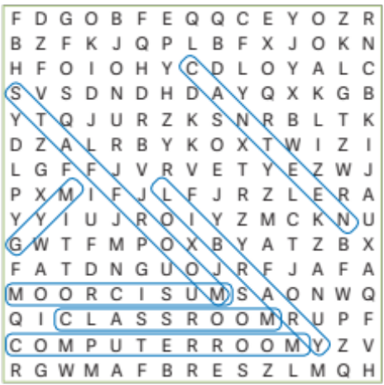
B.
1. principal’s oﬃce 2. toilet 3. sports field 4. playground 5. art room 6. tuck shop

Worksheet 9: School clubs (p. 38)

A.
1. English club 2. science club / chemistry club 3. sports club 4. choir 5. cooking club 6. chess club 7. photography club 8. music club 9. environmental club

B.
1. drama 2. choir 3. computer 4. cooking 5. photography
C. Personal answers

Worksheet 10: Jobs (p. 39)

A.
1. teacher 2. doctor 3. vet 4. dentist 5. police oﬃcer 6. plumber 7. cashier 8. chef
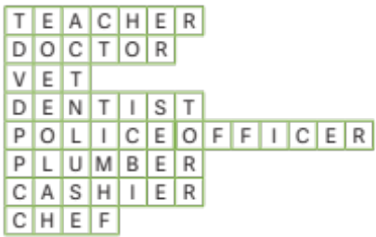
B.
1. firefighter 2. farmer 3. waiter 4. architect 5. mechanic 6. lawyer 7. postman

Worksheet 11: Family picnic (p. 40)
A. 1. hotdog 2. fruit tart 3. soft drink 4. pizza

B.
1. a. apple pie b. shrimp(s)
2. a. apple pie b. fruit c. shrimps d. crisps
3. a. crisps
C. 1. c 2. d 3. e 4. a 5. b

Worksheet 12: Food (p. 41)

A.
1. toast 2. eggs 3. cheese 4. orange juice 5. butter 6. cake 7. yoghurt 8. cereal 9. muﬃn 10. fruit salad / fruit cup 11. coﬀee 12. sandwich

B.
1. pancakes 2. milk 3. apple 4. chicken 5. rice 6. salad 7. biscuits 8. tea 9. soup 10. fish 11. potatoes

Worksheeet 13: Household chores (p. 42)
A.
1. do the laundry 2. do the dusting 3. set the table 4. do the washing up 5. make the bed 6. make dinner
B. 1. do 2. make 3. do 4. make 5. do 6. do
C. Personal answer

Worksheet 14: Public places (p. 43)
A.
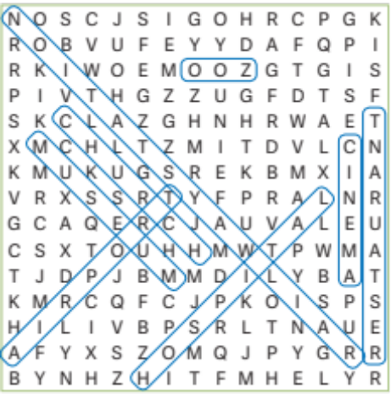
1. railway station 2. restaurant 3. cinema 4. zoo 5. church 6. hospital 7. airport 8. museum

B. 1. shopping centre 2. hotel 3. theatre 4. post oﬃce 5. library

Worksheet 15: Means of transport (p. 44)
A.
1. b 2. d 3. a 4. k 5. l 6. f 7. e 8. h 9. j 10. m 11. i 12. g 13. n 14. c
B. Personal answers

Worksheet 16: Types of buildings (p. 45)
A.
1. stadium 2. mansion 3. oﬃce building 4. castle 5. cottage 6. fort 7. skyscraper 8. lighthouse 9. tower 10. factory 11. warehouse 12. block of flats 13. bungalow

Worksheet 17: Shops (p. 46)

A.
1. bookshop 2. florist’s 3. fishmonger’s 4. jeweller’s 5. newsagent’s 6. baker’s 7. sports shop 8. clothes shop 9. shoe shop 10. chemist’s 11. supermarket 12. butcher’s
B. Personal answer

Worksheet 18: Cool summer activities (p. 47)
A.
1. play videogames 2. go camping 3. go bowling 4. go sailing 5. go horse riding 6. have a band 7. play paintball 8. go to a concert 9. go canoeing

B.
1. go sailing 2. go canoeing 3. play paintball 4. go to a concert 5. have a band 6. play videogames 7. go horse riding 8. go camping 9. go bowling

Worksheet 19: Water parks (p. 48)

A.
1. swim in the wave pool 2. sunbathe 3. visit the dolphin arena 4. put on sunscreen 5. relax in the pool 6. buy a souvenir 7. go on the slide
B. Personal answers

Worksheet 20: Theme park (p. 49)

A.
1. parade 2. water 3. carousel 4. horror 5. character 6. musical 7. roller coaster
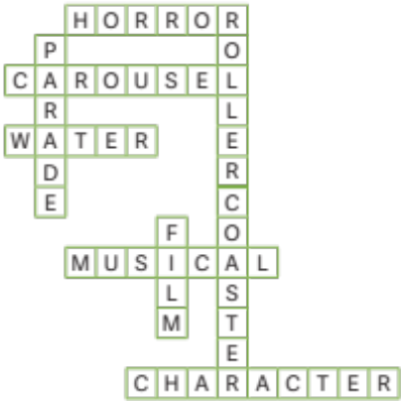
B. Personal answer

CLIL worksheets

History
Unit 1: Portuguese mid-XIX century lifestyles (p. 50)
A.
In the mid-19th century the Portuguese rich nobility live in luxurious mansions with beautiful gardens on the outskirts of the cities. The high bourgeoisie have money, so they live comfortably like the nobility.
They dress like the nobles. The nobles and the bourgeoisie follow French fashion and buy their clothes from famous big shops in Lisbon called “Armazéns do Chiado”, the “Grandela” or the “Casa Africana” that are very popular at this time.

B.
1. The high nobility live in luxurious mansions.
2. The high bourgeoisie have money.
3. The high bourgeoisie and the nobles follow French fashion.
4. There are famous big shops in Lisbon at this time called “Armazéns do Chiado”, the “Grandela” or the “Casa Africana”.
C. a. 2 b. 3 c. 4 d. 1

Unit 2: School reform in the 1st Republic (p. 51)
A.
Republicans consider that education is important. They defend that education makes people better. So, the Republic governments start passing laws to reform education in Portugal in 1910.

Nursery and Primary education
Nursery schools are created for children between the ages of 4-7. Primary school becomes obligatory and free for every child. They teach children to read, write and count.
More primary schools are opened. Colleges are opened to train teachers.

Secondary and vocational (to prepare people for jobs) education More high schools and vocational (agricultural, commercial and industrial) schools are opened.

Tertiary (university) education
The Universities of Lisbon and Oporto are created.
Portugal now has three universities (Coimbra, Lisbon and Porto).

B.
1. In 1900.
2. In 1930.
3. Model of an answer: Yes, I do, because they opened more schools – primary schools, secondary schools and universities – and so the number of illiterate people reduced.

Unit 3: The modern economy (p. 52)

A.
The modern economy is divided into three sectors: the primary, the secondary and the tertiary sectors. The primary sector involves activities that are linked to the land and getting nature’s products. The secondary sector involves transforming natural and primary products like wood into new products. The tertiary sector involves all jobs that supply services to others so that people can live more comfortable lives.

B.
1. primary 2. tertiary 3. secondary 4. secondary 5. tertiary 6. primary 7. tertiary 8. primary 9. tertiary

Unit 4: The importance of public transport (p. 53)
A. 1. f 2. a 3. i 4. h 5. j 6. d 7. b 8. e 9. g 10. c
B. a. airplane b. ship c. train d. lorry

Unit 5: Tourism in Portugal (p. 54)
A.
1. religious tourism 2. recreational tourism 3. cultural tourism 4. sports tourism 5. rural tourism 6. adventure tourism
B. 1. T 2. T 3. F 4. F 5. T 6. F 7. T 8. T

Science
Unit 1: Habits to keep your skin healthy (p. 55)
B. 1. d 2. f 3. a 4. c 5. b 6. e
C. a. 1 b. 4 c. 3 d. 5 e. 2 f. 6

Unit 2: Protecting our forests (p. 56)
B. 1. T 2. F 3. F 4. T
C. 2; 3; 5; 7; 8

Unit 3: Child health care (p. 57)
B. 1. should 2. shouldn’t 3. shouldn’t 4. shouldn’t 5. should / should
C. a. 3 b. 1 c. 5 d. 2 e. 4

Unit 4: Environmental pollution (p. 58)
B.
Causes
Air pollution – “caused by the emission of gases like carbon dioxide into the atmosphere”; “Farmers also pollute the air with nitrous oxide and methane.”
Water pollution – “releasing domestic and industrial waste in our rivers”; “caused by pesticides and fertilizers that infiltrate the soil.” Soil pollution – “Deforestation and urbanisation also pollute the land. Cities produce a lot of rubbish and waste that pollute the soil.” “Agriculture is also a major polluter by releasing pesticides and fertilizers in the soil.”

Eﬀects
“alter the environment and harm living organisms, our natural habitat and human health.”
C. 1. water pollution 2. soil pollution 3. air pollution

Unit 5: Pollination (p. 59)
A. T
B. a. stigma b. anther c. ovule d. style
C. 1. bee 2. butterfly 3. bird 4. squirrel 5. wind 6. water

