Question words
Complete the questions with the correct question words.
1
- does she live? In Coimbra.
- do they get up? At seven o’clock.
- is that skyscraper? It’s 2000 metres high.
- is your piano lesson? It’s at half past four.
- is she? She is my aunt.
- ruler is this? It’s Ben’s.
- are you sad? Because I’m sick.
- is she not working? Because it’s her birthday.
- does he play volleyball? Once a week.
- is your performance? It’s next Saturday.
- is she? She is 1 metre 50 tall.
- is your nickname? I don’t have one!
- is his house? It’s big. It has got three floors.
- are you? I’m twelve.
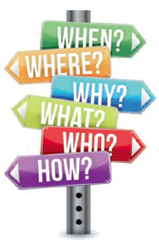
- is she from? She is from Japan.
- is he? He’s my teacher.
- is your favourite sport?
It’s football.
- __________ are you today?
We’re fine, thanks.
- is his birthday?
It’s on 5th September.

Question words
1
- 1Where
- What time
- How high
- What time
- Who
- Whose
- Why
- Why
- How often
- When
- How tall
- What
- How big
- How old
- Where
- Who
- What
- How
- When

To be / Have got
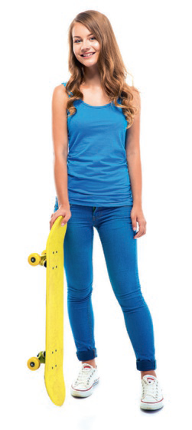
Complete the gaps with the verb to be or have got in the Present Simple.
1
- I a beautiful dress for your party.
- They ___ my classmates.
- she your new teacher?
No, she ____.
- you _____ a computer?
No, I __________.
- We (not) thirteen years old.
- I two older brothers.
- My favourite singer _____ Shawn Mendes.
- He (not) green eyes.
- My grandfather ____________ funny.
- she ____ long hair?
Yes, she ______.
- My eyes ______ blue.
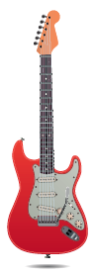
Put the words in order to write correct sentences.
2
- got / a guitar / he / has / ?

- favourite / is / her / subject / music / .

- same / the / in / are / class / Dan and Tom / ?

- ponytail / got / Grace / not / has / a / .

To be / Have got
1
- have got (’ve got)
- are (’re)
- Is; is not (isn’t)
- Have, got; have not got (haven’t)
- are not (aren’t)
- have got (’ve got)
- is (’s)
- has not got (hasn’t got)
- is (’s)
- Has, got; has (’s)
- are (’re)
2
- Has he got a guitar?
- Her favourite subject is music.
- Are Dan and Tom in the same class?
- Grace has not got a ponytail.

Present Simple
Complete the gaps with the verbs in brackets in the Present Simple.
1
- I (watch) YouTube videos at the weekend.
- Maria __________ (eat) muesli in the morning.
- Fred never _______ (drive) to work.
- Jim (sing) in a band.
- They always _______ (go) to bed at ten o’clock.
- Lily (speak) French very well.
- Jane __ (play) in the park after school.
Put the words in order and make sentences.
2
- newspaper / does / he / read / not / the / .

- they / kitchen / parents / in / help / the / do / their / ?

- school / do / on / not / we / to / foot / go / .

- time / do / Sundays / get up / what / you / on / ?

- weekend / what / she / at / do / the / does / ?

- the / watch / not / during / does / my brother / TV / week / .

- the / go / football / to / practice / school / children / after / .

Present Simple
1
- watch
- eats
- drives
- sings
- go
- speaks
- plays
2
- He does not read the newspaper.
- Do they help their parents in the kitchen?
- We do not go to school on foot.
- What time do you get up on Sundays?
- What does she do at the weekend?
- My brother does not watch TV during the week.
- The children go to football practice after school.

Present Continuous
Complete the gaps with the verbs in brackets in the Present Continuous.
1

- My younger sister ____ (learn) to read.
- At the moment my mother __________ (cook).
- Today he _____ (not / work).
- They __ (play) in the bedroom.
- What __ she ________ (do)?
Her homework.
- I __________ (look) for my mobile.
- They __ (not / speak) Swedish! It’s German.
- I must go! She __________ (wait) for me.
- The baby ___________ (sleep) now.

Present Simple / Present Continuous
Complete the gaps with the verbs in the Present Simple or in the Present Continuous.
2

- We usually _______ (stay) at home on Saturdays.
- Look! She ______ (wear) the same dress as I am!
- What time ______ your school ____ (start)?

At 8:20.
- They __ (think) I am in Canada.
- At the moment he ____ (read) comics.
- She _ (want) to be an actress.
- Look! My best friend ______ (come).
- Vegetarians ________ (not / eat) meat.
- Listen! The telephone ________ (ring)

Present Continuous
1
- 1is learning / ‘s learning
- is cooking / ‘s cooking
- is not (isn’t) working
- are playing / ‘re playing
- is, doing
- am looking / ‘m looking
- are not (aren’t) speaking
- is waiting / ’s waiting
- is sleeping / ’s sleeping

Present Simple / Present Continuous
2
- stay
- is wearing / ‘s wearing
- does, start
- think
- is reading / ‘s reading
- wants
- is coming / ‘s coming
- do not (don’t) eat
- is ringing / ’s ringing

Comparative
Complete the gaps with the comparative form.
1
- Daisy is _____ (bad) than Pat at Portuguese.
- That car is _______ (expensive) than my car.
- Tom is _____ (short) than his twin brother.
- Porto is ______ (big) than Viana do Castelo.
- This book is ________ (good) than the one on the shelf.
- I get up ______ (early) than my sister every day.



Superlative
Complete the gaps with the superlative form.
2

tall ○ good ○ diﬃcult ○ expensive
funny ○ old ○ fat

- Jim is ______ person I know. I laugh a lot with him!
- She is ______ in our family. She is 1.85 metres tall!
- My dog is ______ dog in my street. It weighs 60 kilos!
- In my opinion maths is _________ school subject.
- My grandmother is _______ person in our family. She’s 85!
- This is ______ book in the library.
- This is ______ book in the shop. It’s 30 euros!

Comparative
1
- 1worse
- more expensive
- shorter
- bigger
- better
- earlier

Superlative
2
- the funniest
- the tallest
- the fattest
- the most diﬃcult
- the oldest
- the best
- the most expensive

Past Simple
Complete the gaps using the correct forms of the verbs to be and there to be in the Past Simple.
1

- We ___ (not) at home.
- How many rooms ______ in the house?
- What ____ your favourite film?
- _ a music test yesterday.
- It ____________ rainy yesterday.
- __ many students at that party.
- He ______ (not) my English teacher last year.
- I ____ at home last Friday.
- No, _____ (not) any book on my desk.
- Where _____ you born?
- ___ a swimming pool?

Rewrite the sentences in the interrogative form.
2

- They were at the cinema last Saturday.

- Her English test was very easy.

- There were sixty people at their 60th birthday party.

- There was a football match yesterday.

Past Simple
1
- were not (weren’t)
- were there
- was
- There was
- was
- There were
- was not (wasn’t)
- was
- there was not (wasn’t)
- were
- Was there
2
- Were they at the cinema last Saturday?
- Was her English test very easy?
- Were there sixty people at their 60th birthday party?
- Was there a football match yesterday?

Past Simple – regular verbs

Complete the gaps with the verbs in the Past Simple.
1
- Ben ___ (study) for the history test.
- Grace ____ (watch) a film yesterday.
- Our teacher _________ (plan) a school trip with us.
- Last year they __________ (travel) around the world.
- Last summer holiday we _________ (visit) Paris.
- I _ (play) tennis last weekend.
Rewrite the sentences in the negative form.
2
- Daisy arrived late.

- We listened to music.

- They prepared their own meals.

Rewrite the sentences in the interrogative form.
3
- Nick surfed a lot last month.
?
- Anna tidied her bedroom.
?

- Sue and Jane missed the bus yesterday.
?
- The boys played football yesterday.
?

Past Simple – regular verbs
1
- studied
- watched
- planned
- travelled
- visited
- played
2
- Daisy didn’t arrive late.
- We didn’t listen to music.
- They didn’t prepare their own meals.
3
- Did Nick surf a lot last month?
- Did Anna tidy her bedroom?
- Did Sue and Jane miss the bus yesterday?
- Did the boys play football yesterday?

Prepositions of movement
Choose the correct preposition to fill in each gap.
1
- My mother likes to come __________ my bedroom to see what I am doing.
1. onto 2. into 3. around
- We are driving __________ the tunnel.
1. through 2. to 3. onto
- There’s a mouse running ___ the table.
1. through 2. around 3. into
Complete the gaps with a preposition of movement.
2
- That boy is running ____ me (in my direction).
- We have to enter the house ____________ the front door.
- The girls opened the door and went ___________ the museum.
- They walked _____________ the park to the other side.
Write sentences with a preposition of movement for the pictures below.
3

 | 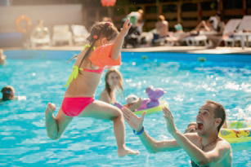
. | .

Prepositions of movement
1
- into
- through
- around
2
- towards
- through
- to
- across
3
- They are climbing onto the train.
- She is jumping into the swimming pool.

Past Simple
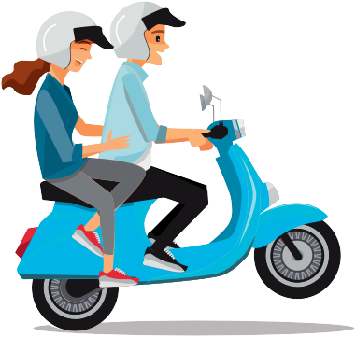 Complete the table.
1

Infinitive | Past Simple
write
give
drive
go
read
eat
see
do
speak
Complete the gaps with the verbs in brackets in the Past Simple.
2
- Yesterday I ____________ (not / get up) early.
- _ Jane __________ (speak) with you last night?
- My parents _________ (buy) a new car last month.
- We __ (not / make) sandwiches for the picnic.
- you _______ (see) Tom last week?
- Jill _ (not / win) the spelling contest.
- She __ (meet) an old friend.
- I (write) my first novel in 2016.
- Karen ____ (give) me a beautiful birthday present.
- ____ he ______ (drive) his new motorbike?

Past Simple
1
- wrote
- gave
- drove
- went
- read
- ate
- saw
- did
- spoke
2
- Yesterday I did not (didn’t) get up late.
- Did Jane speak with you last night?
- My parents bought a new car last month.
- We did not (didn’t) make sandwiches for the picnic.
- Did you see Tom last week?
- Jill did not (didn’t) win the spelling contest.
- She met an old friend.
- I wrote my first novel in 2016.
- Karen gave me a beautiful birthday present.
- Did he drive his new motorbike?
Be going to
1Complete the sentences with the correct forms of be going to.
1
- What time ______ they __________ (come)?
- She __ (travel) to see the beautiful monuments.
- I am very tired. I ____ (rest) for a while.
- Tomorrow they ___________ (watch) a film at home.
- When __ Jack __________ (call) you?
What is going to happen? Use the expressions below and write sentences.
2

- they / invite us / to a party
- he / travel / today
- I / fix / my bike
- she / plant / a tree

-  . b. .

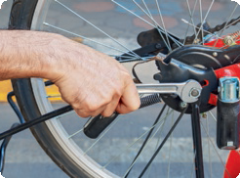c. . d. .

Be going to
1
- are, going to come
- is going to travel
- am going to rest
- are going to watch
- is, going to call
2
- She is going to plant a tree.
- He is going to travel today.
- I am going to fix my bike.
- They are going to invite us to a party.

Adverbs of manner
Read and complete the sentences with the correct adverb.
1

She is lazy. She works lazily.
- Ann is kind to me. She treats me _________.
- He is a nervous person. He answered _____.
- Pete has a loud voice. He speaks ___________.
- Mr Hart is a polite teacher. He talks _____.

Complete the sentences with an adverb using the adjectives below.
2

quiet ○ rude ○ easy ○ beautiful

- 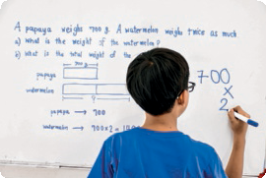You shouldn’t talk
.
- He solved that problem
.

- 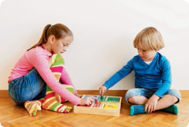We always sit and play
in our room.
- She played the violin
.

Adverbs of manner
1
- kindly
- nervously
- loudly
- politely
2
- rudely
- easily
- quietly
- beautifully

