Physical features
Label the pictures.
1
 | 
- b | - m
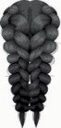 | 
- b | - s hair
Write the opposites.
2

- pretty
- big
- old
- curly
- tall
- fat
- long
- oval
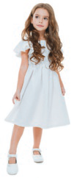
Look at the picture and complete the description.
3
She is a. (age) and b. (appearance)
She is c. (weight).
She has got d. ___ , brown hair and
e. _______ eyes.

Physical features
1
- beard
- moustache
- braids
- spiky

2

- ugly
- small
- young
- straight
- short
- thin
- short
- square

3
She is young and pretty.
She is slim.
She has got long, curly, brown hair and brown eyes.

Personalities

Match the words with the pictures.
1
happy ○ grumpy ○ serious ○ shy ○ intelligent ○ unhappy

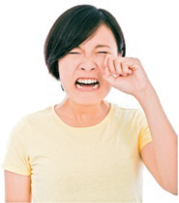 |  | 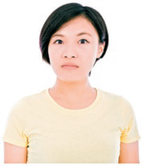 |  | 
 |  |  |  | 
Now translate the words below into English.
2
- ativo
- preguiçoso
- paciente
- nervoso
- bem-educado
- rude

Personalities
1
- unhappy
- serious
- intelligent
- shy
- happy
- grumpy
2
- active
- lazy
- patient
- nervous
- polite
- rude

Daily routine
Label the pictures about Tom’s daily routine.
1
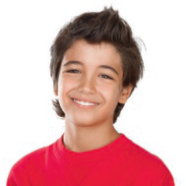 |  | 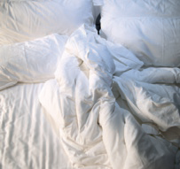 |  | 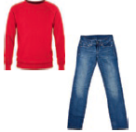
Hi! My name is Tom.
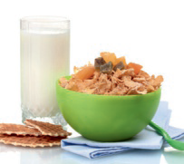 |  | 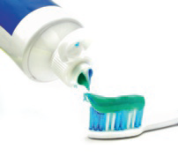 |  | 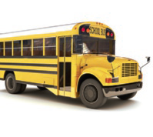
 |  | 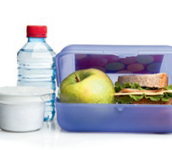 |  | 
 |  | 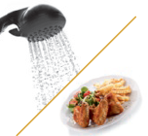 |  | 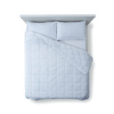

Daily routine
1
- gets up
- gets dressed
- has breakfast
- brushes his teeth
- goes to school by bus
- has lessons / classes
- has lunch
- does his homework
- plays video games
- has a shower and has dinner
- goes to bed

School facilities

Discover and write the places at school.
1
- I talk and laugh with my friends here.

- We play outdoor volleyball, basketball, handball and football here.

- There is a lot of information here. It’s where I do my projects and borrow books.

- This is the room where students learn diﬀerent subjects like Portuguese and history.

- We can buy a snack here. It always smells good here!

- This is a room where we do scientific experiments.

- This is where we have lunch.

- This is where I find my teachers during the breaks.

- There’s a lot of technology here.

- There’s a piano, some drums and triangles here.

- You can ask for information about timetables here.

- There are school meetings here.

School facilities
1
- playground
- sports field
- library
- classroom
- tuck shop
- laboratory
- canteen
- staffroom
- computer room
- music room
- secretary’s oﬃce
- assembly hall

School clubs


Read the clues and discover the school club.
Then, write.
1

- There is flour everywhere.
I can smell cakes.

- I can hear children singing.
The teacher is singing too.

- I can smell flowers and feel the wet grass.

- The children are wearing great costumes and masks.
They are speaking loudly.

- It is silent. The children are playing a board game.

- There are some machines moving around and doing things
automatically here.

- I can see a ball, a coach and some children running.

School clubs
1
- cooking club
- choir
- environmental club
- drama club
- chess club
- robotics club
- sports club

Jobs
Read and discover the job. Then, write.
1

- He fights crime. He is a .
- She works in the government. She is a .
- She acts in films. She is an .
- He makes our fresh bread. He is a .
- She writes for the newspaper. She is a .
- She works in a supermarket. People pay her for the things they buy.
She is a ________.
- He cuts and styles your hair. He is a _______.
- He catches fish. He is a .
- She cuts and sells meat. She is a .
- She designs engines/machines. She is an _____ ___.
- He trains people in a gym. He is a .
- He repairs cars. He is a .
- He designs clothes. He is a .
- She treats our teeth. She is a .
- He repairs broken pipes and sanitation systems.
He is a .


Jobs
1
- police oﬃcer
- politician
- actress
- baker
- journalist
- cashier
- hairdresser
- fisherman
- butcher
- engineer
- personal trainer
- mechanic
- fashion designer
- dentist
- plumber

Household chores

Discover and write the household chores. Then, circle the correct verb: do or make.
1
 |  | d |  | n |  | e
 |  | t |  |  |  | b
  do / make
 |  | t |  |  |  | f
 |  | t |  |  |  |  | o |  |  |  |  | g
 |  | t |  |  |  | d |  | s |  |  |  | g
  do / make
 |  | t |  |  |  | l |  | u |  | d
 |  | t |  |  |  | w |  |  | h |  |  | g |  | u
 |  | t |  |  |  | c |  | e |  |  | i
 |  | t |  |  |  | i |  | o |  | i
Label the pictures.
2

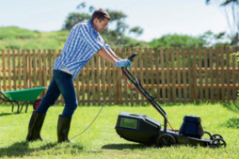 |  | 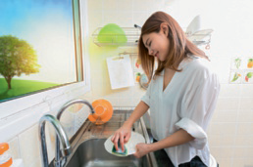
 |  | 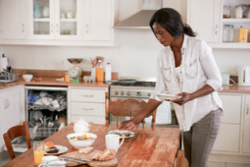

Household chores
1
- dinner – make
- the bed – make
- the food – make
- the cooking – do
- the dusting – do
- the laundry – do
- the washing up – do
- the cleaning – do
- the ironing – do
2
- cut the grass
- do the dishes / do the washing up
- make a cake
- set the table

Places in a city

Label the pictures.
1

 |  | 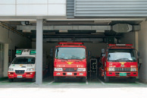 |  | 
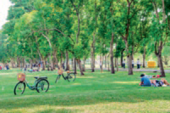 |  |  |  | 
Unscramble and write:
2
- SBU TONISTA
- HCURHC
- TSAUTERRAN
- EMNICA
- HOLOCS
- WNTO LALH
- SOTP FICOFE
- UMESUM
- RETHTEA
- BRLIAYR

Places in a city
1
- café
- fire station
- police station
- park
- airport
- hospital
2
- bus station
- church
- restaurant
- cinema
- school
- town hall
- post oﬃce
- museum
- theatre
- library


Types of shops

Read and discover the shop. Then, write its name.
1

- I am buying a puppy.
I’m at the ___ .

- He is buying the newspaper.
He is at the .

- She is buying vegetables.
She is at the .

- I am buying tasty meat and sausages here.
I am at the .

- She is buying some medicine.
She is at the .

- He is buying some new clothes.
He is at the .

- I am buying school supplies.
I am at the .

Types of shops
1
- pet shop
- newsagent’s
- greengrocer’s
- butcher’s
- chemist’s
- clothes shop
- stationer’s

Cool summer activities

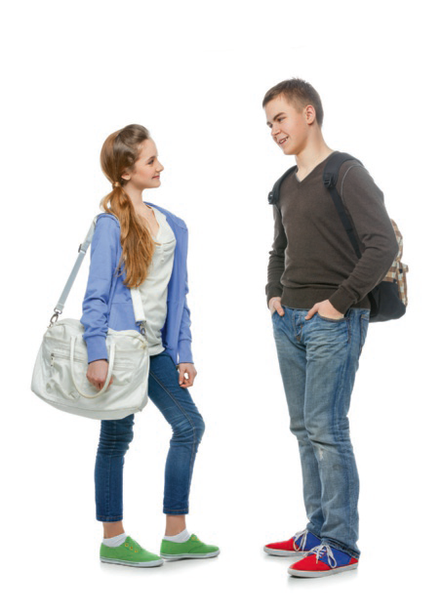
Read and complete the dialogue with the names of cool summer activities.
Which cool summer activities do you want to try this summer holiday?
1

I think that I want to
try a.
because I love boats,
the wind and the sea!
And I also want to try
b. because I like team
war games.

Look at the objects. Discover and write the names of the activities.
2

 | 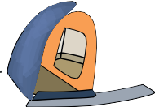 |  | 

Cool summer activities
1
- sailing
- paintball
2
- skateboarding
- camping
- bowling
- jet skiing

Theme park
Label the pictures.
1

 |  | 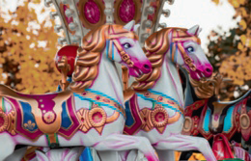
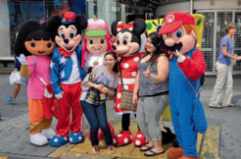 |  | 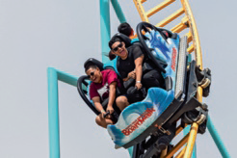
What is Jill going to do in the park? Read the clues and write a sentence with the connector.
2

 | skeleton | First, she is going to visit a horror house.
First | screams | First, she is going to visit a horror house.
 | ghosts | First, she is going to visit a horror house.

 | actors
Then | dancing
 | singing

 | 3D
Finally | actors
 | special effects

Theme park
1
- water ride
- carousel
- character photo
- roller coaster
2
- Then, she is going to watch a musical.
- Finally, she is going to watch a 3D film.

