WORKSHEET 10 | PRESENT CONTINUOUS
Name |  | No. | Class
Date | Mark | Teacher
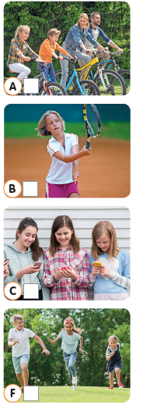
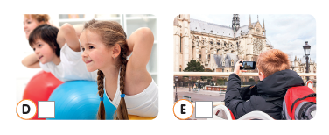
- Write sentences in the present continuous and match
them with the pictures.

- My friends / read / text messages /.
________________________________________
- Alex and Sue / run / the park /.
________________________________________
- Emma and her parents / ride / their bikes /.
________________________________________
- Bill / take / photos /.
________________________________________
- The children / do / gymnastics /.
_________________________________________
- Amy / play / tennis /.
_________________________________________

B. Choose a verb from the box to complete the sentences.

work • watch • dance • eat • read • swim • make

1. We_______________ popcorn.
2. They_______________ a chocolate cake.
3. I________________ a book about dinosaurs.
4. Daniel_________________ a film on TV.
5. Sue and John are at the party. They__________.
6. Maggie is not at home. She ______________.
7. The children______________ in the sea.

ANSWERS
- Write sentences in the present continuous and match
them with the pictures.

- My friends / read / text messages /.
My friends are reading text messages – C

- Alex and Sue / run / the park /.
Alex and Sue are running in the park. – F

- Emma and her parents / ride / their bikes /.
Emma and her parents are riding their bikes. – A

- Bill / take / photos /.
Bill is taking photos. – E

- The children / do / gymnastics /.
The children are doing gymnastics. – D

- Amy / play / tennis /.
Amy is playing tennis. – B

B. Choose a verb from the box to complete the sentences.

work • watch • dance • eat • read • swim • make
1. We are eating popcorn.
2. They are making a chocolate cake.
3. I am reading a book about dinosaurs.
4. Daniel is watching a film on TV.
5. Sue and John are at the party. They are dancing.
6. Maggie is not at home. She is working.
7. The children are swimming in the sea.

