WORKSHEET 13 | PRESENT SIMPLE: AFFIRMATIVE
Name |  | No. | Class
Date | Mark | Teacher

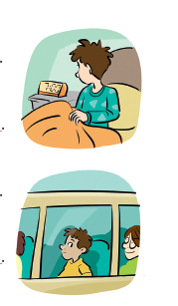
A. Rewrite the sentences in the 3rd person singular.
1. I get up at seven o’clock.
He______________________________________________.
2. I go to school by bus.
She_____________________________________________.
3. They study hard.
He _____________________________________________.
4. We watch TV in the evening.
She_____________________________________________.

B. Order the sentences and draw the hands on the clocks.

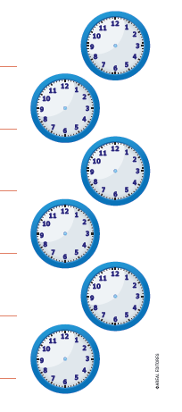
- gets up / at / Ben / a quarter past seven /.
___________________________________________________.
2. breakfast / at / has / half past seven / he /.
__________________________________________________.
3. start / half past eight / at / lessons /.
____________________________________________________.
4. has / he / at / lunch / midday /.
____________________________________________________.
5. home / he / at / goes / five o’clock / .
. ____________________________________________________.
6. goes / to / a quarter to ten / at / he / bed /.
____________________________________________________.

Answers

A. Rewrite the sentences in the 3rd person singular.
1. I get up at seven o’clock.
He gets up at seven o’clock.
2. I go to school by bus.
She goes to school by bus.
3. They study hard.
He studies hard.
4. We watch TV in the evening.
She watches TV in the evening.

B. Order the sentences and draw the hands on the clocks.
- gets up / at / Ben / a quarter past seven /
Ben gets up at a quarter past seven. 7.15

- breakfast / at / has / half past seven / he /.
He has breakfast at half past seven. 7.30

- start / half past eight / at / lessons /.
Lessons start at half past eight. 8.30
4. has / he / at / lunch / midday /.
He has lunch at midday. 12.00

5. home / he / at / goes / five o’clock /
He goes home at five o’clock. 5.00

6. goes / to / a quarter to ten / at / he / bed /.
He goes to bed at a quarter to ten. 9.45

