WORKSHEET 14 | THE TIME
Name |  | No. | Class
Date | Mark | Teacher

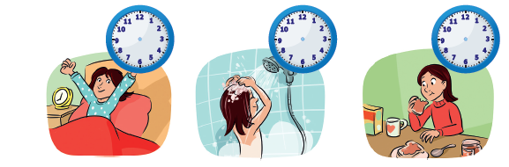
A. Draw the hands on the clocks.

1. I always get up at
seven o’clock.
2. I have a shower at ten
past seven.
3. I have breakfast at half
past seven.
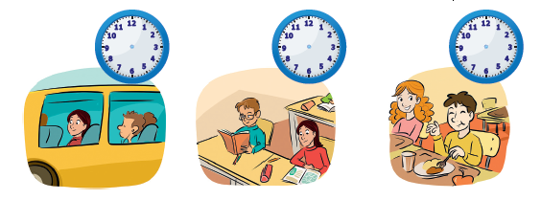

4. I go to school at five
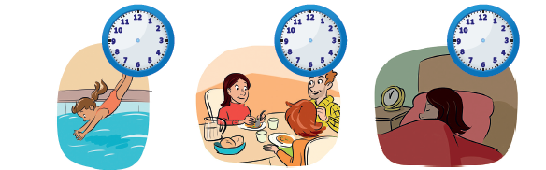
past eight.
5. School starts at half
past eight.
6. I have lunch with my
friends at midday.

7. I go to the swimming
pool with my sister at
a quarter past five.
8. I have dinner at
quarter to eight.

9. I go to bed at ten to
ten.

Answers
A. Draw the hands on the clocks.
1. I always get up at
seven o’clock.
2. I have a shower at ten
past seven.
3. I have breakfast at half
past seven.

4. I go to school at five
past eight.
5. School starts at half
past eight.
6. I have lunch with my
friends at midday.

7. I go to the swimming
pool with my sister at
a quarter past five.
8. I have dinner at
quarter to eight.

9. I go to bed at ten to
ten.

