WORKSHEET 16 | PRESENT SIMPLE: INTERROGATIVE
Name |  | No. | Class
Date | Mark | Teacher



A. Read and match.
Does Jim do his homework after dinner? 1 Yes, I do.
Do Sam and Harry like playing chess? 2 Yes, she does.
Do you have breakfast every day? 3 No, they don’t.
Does Barbara make her bed? 4 No, he doesn’t.

B. Complete the answers.
1. Do you brush your teeth every day? Yes, ___________________.
2. Do you go to school by bus? No, ___________________.
3. Does Amanda have lunch at home? Yes, ___________________.
4. Does David play cards on Sundays? No, ___________________.
5. Do they go to bed early? Yes, ___________________.
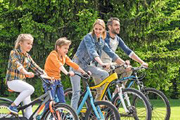
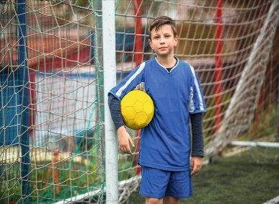


she / like reading? (✓)
_________________________
_________________________

C. Ask and answer. Follow the example.
Tom / play board games every day?
Does Tom play board games every day?
(✓) Yes, he does. / (✗) No, he doesn’t.
Peter / play golf? (✗)
____________________________
___________________________

you / wear glasses? (✓)
___________________________
___________________________

they / go cycling on Sundays? (✗)
_____________________________
_____________________________

ANSWERS

A. Read and match.
Does Jim do his homework after dinner? 1 Yes, I do.
Do Sam and Harry like playing chess? 2 Yes, she does.
Do you have breakfast every day? 3 No, they don’t.
Does Barbara make her bed? 4 No, he doesn’t.

B. Complete the answers.
1. Do you brush your teeth every day? Yes, I do.
2. Do you go to school by bus? No, I don’t.
3. Does Amanda have lunch at home? Yes, she does.
4. Does David play cards on Sundays? No, he doesn’t.
5. Do they go to bed early? Yes, they do.
C. Ask and answer. Follow the example.
Tom / play board games every day?
Does Tom play board games every day?
(✓) Yes, he does. / (✗) No, he doesn’t.
Peter / play golf? (✗)
Does Peter play golf?
No, he doesn’t.
you / wear glasses? (✓)
Do you wear glasses?
Yes, I do.

they / go cycling on Sundays? (✗)
Do they go cycling on Sundays?
No, they don’t.

she / like reading? (✓)
Does she like reading?
Yes, she does.

