WORKSHEET 18 | ADVERBS OF FREQUENCY
Name |  | No. | Class
Date | Mark | Teacher
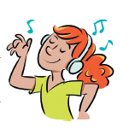
- Insert the adverb in the right place.

1. I listen to music in the afternoon. (usually)
____________________________________________________
2. We get up late. (hardly ever)
____________________________________________________
3. I play chess with my cousin. (often)
____________________________________________________
4. Lia does her homework after dinner. (never)
____________________________________________________
5. They’re on time for school. (always)
____________________________________________________
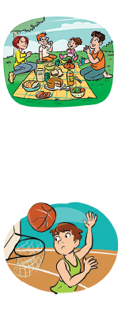
B. Order the sentences.
1. often / have / in the park / we / a picnic /.
______________________________________________________
2. always / we / have / lunch / at 12.30 /.
______________________________________________________
3. always / I / go / by bus / to school /.
______________________________________________________
4. rides / sometimes / in the afternoon / her bike / Sam /.
______________________________________________________
5. for school / hardly ever / are / late / we /.
______________________________________________________
6. play / I / sometimes / basketball / at the weekend /.
______________________________________________________
7. my brother / eats / yoghurt / never / for breakfast /.
_____________________________________________________

ANSWERS
- Insert the adverb in the right place.

1. I listen to music in the afternoon. (usually)
I usually listen to music in the afternoon.

2. We get up late. (hardly ever)
We hardly ever get up late.

3. I play chess with my cousin. (often)
I often play chess with my cousin.

4. Lia does her homework after dinner. (never)
Lia never does her homework after dinner.

5. They’re on time for school. (always)
They’re always on time for school.
B. Order the sentences.
1. often / have / in the park / we / a picnic /.
We often have a picnic in the park.

2. always / we / have / lunch / at 12.30 /.
We always have lunch at 12.30.

3. always / I / go / by bus / to school /.
I always go to school by bus.
4. rides / sometimes / in the afternoon / her bike / Sam /.
Sam sometimes rides her bike in the afternoon.
5. for school / hardly ever / are / late / we /.
We are hardly ever late for school.

6. play / I / sometimes / basketball / at the weekend /.
I sometimes play basketball at the weekend.

7. my brother / eats / yoghurt / never / for breakfast /.
My brother never eats yoghurt for breakfast.

