WORKSHEET 2 | POSSESSIVE DETERMINERS
Name |  | No. | Class
Date | Mark | Teacher

A. Fill in the gaps with my, your, his, her, our, their.
1. Tom, is_____________ mother a teacher?
2. I am Alison. ____________ parents are Scottish.
3. They are studying English. _____________ teacher is very friendly.
4. We are from France, but_____________ grandparents are Portuguese.
5. Richard is eleven years old. _____________ birthday is on 2nd November.
6. Lia is a student. _____________ email address is lia.smith@btween.com.

B. Complete the sentences with a possessive determiner. Then match them with the corresponding picture.

1. Mia is eleven. _____________ parents are from New Zealand.
2. They are twelve. _____________birthday is in May.
3. Thomas, are_____________ parents from the USA?
4. This is Peter. _____________ favourite hobby is listening to music.
5. We are brushing_____________ teeth.
6. I am riding_____________ bike.
7. I’ve got a goldfish. _____________ name is King.
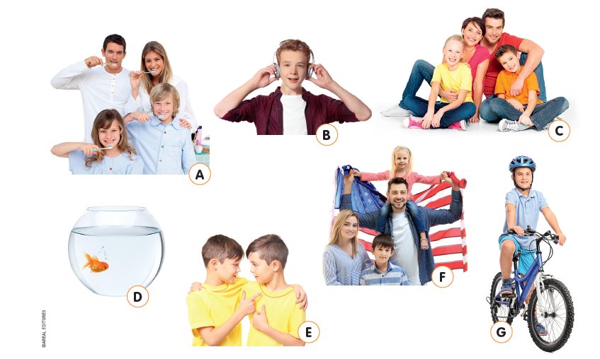

ANSWERS
A. Fill in the gaps with my, your, his, her, our, their.
1. Tom, is your mother a teacher?
2. I am Alison. My parents are Scottish.
3. They are studying English. Their teacher is very friendly.
4. We are from France, but our grandparents are Portuguese.
5. Richard is eleven years old. His birthday is on 2nd November.
6. Lia is a student. Her email address is lia.smith@btween.com.

B. Complete the sentences with a possessive determiner. Then match them with the corresponding picture.
1. Mia is eleven. Her parents are from New Zealand.
A
G
C
E
F
B
D
2. They are twelve. Their birthday is in May.
3. Thomas, are your parents from the USA?
4. This is Peter. His favourite hobby is listening to music.
5. We are brushing our teeth.
6. I am riding my bike.
7. I’ve got a goldfish. Its name is King.

