WORKSHEET 20 | WHEN / WHILE
Name |  | No. | Class
Date | Mark | Teacher

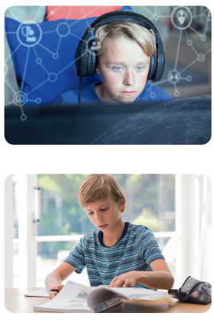
A. Choose the correct option.
1. My brother usually plays online games
when / while he is waiting for dinner.
2. Susan often listens to music when /
while she is doing the ironing.
3. When / While I don’t do my homework,
the teacher gets angry.
4. My mother always gets nervous when /
while she can’t find her car keys.
5. Max sings pop songs when / while he is
having a shower.
6. When / While I have an important test I

never watch TV.
B. Complete the sentences and match them with the pictures A – D.
1. I always drink water while I___________________________ (run).
2. Linda always listens to music while she___________________ (work).
3. Robert always cooks dinner when he___________________ (get) home.
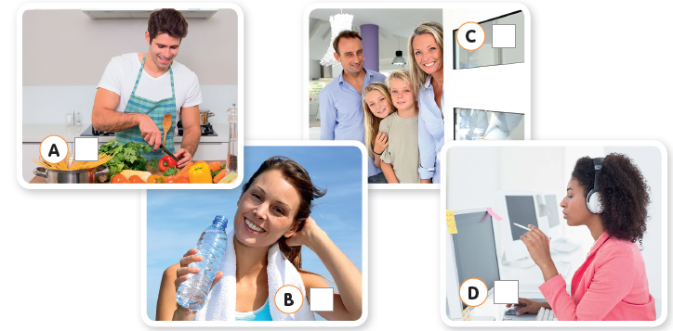
4. We usually answer the door immediately when our friends_______ (arrive).
ANSWERS
A. Choose the correct option.
1. My brother usually plays online games
when / while he is waiting for dinner.
2. Susan often listens to music when /
while she is doing the ironing.
3. When / While I don’t do my homework,
the teacher gets angry.
4. My mother always gets nervous when /
while she can’t find her car keys.
5. Max sings pop songs when / while he is
having a shower.
6. When / While I have an important test I
never watch TV.
B
D
A
C
B. Complete the sentences and match them with the pictures A – D.
1. I always drink water while I am running (run).
2. Linda always listens to music while she is working (work).
3. Robert always cooks dinner when he gets (get) home.
4. We usually answer the door immediately when our friends arrive (arrive).

