WORKSHEET 21 | SCHOOL SUBJECTS
Name |  | No. | Class
Date | Mark | Teacher

- Label the pictures.
Portuguese • English • mathematics (maths) • science • French
• history • geography • art • music • physical education (PE)
• information and communication technology (ICT) • religious education (RE)
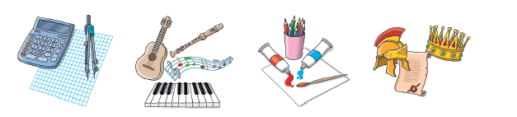
1.___________
3.___________

2.___________

4.___________


6.___________

7.___________

8.___________

5.___________


12.___________

11.___________

10.___________

9.___________

- What are your favourite school subjects?
______________________________________________________________________________________________________________________________________
ANSWERS

- Label the pictures.
Portuguese • English • mathematics (maths) • science • French
• history • geography • art • music • physical education (PE)
• information and communication technology (ICT) • religious education (RE)

1. maths
3. art

2. music

4. history

6. PE

7. English

8. Portuguese

5. geography _

12. religious education

11. ICT

10. science

9. French

- What are your favourite school subjects?
Personal answers. ___________________________________________
____________________________________________________________

