WORKSHEET 23 | ADVERBS OF MANNER
Name |  | No. | Class
Date | Mark | Teacher

Adjective | Adverb
wonderful | ____________
____________ | slowly
____________ | loudly
dangerous | ____________
A. Complete the tables.
Adjective | Adverb
____________ | happily
bad | ____________
sad | ____________
____________ | quickly


B. Choose an adverb from A to complete the sentences.
2. When I’m in the
shower, I sing
____________.

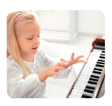
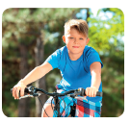
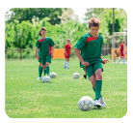
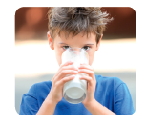


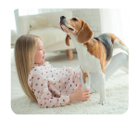
- She is playing the
piano__________.

4. Our team plays
______________.
We always lose
the game.
3. Can’t you ride
your bike more
____________?

6. He is drinking
his cup of milk
___________.

5. My dog
always plays
____________.

8. He’s ill in bed.
‘Look at me’, he
says_________.
7. Charles doesn’t
drive his car
_____________.

ANSWERS

Adjective | Adverb
wonderful | wonderfully
slow | slowly
loud | loudly
dangerous | dangerously
A. Complete the tables.
Adjective | Adverb
happy | happily
bad | badly
sad | sadly
quick | quickly

B. Choose an adverb from A to complete the sentences.
2. When I’m in the
shower, I sing
happily.

- She is playing the
Piano wonderfully.

4. Our team plays
badly.
We always lose
the game.
3. Can’t you ride
your bike more
slowly?

6. He is drinking
his cup of milk
quickly.

5. My dog
always plays
loudly.

8. He’s ill in bed.
‘Look at me’, he
says sadly.
7. Charles doesn’t
drive his car
dangerously.

