WORKSHEET 25 | POSSESSIVE PRONOUNS
Name |  | No. | Class
Date | Mark | Teacher

A. Complete the sentences with a possessive pronoun.
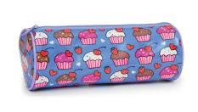
1. That pencil case is___mine___. (my)
2. Is that ruler__________? (your)
3. Those books are __________. (their)
4. That pencil is __________. (his)
5. Is this wallet __________? (her)
6. Those bags are __________. (our)

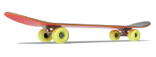
B. Complete each sentence with a possessive pronoun.
1. That skateboard belongs to my brother. It’s__his___.
2. That schoolbag belongs to me. It’s__________.
3. That pink house belongs to Mr and Mrs Smith. It’s__________.
4. The blue bike belongs to Vera. It’s __________.
5. This English book belongs to you. It’s __________.
6. This laptop belongs to me and my brother. It’s__________.
7. This pen belongs to my mother. It’s__________.

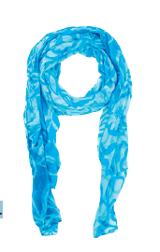
C. Choose the right word.
1. Is this pencil my / mine or your / yours?
2. Whose scarf is that? – It’s her / hers.
3. Whose scissors are those? Your / Yours or my / mine?
4. I don’t have an umbrella. Can I take your / yours?
5. That’s not my / mine car. My / Mine is grey.
6. Our / Ours house is bigger than your / yours.
7. They’ve got two dogs, but I don’t know their / theirs names.
8. Peter has got a big flat. Its / It’s windows face the south.
9. I’ve got two sisters. Their / Theirs bicycles are over there.
10. Is this your / yours puppy? No, it’s not my / mine.

Answers

A. Complete the sentences with a possessive pronoun.
1. That pencil case is___mine___. (my)
2. Is that ruler yours? (your)
3. Those books are theirs. (their)
4. That pencil is his. (his)
5. Is this wallet hers? (her)
6. Those bags are ours. (our)

B. Complete each sentence with a possessive pronoun.
1. That skateboard belongs to my brother. It’s__his___.
2. That schoolbag belongs to me. It’s mine.
3. That pink house belongs to Mr and Mrs Smith. It’s theirs.
4. The blue bike belongs to Vera. It’s hers.
5. This English book belongs to you. It’s yours.
6. This laptop belongs to me and my brother. It’s ours.
7. This pen belongs to my mother. It’s hers

C. Choose the right word.
1. Is this pencil my / mine or your / yours?
2. Whose scarf is that? – It’s her / hers.
3. Whose scissors are those? Your / Yours or my / mine?
4. I don’t have an umbrella. Can I take your / yours?
5. That’s not my / mine car. My / Mine is grey.
6. Our / Ours house is bigger than your / yours.
7. They’ve got two dogs, but I don’t know their / theirs names.
8. Peter has got a big flat. Its / It’s windows face the south.
9. I’ve got two sisters. Their / Theirs bicycles are over there.
10. Is this your / yours puppy? No, it’s not my / mine.

