WORKSHEET 32 | PAST SIMPLE (IRREGULAR VERBS)
Name |  | No. | Class
Date | Mark | Teacher

A. Complete the sentences with the past simple. Then put the pictures in the correct
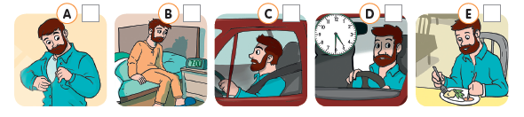
order (1 – 11).
Yesterday John (1) ___got up_____ (get up) at 7 o’clock. First, he (2) ____________ (go)
to the bathroom. He (3) ____________ (not have) a bath; he (4) ____________ (have)
a shower. Then, he (5) ____________(get) dressed. After that, he (6) ____________ (go)
to the kitchen and (7) ____________ (drink) a glass of milk and (8) ____________ (eat)
toast for breakfast.
At quarter to eight he (9) __________ (drive) to work, he (10) _________ (not catch) the bus. At lunch time he (11) ___________ (not go) home, he (12) ____________ (have) lunch in a restaurant. He (13) ____________ (leave) his office at half past five
and (14) ____________ (go) home.
At seven o'clock he (15) ____________ (have) dinner with his family. Then he
(16) ____________ (read) the newspaper, but he (17) ____________ (not write) emails.
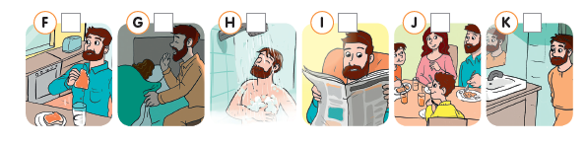
At a quarter to eleven he (18) ____________ (go) to bed.
B. Write six sentences about what you did yesterday.
_____________________________________________________________________
_____________________________________________________________________
_____________________________________________________________________
_____________________________________________________________________
_____________________________________________________________________
_____________________________________________________________________

ANSWERS

A. Complete the sentences with the past simple. Then put the pictures in the correct
order (1 – 11).
4
1
6
8
7

Yesterday John (1) ___got up_____ (get up) at 7 o’clock. First, he (2) went (go)
to the bathroom. He (3) didn’t have (not have) a bath; he (4) had (have)
a shower. Then, he (5) got (get) dressed. After that, he (6) went (go)
to the kitchen and (7) drank (drink) a glass of milk and (8) ate (eat) toast for breakfast.
At quarter to eight he (9) drove (drive) to work, he (10) didn’t catch (not catch) the bus. At lunch time he (11) didn’t go (not go) home, he (12) had (have) lunch in a restaurant. He (13) left (leave) his office at half past five and (14) went (go) home.
At seven o'clock he (15) had (have) dinner with his family. Then he (16) read (read) the newspaper, but he (17) didn’t write (not write) emails.
At a quarter to eleven he (18) went (go) to bed.
5
11
3
10
2
B. Write six sentences about what you did yesterday.
9
_____________________________________________________________________
_____________________________________________________________________
_____________________________________________________________________
_____________________________________________________________________

Personal answers.
_____________________________________________________________________
_____________________________________________________________________
_____________________________________________________________________
_____________________________________________________________________
_____________________________________________________________________

