WORKSHEET 34 | REFLEXIVE PRONOUNS
Name |  | No. | Class
Date | Mark | Teacher

A. Read and match.


He painted yourselves.
You can do your homework herself in the mirror.
She is always looking at himself in the art lesson.
The cat cleans yourself.
You and Jim can do the exercise themselves.
They looked in the mirror and laughed at itself with the tongue.

B. Fill in the gaps with a reflexive pronoun.

1. I hurt_______________ on my arm in the PE lesson.
2. He considers_______________ to be the best student in class.
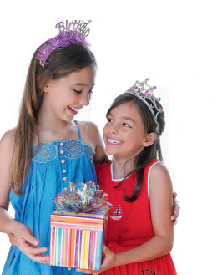
3. She fell down the stairs, but she didn’t hurt___________.
4. The black cat is washing _______________.
5. I cut_______________ with a knife while making a sandwich.
6. Corinne went to a birthday party.
She enjoyed_______________ very much.
7. Some of her friends didn’t behave_______________.
8. Mary and John, help _______________.
There’s a lot a food in the fridge.
9. You should make your bed by_______________.
10. You can watch TV if you behave _______________.
11. I wasn’t with Peter. I was by _______________.
12. We had great fun in our summer holiday.
We enjoyed_______________ very much.

ANSWERS
A. Read and match.
He painted yourselves.
You can do your homework herself in the mirror.
She is always looking at himself in the art lesson.
The cat cleans yourself.
You and Jim can do the exercise themselves.
They looked in the mirror and laughed at itself with the tongue.

B. Fill in the gaps with a reflexive pronoun.

1. I hurt myself on my arm in the PE lesson.
2. He considers himself to be the best student in class.
3. She fell down the stairs, but she didn’t hurt herself.
4. The black cat is washing itself.
5. I cut myself with a knife while making a sandwich.
6. Corinne went to a birthday party.
She enjoyed herself very much.
7. Some of her friends didn’t behave themselves.
8. Mary and John, help yourselves.
There’s a lot a food in the fridge.
9. You should make your bed by yourself.
10. You can watch TV if you behave yourself.
11. I wasn’t with Peter. I was by myself.
12. We had great fun in our summer holiday.
We enjoyed ourselves very much.

