WORKSHEET 36 | FUTURE: BE GOING TO
Name |  | No. | Class
Date | Mark | Teacher

A. What are they going to do? Write a sentence for each picture.
Use the expressions in the box:

have
a party
play
the flute
eat an
ice cream
visit
monuments
draw
a picture
catch
the bird

1. He’s going to_____ 2. ____________ 3. _____________
play the flute_____ ______________ _______________
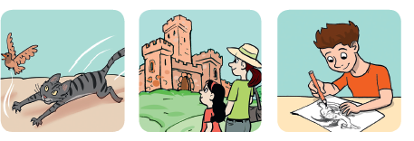

4. ______________ 5. _____________ 6. _______________
________________ _______________ ________________

B. Follow the model.

1. Jim / see a film – Yes
Is Jim going to see a film? – Yes, he is. ______________
2. John / visit a museum – Yes
_____________________________________________
3. the boys / chat on the Net – No
_____________________________________________
4. Alice / write a story – Yes
_____________________________________________
5. The students / play baseball – No
_____________________________________________

ANSWERS

A. What are they going to do? Write a sentence for each picture.
Use the expressions in the box:
have
a party
play
the flute
eat an
ice cream
visit
monuments
draw
a picture
catch
the bird

1. He’s going to____ 2. They are going to 3. She’s going to
play the flute_____ have a party eat an ice cream

4. The cat is going to 5. They are going to 6. He’s going to
catch the bird. visit monuments. draw a picture

B. Follow the model.
1. Jim / see a film – Yes
Is Jim going to see a film? – Yes, he is. ______________
2. John / visit a museum – Yes
Is John going to visit a museum?
- Yes, he is.
3. the boys / chat on the Net – No
Are the boys going to chat on the Net?
– No, they aren’t.
4. Alice / write a story – Yes
Is Alice going to write a story?
– Yes, she is.
5. The students / play baseball – No
Are the students going to play baseball?
– No, they aren’t.

