WORKSHEET 4 | PRESENT SIMPLE: TO BE
Name |  | No. | Class
Date | Mark | Teacher

A. Complete the sentences. Use the affirmative of the verb to be.

1. I___________ 12 years old.
2. We__________ happy.
3. My father__________ Canadian.
4. My grandparents__________ from Italy.
5. My dog__________ white.
6. James__________ from Washington.
B. Complete the sentences. Use the negative of the verb to be.
1. She__________ Dutch. She’s Swiss.

2. You__________ from Wales.
3. I__________ a doctor.
4. They__________ at home.
5. Dave__________ thirteen years old.
6. Peter and I__________ in year 6.
C. Order the questions and answer them.
1. German / are / you /? (✓)
_________________________________________
2. are / French / they /? (✗)
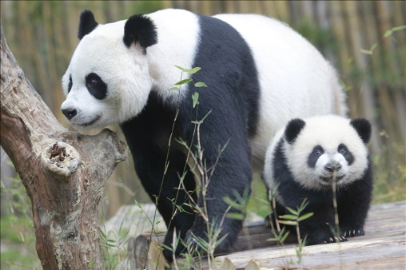
_______________________________________
3. he / twelve / is /? (✓)
_________________________________________
4. it / is / cold /? (✗)
_______________________________________
5. pandas / black and white / are /? (✓)
_______________________________________
6. Mrs Smith / a maths teacher / is /? (✗)
________________________________________
Answers
A. Complete the sentences. Use the affirmative of the verb to be.
1. I am 12 years old.
2. We are happy.
3. My father is Canadian.
4. My grandparents are from Italy.
5. My dog is white.
6. James is from Washington.
B. Complete the sentences. Use the negative of the verb to be.
1. She isn’t Dutch. She’s Swiss.
2. You aren’t from Wales.
3. I ’m not a doctor.
4. They aren’t at home.
5. Dave isn’t thirteen years old.
6. Peter and I isn’t in year 6.
C. Order the questions and answer them.
1. German / are / you /? (✓)
Are you German? Yes, I am. / Yes, we are.

2. are / French / they /? (✗)
Are they French? No, they aren’t.

3. he / twelve / is /? (✓)
Is he twelve? Yes, he is. _______

4. it / is / cold /? (✗)
Is it cold? No, it isn’t. __________

5. pandas / black and white / are /? (✓)
Are pandas black and white? Yes, they are.

6. Mrs Smith / a maths teacher / is /? (✗)
Is Mrs Smith a maths teacher? No, she isn’t.

