WORKSHEET 6 | PRESENT SIMPLE: HAVE GOT
Name |  | No. | Class
Date | Mark | Teacher
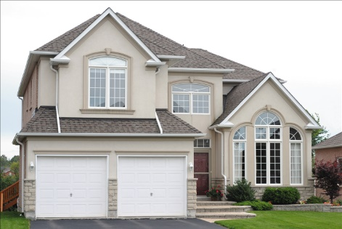
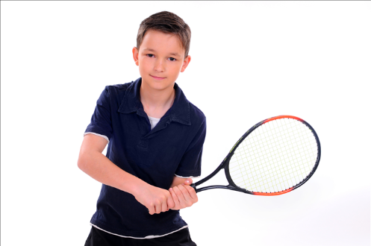
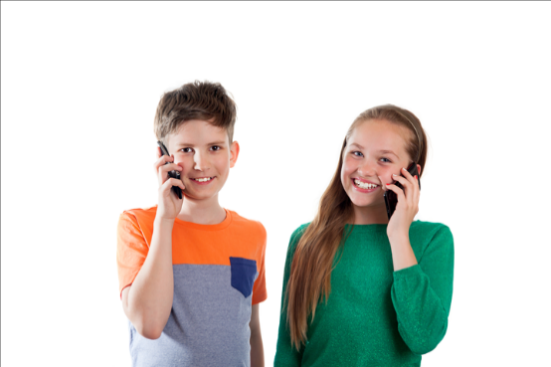


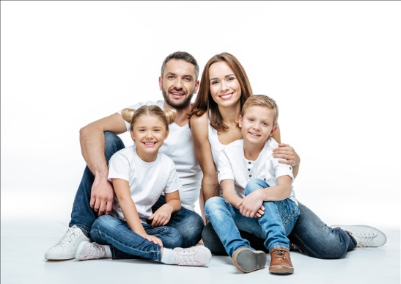
A. What have they got? Write have got or has got.


1. She____________ braces on her teeth.
2. My grandparents____________ a big house.
3. He____________ a tennis racket.
4. My brother and I____________ a mobile phone.
5. I____________ sunglasses.

B. Write haven’t got or hasn’t got.
1. They____________ a Dalmatian dog.
2. She____________ a sister.
3. We____________ a new car.
4. I____________ a pet parrot.
5. My grandparents____________ a digicam.
6. Michael____________ a computer

C. Write sentences. Use the right form of the verb have got.
1. Brian / have got / a lovely family /.
__________________________________________________
__________________________________________________
2. My parents / not / have got / a swimming pool /.
_________________________________________________
3. My sister / not / have got / a skateboard /.
__________________________________________________

ANSWERS
A. What have they got? Write have got or has got.

1. She has got braces on her teeth.
2. My grandparents have got a big house.
3. He has got a tennis racket.
4. My brother and I have got a mobile phone.
5. I have got sunglasses.

B. Write haven’t got or hasn’t got.
1. They haven’t got a Dalmatian dog.
2. She hasn’t got a sister.
3. We haven’t got a new car.
4. I haven’t got pet parrot.
5. My grandparents haven’t got a digicam.
6. Michael hasn’t got a computer

C. Write sentences. Use the right form of the verb have got.
1. Brian / have got / a lovely family /.
Brian has got a lovely family.
2. My parents / not / have got / a swimming pool /.
My parents haven’t got a swimming pool.

3. My sister / not / have got / a skateboard /.
My sister hasn’t got a skateboard.

