WORKSHEET 8 | PRESENT SIMPLE: TO BE / HAVE GOT
Name |  | No. | Class
Date | Mark | Teacher
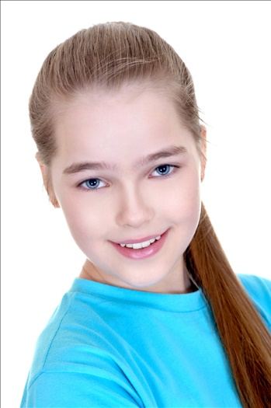

- Complete the text with the correct form of
the verb to be or have got.
This (1) __________ Helen. She (2) __________ eleven
years old. She (3) __________ English.
Her best friend (4) __________ Jane. She (5) __________
short and thin and she (6) ____________ long
blonde hair and big green eyes. She (7) __________
beautiful, calm and honest.
They (8) __________ in year 6 and they (9) __________
lots of friends.

B. Write a text about Henry. Use the notes in the box.

Name: Henry
Age: 16
Nationality: Welsh
Height: tall
Weight: slim
Eyes: big, brown
Hair: short, straight, brown
Appearance: handsome
Personality: sociable and friendly

___________________________________________________________________________
___________________________________________________________________________
___________________________________________________________________________
___________________________________________________________________________
___________________________________________________________________________
___________________________________________________________________________
ANSWERS

- Complete the text with the correct form of
the verb to be or have got.
This (1) is Helen. She (2) is eleven
years old. She (3) is English.
Her best friend (4) is Jane. She (5) is
short and thin and she (6) has got long
blonde hair and big green eyes. She (7) is
beautiful, calm and honest.
They (8) are in year 6 and they (9) have got
lots of friends.

B. Write a text about Henry. Use the notes in the box.

Name: Henry
Age: 16
Nationality: Welsh
Height: tall
Weight: slim
Eyes: big, brown
Hair: short, straight, brown
Appearance: handsome
Personality: sociable and friendly

This is Henry.
He is sixteen.
He is Welsh.
He is tall and slim.
He has got big brown eyes and short, straight brown hair.
He is handsome, sociable and friendly.

