WORKSHEET 9 | PRESENT CONTINUOUS
Name |  | No. | Class
Date | Mark | Teacher

A. Write the -ing form of the following verbs.
5. dance______________________ 6. write_______________________ 7. watch ______________________ 8. walk _______________________

1. cook ______________________
2. swim ______________________
3. run ________________________
4. read_______________________

B. Complete the sentences with the present continuous of the verbs in brackets.

1. I__________________________ (listen) to music.
2. You_________________________ (watch) a film.
3. Mia________________________ (read) a book.
4. My mother_____________________ (make) a cake.
5. We____________________________ (play) video games.
6. Peter and Ann ________________________ (run).

C. Look at the pictures and write positive or negative sentences. Use the present continuous. Then correct the negative ones.
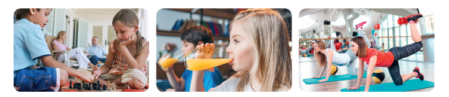

1. They / play / cards 2. Lucy / drink / water
3. We / do gymnastics

____________________

_____________________ _____________________ ____________________


4. The children / make a cake 5. The girls / surf the Net 6. I / study
_____________________ _____________________ _____________________

ANSWERS
A. Write the -ing form of the following verbs.
5. dance dancing 6. write write 7. watch watching 8. walk walking

1. cook cooking
2. swim swimming
3. run running
4. read reading

B. Complete the sentences with the present continuous of the verbs in brackets.
1. I am listening (listen) to music.
2. You are watching (watch) a film.
3. Mia is reading (read) a book.
4. My mother is making (make) a cake.
5. We are playing (play) video games.
6. Peter and Ann are running (run).

C. Look at the pictures and write positive or negative sentences. Use the present continuous. Then correct the negative ones.

1. They / play / cards 2. Lucy / drink / water
3. We / do gymnastics

____________________

They aren’t playing cards.
Lucy is not drinking water. (She is drinking orange (juice.)
(They are playing chess.
We are doing gymnastics

4. The children / make a cake 5. The girls / surf the Net 6. I / study
The children are
I am not studying.
(I am painting.)
The girls are surfing the Net.
making a cake.

