Listening
Progress Test B

Name |  | No. | Class
Date | Mark | Teacher

 Listen to Jamal and choose the correct option.
A
A
- Jamal is
- ten years old. | - eleven years old.
- Jamal is
- short and slim. | - short and fat.
- Jamal is from
- India. | - Pakistan.
- Jamal’s mother is from
- India. | - Mozambique.
- Jamal’s mother is
- a teacher. | - a chef.

Listen to the dialogue and write Jamal or Rebecca under each photo.
B

 |  |  |  | 
1. _____________________ |  | 2. _____________________ |  | 3. ______________________
 |  |  | 
 | 4. ______________________ |  | 5. ______________________

Reading
Progress Test B

Name |  | No. | Class
Date | Mark | Teacher

Read the text.
 | At the bus stop
Noah:  George:  Noah:  George:  Noah:  George:  Noah:  George:  Noah:  George:  Noah:  George:  Noah:  George:  Noah: |   Hi! I’m Noah. Noah Lewis. What’s your name?  Hello! Nice to meet you, Noah! I’m George. Are you a new student?  Yeah! I’m from Birmingham, but now I live here in Liverpool with my parents and my little brother.  I’m sure Birmingham is lovely, but Liverpool is cool too.    Yes, it is! I like Liverpool! By the way, are you in year 6? I’m in class C.  Yes, I am, but I’m in class B. Do you know Olivia? A tall and thin blonde girl?  Yeah! I do! She’s my neighbour.  Cool! She’s in your class, Noah!  Really?! Great! I really like her!  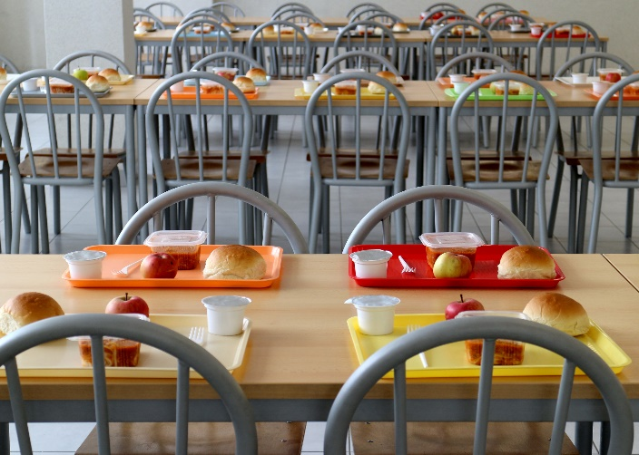  Me too! She’s very funny and friendly!  Yes, she is. Where do you have lunch?  I have lunch at the school canteen. And you?  Me too! It’s my first time today.  OK, let’s have lunch together! Bring Olivia!  Great! Let’s do that!

Complete the table with the underlined information in the text.
A

- Noah’s surname
- Noah’s new friend
- Noah’s family
- City where they live
- Noah’s neighbour
- Place where they have lunch

Are the sentences True (T) or False (F)?
B
 | T | F
1. Noah is at home.
2. Noah is talking to Olivia.
3. Noah and George live in London.
4. They are in the same year.
5. Noah is having lunch with his friends.

Answer the questions about the text.
C
1. Where is Noah from?
Noah is from
2. Who does Noah live with?
Noah lives with
3. Is Noah in year 5?
No, he isn’t. He
4. What does Olivia look like?
Olivia is
5. Is she funny?
Yes, she is. She’s

Vocabulary and Grammar
Progress Test B

Name |  | No. | Class
Date | Mark | Teacher

Vocabulary

Write the name of these countries. Choose from the box.

A
Spain Brazil United States of America England Japan

 |  |  |  | 
1. _____________________ |  | 2. _____________________ |  | 3. ______________________
 |  |  | 
 | 4. ______________________ |  | 5. ______________________

Write the name of these jobs. Choose from the box.
police officer farmer vet teacher doctor
B
 |  | 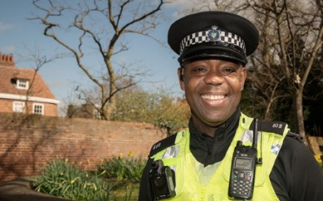 |  | 
1. ______________________ |  | 2. ______________________ |  | 3. ______________________
 |  |  | 
 | 4. _________________________ |  | 5. _________________________
Grammar
Grammar

Complete the sentences with the correct personal pronouns (I, he, she, we, they) or possessive determiners (my, his, her, our, their).
A
- Noah lives in Liverpool but ______ favourite city is Birmingham. _____ loves Birmingham!
- ______ am Olivia’s cousin. ______ name is Alice.
- Noah has got a funny neighbour. ______ name is Olivia. ______ is in his class.
- Welcome to ______ house! ______ are Noah’s parents.
- Noah and George are at school. ______ have lunch at the school canteen every day. ______ school is great!

Complete the sentences. Use possessive pronouns (his, hers, ours, theirs).
B
- This is Noah’s house. It is ________.
- This is the students’ school. The school is ________.
- Olivia has got a new cap. Noah’s cap is red but ________ is blue.
- “There’s bus number 101, Noah. Is it our bus?” “No, ________ is bus 102.”

Put the words in order to write correct sentences. The first word of each sentence is given.
C
1. often / his / Noah / plays / friends / with /.
Noah
2. school / He / goes / always / bus / by / to /.
He
3. around / usually / helps / Olivia / him / school /.
Olivia
4. are / They / never / late /.
They
5. sometimes / Students / listen / class / in / music / to /.
Students

Choose the correct option to complete the sentences.
D
- Olivia watch / watches TV after dinner.
- Do / Does Noah surf / surfs the net at night?
- What time do / does you go / goes to bed?
- They do /does their homework in the afternoon.
- George don’t drink / doesn’t drink milk for breakfast.
- Students don’t go / doesn’t go to school by train.

Writing
Progress Test B

Name |  | No. | Class
Date | Mark | Teacher


Imagine you meet a new friend. Write a dialogue where you get to know each other.
You can use these ideas:
You: Hello! My _____________ is _____________. What’s _____________ name?
Your friend: _______ ! _______ name is _____________ and _____________ surname is _____________. What´s _______ surname?
You: My ___________ is _____________. I’m _______ years old. How old are you?
Your friend: I’m _________ __________ _________. I __________ from _____________. And _________?
You: _____ am ______________________. I live with my _____________________ and my _____________________.
Your friend: I live with my _____________________ and my _____________________.
You: Nice to meet ______!
Your friend: Nice to _______ you too!
Greeting
Names and surnames

Age

Birthplace

Family

Saying
goodbye
A

