Listening
Progress Test A

Name |  | No. | Class
Date | Mark | Teacher

 Listen to part 1 and tick () the subjects Deborah likes.
A
A
  1 |   2 |   3
  4 |   5 |   6
  7 |   8

Listen to part 1 again. Are these sentences True (T) or False (F)?
F
G
H
B
A
 | T | F
1. Andy’s favourite subject is geography.
2. He doesn’t like French.
3. He hates physical education.
4. Deborah is good at singing.

Listen to part 2 and complete the sentences.
C
A
On a typical Tuesday, students have English classes in the 1. ________________.
Then, they go to the 2. ________________ to have physical education lessons.
At lunchtime, they go to the 3. ________________.
After lunch, they play on the 4. _______________ or play sports on the 5. ______________.
After the afternoon classes, they go to the 6. ________________ and choose a book to read.
Reading
Progress Test A

Name |  | No. | Class
Date | Mark | Teacher

Read the dialogue.

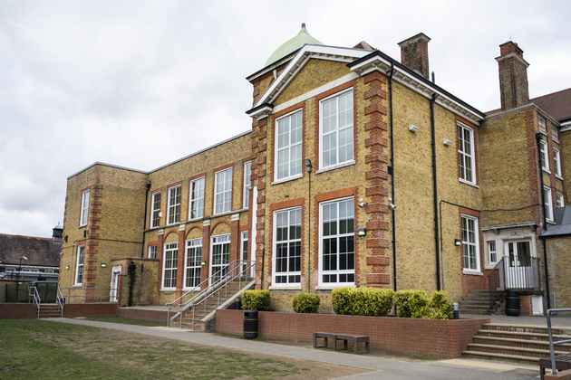
At school
Andy: Kelly, have you got our timetable? I can’t find mine.
Kelly: What do you need to know?
Andy: What time is our next lesson?
Kelly: The art lesson starts at quarter past ten.
Andy: Thank you. Is the art room next to the music room?
Kelly: No, it isn’t. It’s next to the computer room.
Andy: OK. And is there a music lesson today? I haven’t got my flute.
Kelly: Don’t worry. We only have music lessons on Tuesdays and Fridays.
Andy: Great! Are you in any school club?
Kelly: Yes, I’m in the robotics club. It’s awesome!
Andy: Really? I’m in the drama club, but I think I want to join the sports club too.
Kelly: My brother is in the sports club and he loves it! He goes canoeing and plays table tennis.
Andy: Cool! I love canoeing! Do you like sports?
Kelly: Not really! My favourite subject is science and I like maths too.
Andy: Oh! I hate maths! My favourite subjects are English and PE.
Kelly: I like English, but I don’t like PE lessons.
Andy: I love it! And the PE teacher is my favourite teacher.
Kelly: It’s time to go! Come on!

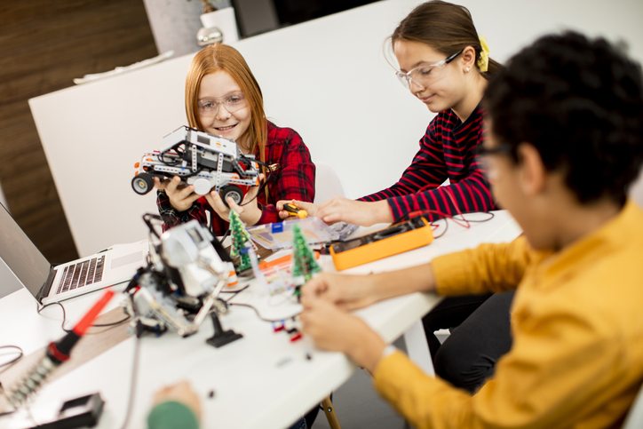
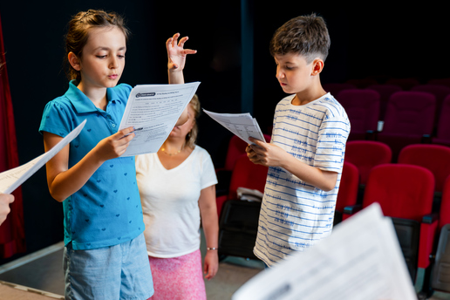

Complete the table in note form.
A
1. Kelly’s school club
2. Andy’s school club
3. Andy’s favourite subjects
4. Kelly’s favourite subject
5. Subject Andy doesn’t like
6. Subject Kelly doesn’t like

Are the sentences True (T) or False (F)? Correct the false ones.
B
 | T | F
1. Andy can’t find his timetable.
2. His next lesson is art.
3. The art lesson starts at 9:45.
4. Andy hasn’t got his music book.
5. The English teacher is Andy’s favourite teacher.

Answer the questions about the text.
C
- Are Andy and Kelly in the same class?
.
- Where is the art room?
.
- When do they have music lessons?
.
- What sports does Kelly’s brother do in the sports club?
.
- Does Kelly like sports?
.

Vocabulary and Grammar
Progress Test A

Name |  | No. | Class
Date | Mark | Teacher


Vocabulary
Complete the sentences with the correct school clubs.
A
1. Are you good at singing or playing musical instruments? The club for you is _______________.
2. Are you creative and do you enjoy drawing? You can join the ______________________.
3. To learn how to cook, you can go to the ______________________.
4. Do you like acting? You should join the ______________________.
5. Is reading your favourite free time activity? Come to the ______________________.

Label the parts of the school.
B

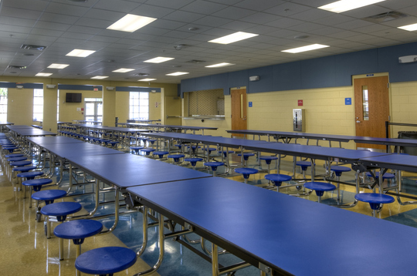 | 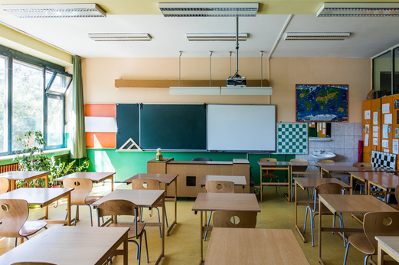 | 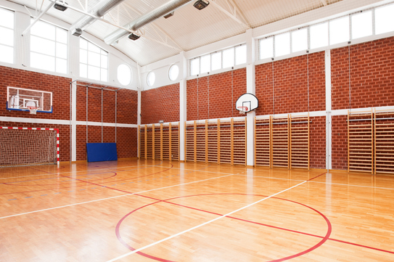
1. ______________________ | 2. ______________________ | 3. ______________________

 | 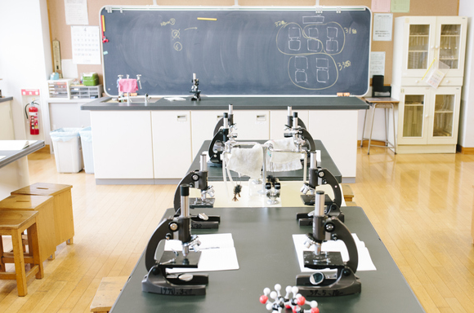
4. ______________________ | 5. ______________________

Grammar
Write the words in the plural.
A
- pencil ____________
- dress ____________
- library ____________
- life ____________
- child ____________

Complete the sentences with the correct form of the verb there to be.
B
- In my school, ________________ a sports field but ________________ (not) a swimming pool.
- “________________ a computer room in your school?” “Yes, _______________.”
- On the second floor, ________________ two labs, but _________________ (not) many classrooms.
- “_______________ many students in your school?” “No, ______________. It’s a small school.”
Write the correct preposition after the adjectives.
C
- Sue is very good ____________ maths.
- Peter is crazy ____________ football.
- Mary is interested ____________ history.
- My mother is afraid ____________ spiders.

Complete the sentences with the comparative or the superlative.
D
- I’m 10 years old. My sister is only 8. She is ______________________ (young) me.
- Paul is ______________________ (good) Ken at playing basketball.
- Thomas has great marks. He is ______________________ (intelligent) Richard.
- Carol is so funny! She is ______________________ (funny) girl in my class.
- In my opinion, history is ______________________ (interesting) subject.
- My English teacher is really nice. She is ______________________ (good) teacher I have.

Complete the sentences with the present continuous of the verbs in brackets.
E
- Luke __________________ (not ride) his bike. He __________________ (climb) ropes.
- My friends __________________ (play) video games. They __________________ (not swim).
- “_______ he ____________ (read) a book?” “No, he ____________.”
- “_______ they ____________ (listen) to music?” “Yes, they ____________.”
- My parents _________________ (take) photos of our pets. They ________________ (not watch) TV.
- My sister __________________ (not run). She __________________ (dance).

Writing
Progress Test A

Name |  | No. | Class
Date | Mark | Teacher

Write a text about your school. These questions can help you:
A
    - Is it big or small?
    - How many floors are there?
    - What parts of the school are there?
    - What is your favourite part of the school?




