Listening
Progress Test B

Name |  | No. | Class
Date | Mark | Teacher

 Listen to part 1 and tick () the subjects Deborah likes.
A
A
  1 |   2 |   3
  4 |   5 |   6

Listen to part 1 again. Are the sentences True (T) or False (F)?
B
A
 | T | F
1. Andy’s favourite subject is geography. 
2. He doesn’t like French. 
3. He hates physical education. 
4. Deborah is good at singing.

Listen to part 2 and complete the sentences with the words in the box.
sports field classroom gym library canteen playground
C
A

On a typical Tuesday, students have English classes in the 1. ________________.
Then, they go to the 2. ________________ to have physical education lessons.
At lunchtime, they go to the 3. ________________.
After lunch, they play on the 4. _______________ or play sports on the 5. ______________.
After the afternoon classes, they go to the 6. ________________ and choose a book to read.

Reading
Progress Test B

Name |  | No. | Class
Date | Mark | Teacher

Read the dialogue.

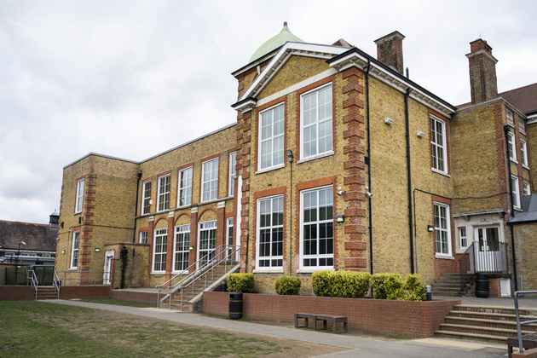
At school
Andy: Kelly, have you got our timetable? I can’t find mine.
Kelly: What do you need to know?
Andy: What time is our next lesson?
Kelly: The art lesson starts at quarter past ten.
Andy: Thank you. Is the art room next to the music room?
Kelly: No, it isn’t. It’s next to the computer room.
Andy: OK. And is there a music lesson today? I haven’t got my flute.
Kelly: Don’t worry. We only have music lessons on Tuesdays and Fridays.
Andy: Great! Are you in any school club?
Kelly: Yes, I’m in the robotics club. It’s awesome!
Andy: Really? I’m in the drama club, but I think I want to join the sports club too.
Kelly: My brother is in the sports club and he loves it! He goes canoeing and plays table tennis.
Andy: Cool! I love canoeing! Do you like sports?
Kelly: Not really! My favourite subject is science and I like maths too.
Andy: Oh! I hate maths! My favourite subjects are English and PE.
Kelly: I like English, but I don’t like PE lessons.
Andy: I love it! And the PE teacher is my favourite teacher.
Kelly: It’s time to go! Come on!


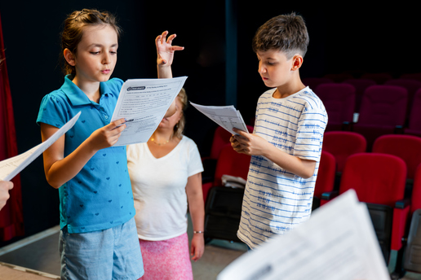

Complete the table in note form.
A
1. Kelly’s school club
2. Andy’s school club
3. Andy’s favourite subjects
4. Kelly’s favourite subject
5. Subject Andy doesn’t like
6. Subject Kelly doesn’t like

Are the sentences True (T) or False (F)?
B
 | T | F
1. Andy can’t find his timetable.
2. His next lesson is art.
3. The art lesson starts at 9:45.
4. Andy hasn’t got his music book.
5. The English teacher is Andy’s favourite teacher.

Answer the questions about the text.
C
- Are Andy and Kelly in the same class?
Yes, .
- Where is the art room?
The art room is .
- When do they have music lessons?
They have music lessons .
- What sports does Kelly’s brother do in the sports club?
He goes ________________________ and plays ____________________________ in the sports club.
- Does Kelly like sports?
No, .

Vocabulary and Grammar
Progress Test B

Name |  | No. | Class
Date | Mark | Teacher


Vocabulary
Complete the sentences with the correct school clubs.
A
1. Are you good at singing or playing musical instruments? The club for you is the m_______________ club.
2. Are you creative and do you enjoy drawing? You can join the a______________ club.
3. To learn how to cook, you can go to the c___________________ club.
4. Do you like acting? You should join the d__________________club.
5. Is reading your favourite free-time activity? Come to the b__________________ club.

Label the parts of the school with the words: classroom, lab, gym, canteen, computer room.
B

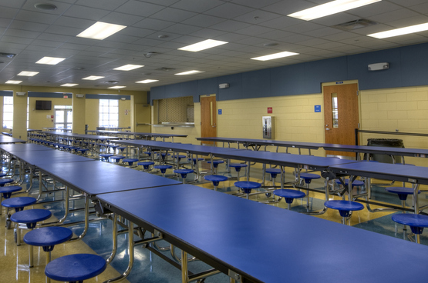 | 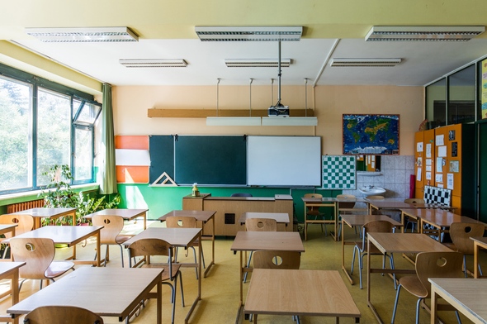 | 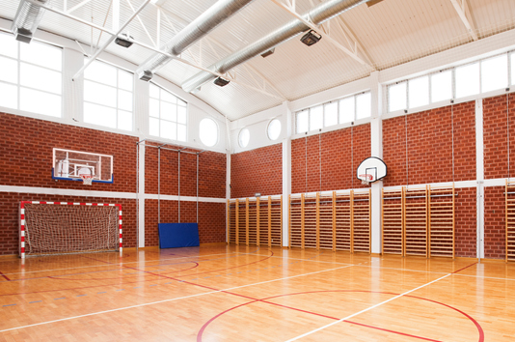
1. ______________________ | 2. ______________________ | 3. ______________________

 | 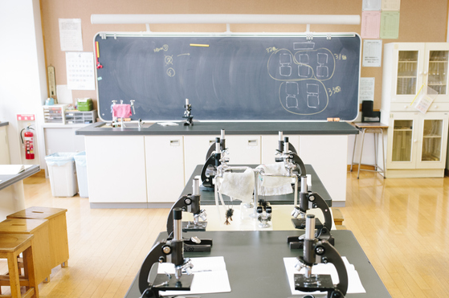
4. ______________________ | 5. ______________________

Grammar
Write the words in the plural.
A
- pencil ____________
- dress ____________
- library ____________
- life ____________
- child ____________

Circle the correct form of the verb there to be.
B
- In my school, there is / there are a sports field, but there isn’t / there aren’t a
swimming pool.
- “Is there / Are there a computer room in your school?” “Yes, there is / there are.”
- On the second floor, there is / there are two labs, but there isn’t / there aren’t many
classrooms.
- “Is there / Are there many students in your school?” “No, there isn’t / there aren’t. It’s a small school.”
Write the correct preposition (about, of, in, at) after the adjectives.
C
- Sue is very good ____________ maths.
- Peter is crazy ____________ football.
- Mary is interested ____________ history.
- My mother is afraid ____________ spiders.

Complete the sentences with the comparative or the superlative. Pay attention to the underlined words.
D
- I’m 10 years old. My sister is only 8. She is ______________________ (young) than me.
- Paul is ______________________ (good) than Ken at playing basketball.
- Thomas has great marks. He is ______________________ (intelligent) than Richard.
- Carol is so funny! She is the ______________________ (funny) girl in my class.
- In my opinion, history is the ______________________ (interesting) subject.
- My English teacher is really nice. She is the ______________________ (good) teacher I have.

Circle the correct form of the present continuous.
E
- Luke isn’t riding / doesn’t ride his bike. He climbs / is climbing ropes.
- My friends are play / are playing video games. They aren’t swimming / don’t swim.
- “Does he read / Is he reading a book?” “No, he isn’t / is.”
- “Are they listening / Do they listen to music?” “Yes, they are / aren’t.”
- My parents are taking / is taking photos of our pets. They aren’t watching / isn’t watching TV.
- My sister isn’t running / aren’t running. She is dancing / are dancing.
Writing
Progress Test B

Name |  | No. | Class
Date | Mark | Teacher

Write a text about your school. The questions below can help you.
A
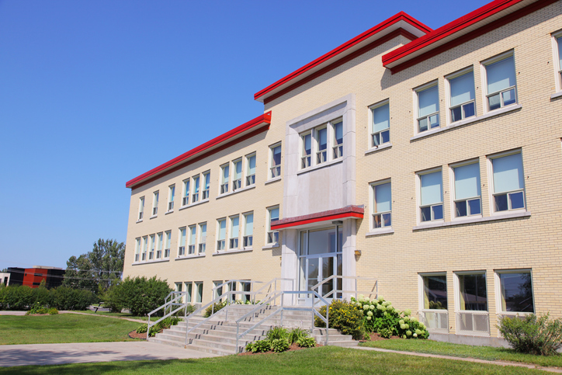

Where do you go to school?  Is it big or small? How many floors are there?  What parts of the school are there?  What is your favourite part of the school? | I go to a school in ______________.  It’s a _______________ school. There are ______________ floors.  In my school there is ______________________________________________  __________________________________________________________________  _________________________________________________________________.  Outside there is / there are________________________________________  ___________________________________________________________________  _________________________________________________________________.  My favourite place is the __________________ because ______________  __________________________________________________________________  __________________________________________________________________  __________________________________________________________________.

