Listening
Progress Test A

Name |  | No. | Class
Date | Mark | Teacher

 Listen to the dialogue and complete it.
A
A

Shop assistant: Good afternoon! Can I 1.___________ you?
Mrs Allen: Good afternoon! I’d like to 2.___________ a new dress for my 3.______________.
Daisy: Yes, I’d like a blue dress, please.
Shop assistant: What is your 4._____________?
Daisy: 5.______________.
Shop assistant: Do you like this one?
Daisy: Yes, I do. May I 6.______________ it on?
Shop assistant: Of 7.______________. The 8.______________ rooms are on the left.
Daisy: I love it!
Mrs Allen: How 9._____________ is it?
Shop assistant: It’s £22.
Mrs Allen: We’ll 10._____________ it.

Listen to the text and match the students with the places they were at yesterday.
B
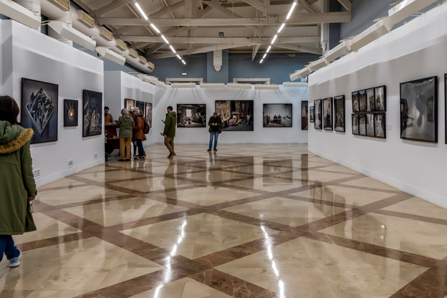

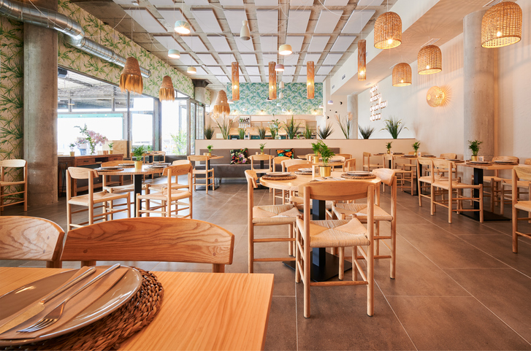
1. Andy _____ 2. Helen _____ 3. Karen _____ 4. George _____ 5. Susan _____

C
B
A

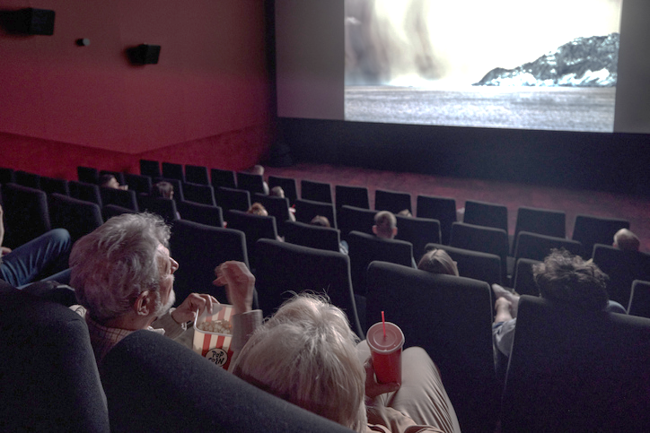

E
D

Reading
Progress Test A

Name |  | No. | Class
Date | Mark | Teacher

Read the text.
A weekend in Edinburgh
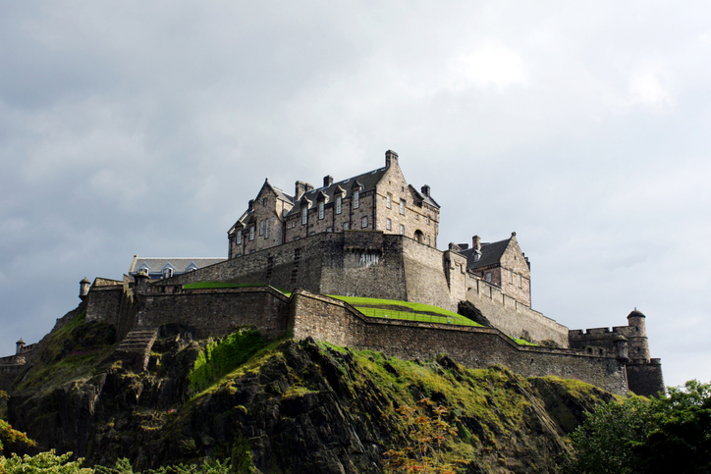
Amy: Hello, Mark! How was your weekend?
Mark: Hi! It was great! I was in Edinburgh, Scotland, for the first time and it was amazing!
Amy: Were you at Edinburgh Castle?
Mark: Yes, I was. I was there on Saturday morning.
Amy: What was your favourite place?
Mark: I think my favourite place was the Royal Mile.
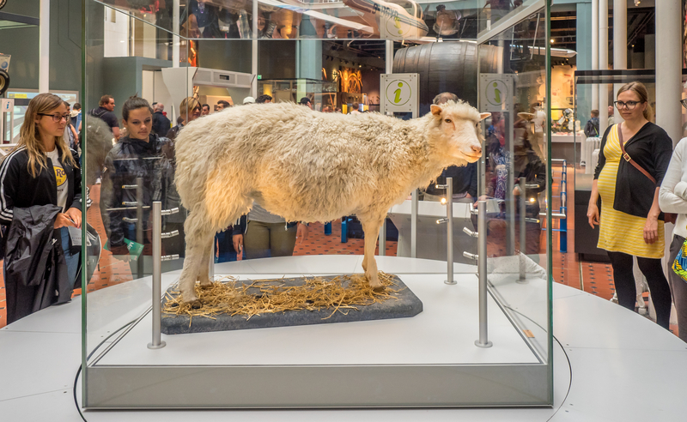
Amy: Cool! Where else were you?
Mark: I was at the National Museum of Scotland on Sunday.
Amy: Oh! What was there for you to see?
Mark: Lots of different things, but my favourite one was Dolly.
Amy: Who’s Dolly?!
Mark: The sheep. It was the first cloned mammal.
Amy: Oh! That Dolly!

Are the sentences True (T) or False (F)? Correct the false ones.
A
 | T | F
1. Mark was in Scotland.
2. It was his second time in Edinburgh.
3. He was in Edinburgh during the week.
4. He was at Edinburgh Castle.
5. His favourite place was Victoria Street.

Answer the questions about the text.
B
1. How was Mark’s short trip?
.
2. In what city was he?
.
3. When was he at the castle?
.
- Was he at a pub on Sunday?
.
5. What was his favourite thing at the National Museum of Scotland?
.
Vocabulary and Grammar
Progress Test A

Name |  | No. | Class
Date | Mark | Teacher


Vocabulary
Complete the sentences with the name of the shops.
A
1. If you need to buy a pair of shoes, you go to a _______________________.
2. You can buy new books at the ______________________.
3. When you need to buy food for your dog, you go to the ______________________.
4. When you want a newspaper or a magazine, you go to the ______________________.
5. If you want fresh bread, you go to the ______________________.

Label the photos with the names of places in the city.
B
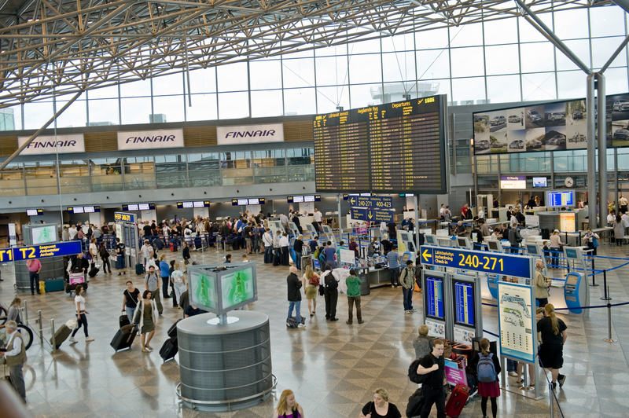 | 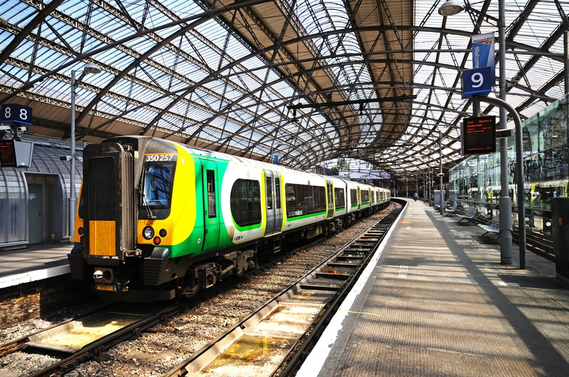 | 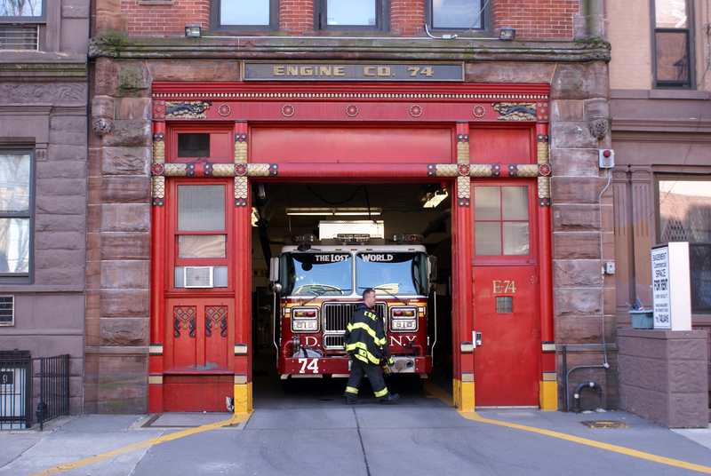 | 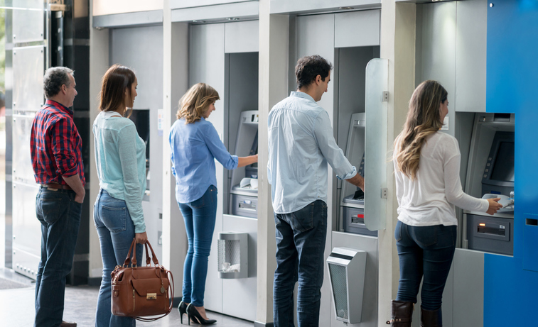 | 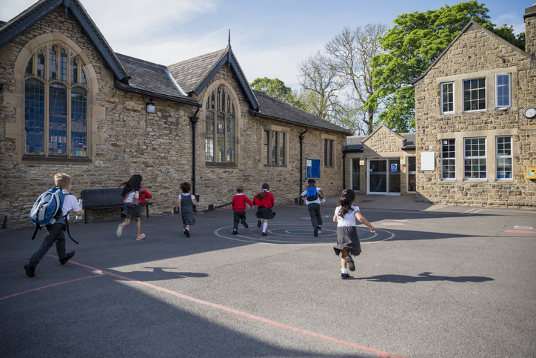
1. ________________ | 2. ________________ | 3. ________________ | 4. ________________ | 5. ________________
Grammar
Look at the picture and complete the sentences with the correct prepositions of place.
A

- The library is ________ the bank.
- The bank is __________ the library and the baker’s.
- The hospital is ___________ the library.
- The sign is ________ the roof of the hospital.
- There are grey buildings _________ the restaurant.
Complete the sentences with the past simple of the verb to be.
B

1. Mr Jones _________ (not) at home last night. He _________ at the cinema.
2. I _________ (not) at school yesterday because I _________ ill.
3. My parents _________ (not) at home this morning. They _________ at the supermarket.
4. “Where _________ you yesterday?” “I _________ at my grandparents’ house.”
5. “_________ Cathy at the park last Sunday?” “No, she _________.”

Put the words in order to write correct sentences.
C
1. lots / were / people / There / at / of / party / the /.

2. vegetable / at / wasn’t / soup / There / restaurant / the /.

3. many / there / How / park / were / people / the / at / ?

4. a / clown / Was / there / ?

5. weren’t / at / the / There / any / magicians / party /.

Complete the table with adverbs of manner.
D
Adjective | Adverbs of manner
1. easy
2. quick
3. comfortable
4. slow
5. real

Writing
Progress Test A

Name |  | No. | Class
Date | Mark | Teacher

Imagine you are telling a friend about a great restaurant you were at last evening. Use the information in the box.
A
________________________________________________________________________________________________________________________________________________________________________________________________________________________________________________________________________________________________________________________________________________________________________________________________________________________________________________________________________________________________________________________________________________________________________________________________________________________________________________________________________________________________________________________________________________________________________________________________________________________________________________________________________________________________________________________________________________________________________________________________________________________________________________________________________________________________________________________________________________________________________________________________________________________________________________________________________________________________________________________________
Restaurant: Giorgio’s (Italian)
Location: London
Occasion: brother’s birthday
Dish you ordered: spaghetti carbonara
Dessert: tiramisu
Decoration: traditional and cosy

