Listening
Progress Test B

Name |  | No. | Class
Date | Mark | Teacher

 Listen to the dialogue and complete it with the words in the box.
take changing help size buy daughter try small course much

A
A

Shop assistant: Good afternoon! Can I 1.___________ you?
Mrs Allen: Good afternoon! I’d like to 2.___________ a new dress for my 3.______________.
Daisy: Yes, I’d like a blue dress, please.
Shop assistant: What is your 4._____________?
Daisy: 5.______________.
Shop assistant: Do you like this one?
Daisy: Yes, I do. May I 6.______________ it on?
Shop assistant: Of 7.______________. The 8.______________ rooms are on the left.
Daisy: I love it!
Mrs Allen: How 9._____________ is it?
Shop assistant: It’s £22.
Mrs Allen: We’ll 10._____________ it.

Listen to the text and match the students with the places they were at yesterday.
B
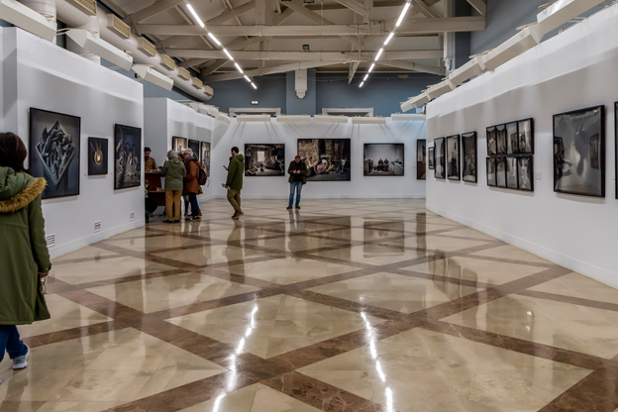

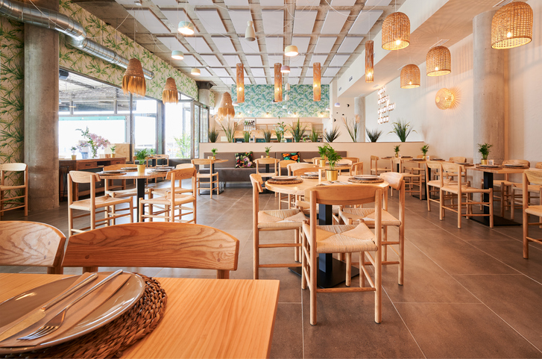
1. Andy _____ 2. Helen _____ 3. Karen _____ 4. George _____ 5. Susan _____

museum
C
B
A
library
restaurant

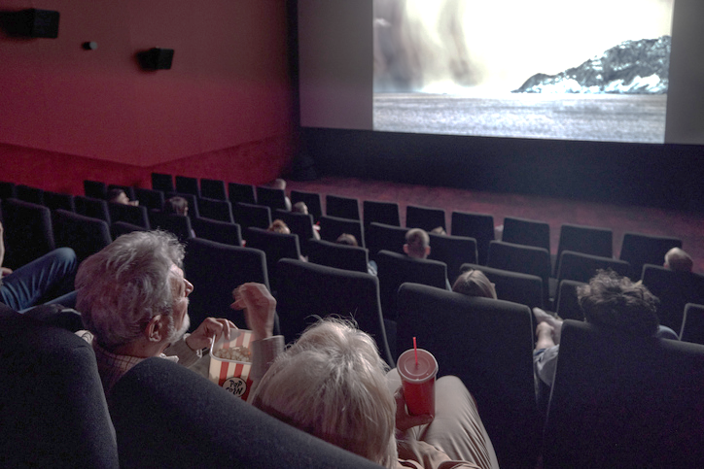
E
D
hospital
cinema
Reading
Progress Test B

Name |  | No. | Class
Date | Mark | Teacher

Read the text.
A weekend in Edinburgh
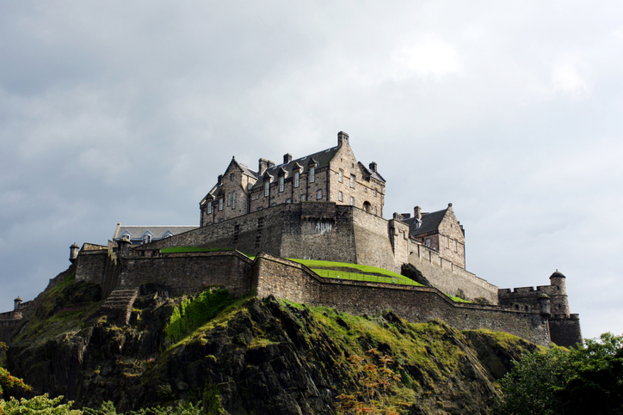
Amy: Hello, Mark! How was your weekend?
Mark: Hi! It was great! I was in Edinburgh, Scotland, for the first time and it was amazing!
Amy: Were you at Edinburgh Castle?
Mark: Yes, I was. I was there on Saturday morning.
Amy: What was your favourite place?
Mark: I think my favourite place was the Royal Mile.
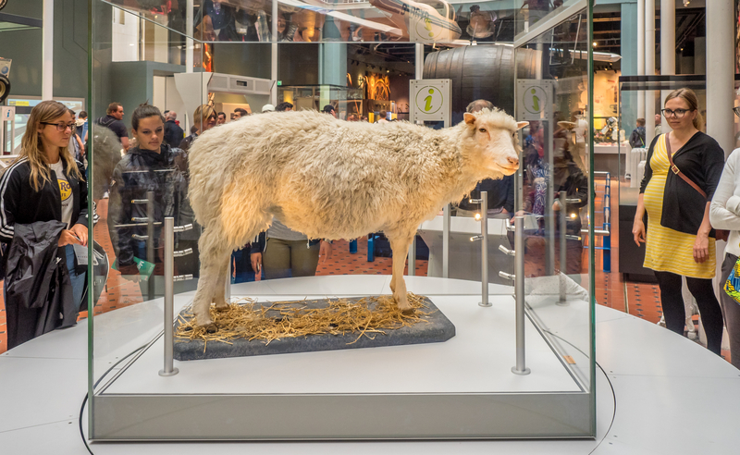
Amy: Cool! Where else were you?
Mark: I was at the National Museum of Scotland on Sunday.
Amy: Oh! What was there for you to see?
Mark: Lots of different things, but my favourite one was Dolly.
Amy: Who’s Dolly?!
Mark: The sheep. It was the first cloned mammal.
Amy: Oh! That Dolly!

Are the sentences True (T) or False (F)?
A
 | T | F
1. Mark was in Scotland.
2. It was his second time in Edinburgh.
3. He was in Edinburgh during the week.
4. He was at Edinburgh Castle.
5. His favourite place was Victoria Street.

Answer the questions about the text.
B
1. How was Mark’s short trip?
Mark’s short trip was .
2. In what city was he?
He was .
3. When was he at the castle?
He was at the castle .
- Was he at a pub on Sunday?
No, .
5. What was his favourite thing at the National Museum of Scotland?
His favourite thing was .
Vocabulary and Grammar
Progress Test B

Name |  | No. | Class
Date | Mark | Teacher


Vocabulary
Complete the sentences with the name of the shops.
A
1. If you need to buy a pair of shoes, you go to a s____________ s____________.
2. You can buy new books at the b________________.
3. When you need to buy food for your dog, you go to the p____________ s____________.
4. When you want a newspaper or a magazine, you go to the n_____________________ .
5. If you want fresh bread you go to the b_______________ .

Label the photos with the names of the places in the city.
B
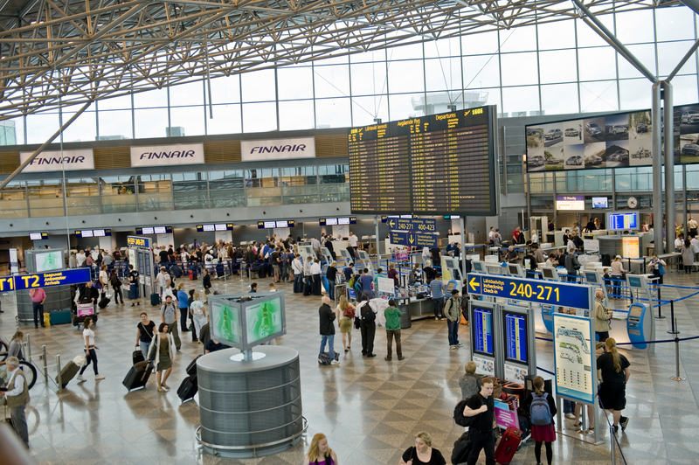 | 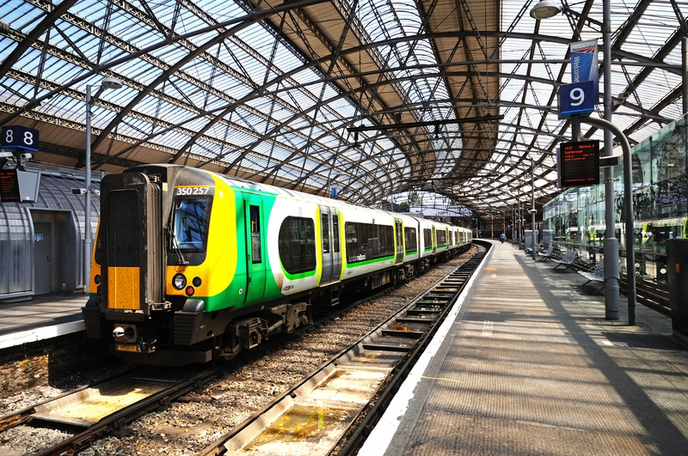 | 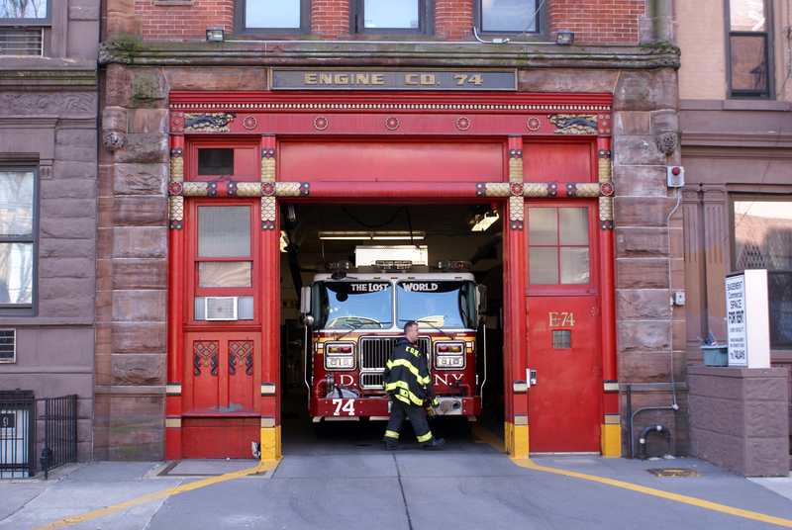 | 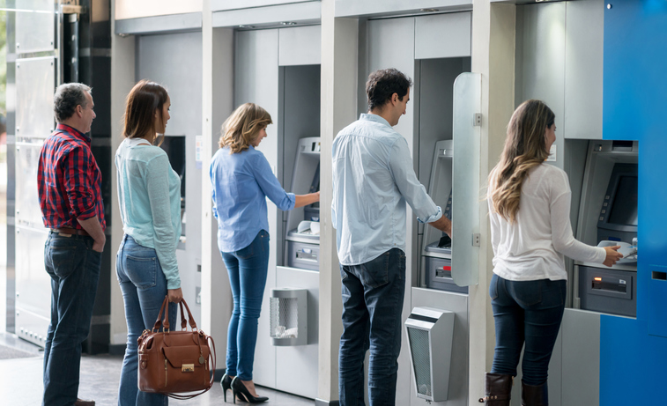 | 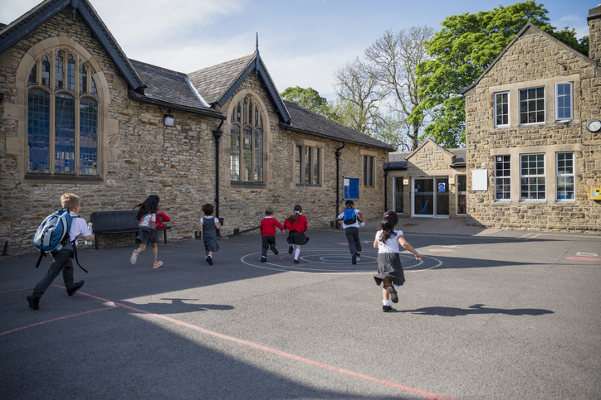
1. a________________ | 2. t________________ | 3. f________________ | 4. b________________ | 5. s________________
Grammar
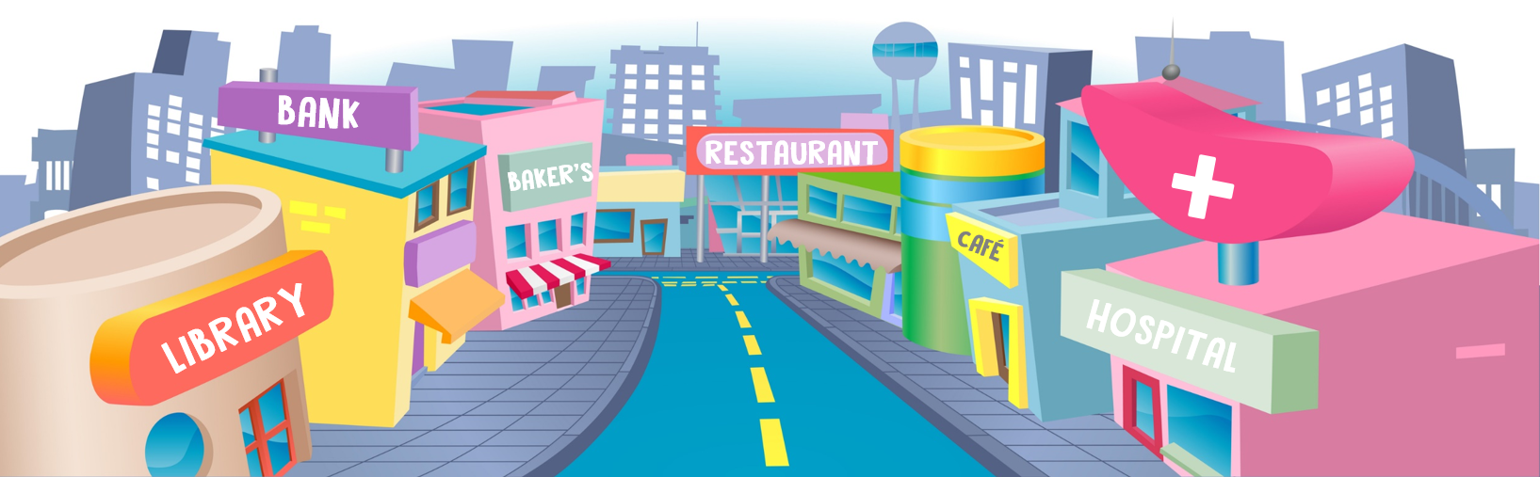
Look at the picture and complete the sentences with these prepositions of place:
on; between; next to; behind; opposite.
A

- The library is ________ the bank.
- The bank is __________ the library and the baker’s.
- The hospital is ___________ the library.
- The sign is ________ the roof of the hospital.
- There are grey buildings _________ the restaurant.
Choose the correct option.
B

1. Mr Jones wasn’t / weren’t at home last night. He was / were at the cinema.
2. I wasn’t / weren’t at school yesterday because I was / were ill.
3. My parents wasn’t / weren’t at home this morning. They was / were at the supermarket.
4. “Where was / were you yesterday?” “I was / were at my grandparents’ house.”
5. “Was / Were Cathy at the park last Sunday?” “No, she wasn’t / weren’t.”

Put the words in order to write correct sentences.
C
1. lots of / were / at / people / There / the party /.
There
2. vegetable / at / wasn’t / soup / There / the restaurant /.
There
3. were there / How many / the park / people / at / ?
How many
4. a / clown / Was / there / ?
Was
5. weren’t / at / There / any magicians / the party /.
There

Complete the table with adverbs of manner. Follow the example.
D
Adjective | Adverbs of manner
> noisy | noisily
1. easy
2. quick
3. comfortable
4. slow
5. real

Writing
Progress Test B

Name |  | No. | Class
Date | Mark | Teacher

Imagine you are telling a friend about a great restaurant you were at last evening. Use the information in the box.
A
- be / Italian restaurant

- be / Giorgio’s

- be / London / next to

- there to be / a lot of people

- It / be / a special day /

- be / my brother’s birthday

- be / spaghetti carbonara

- be / tiramisu

- be / great

- be / beautiful, traditional, cosy

Yesterday, I 1. ____________________________________.
Its name 2. ______________________________________.
The restaurant 3. __________________________________
a hospital.
4. _____________________________ at the restaurant.
5. _____________________________________ because it
6. _____________________________________________.
My favourite dish 7. ______________________________.
My favourite dessert 8. ____________________________.
The restaurant 9. ________________________________.
It 10. __________________________________________.

