Name |  | No. | Class
Date | Mark | Teacher

Circle the correct option of the verb to have got.
A
1. Jane has got / have got a small family.
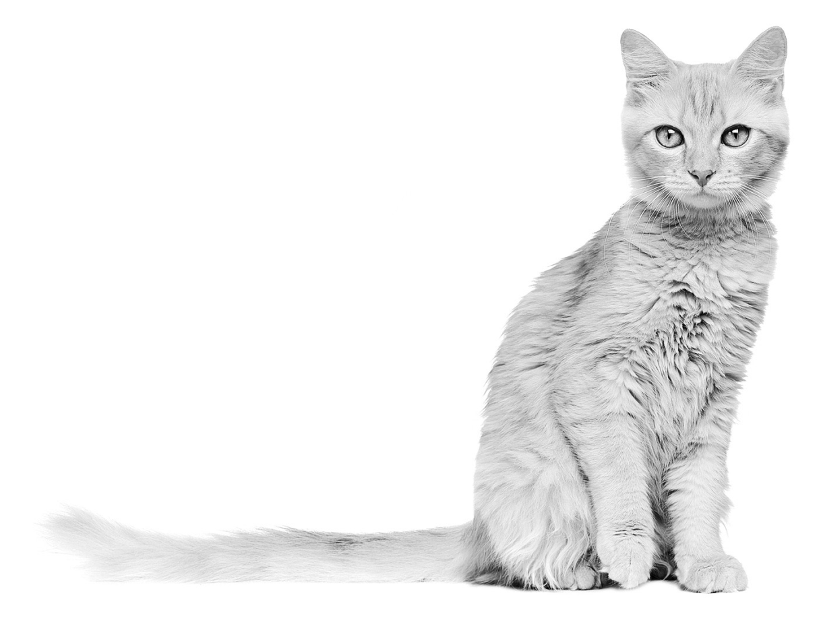
2. The cat has got / have got a long tail.
3. Her parents has got / have got brown eyes.
4. I have got / has got freckles.
5. We has got / have got lots of friends.

Complete the sentences. Use the negative form of the verb to have got.
B
1. I __________________________ a moustache.
2. My friends __________________________ red hair.
3. My mother __________________________ long hair.
4. She __________________________ a big mouth.
5. He __________________________ green eyes.

Look at the table. Follow the example.
C

 | blue eyes | a moustache | grey hair
Susan | ✓ | ✗ | ✗
Bryan | ✗ | ✓ | ✗
Mr and Mrs Smith | ✗ | ✗ | ✓

1. (Susan / blue eyes) .Has Susan got blue eyes? Yes, she has.………………………………….…………….
2. (Susan / a moustache)
3. (Bryan / grey hair)
4. (Bryan / a moustache)
5. (Mr and Mrs Smith / blue eyes)
6. (Mr and Mrs Smith / grey hair)

Name |  | No. | Class
Date | Mark | Teacher

Circle the correct option of the verb to have got.
Rodeia a opção correta do verbo to have got.
A
1. Jane has got / have got a small family.
2. The cat has got / have got a long tail.
3. Her parents has got / have got brown eyes.
4. I have got / has got freckles.
5. We has got / have got lots of friends.

Complete the sentences with haven’t got or hasn’t got.
Completa as frases com haven’t got ou hasn’t got.
B
1. I __________________________ a moustache.
2. My friends __________________________ red hair.
3. My mother __________________________ long hair.
4. She __________________________ a big mouth.
5. He __________________________ green eyes.

Look at the table. Follow the example.
Observa a tabela. Segue o exemplo.
C

 | blue eyes | a moustache | grey hair
Susan | ✓ | ✗ | ✗
Bryan | ✗ | ✓ | ✗
Mr and Mrs Smith | ✗ | ✗ | ✓

1. (Susan / blue eyes) .Has Susan got blue eyes? Yes, she has.…………..…………………………………..
2. (Susan / a moustache) .Has……………………………………………..? .No,…………………….………………
3. (Bryan / grey hair) .Has……………………….…………………..……..? .No,…………………………..…………
4. (Bryan / a moustache) .Has…………………………………….….…..? .Yes,………………………... …………
5. (Mr and Mrs Smith / blue eyes) .Have……………………..……..? .No,………………….……….…………
6. (Mr and Mrs Smith / grey hair) .Have……………………...……..? .Yes,…………………………….………

Name |  | No. | Class
Date | Mark | Teacher

Complete with the correct possessive pronoun.
A
1. It’s Kelly’s doll. It’s __________.
2. It’s Paul’s bike. It’s __________.
3. It’s my brother’s cap. It’s __________.
4. They’re my books. They’re __________.
5. It’s my parents’ car. It’s __________.
6. They’re our crayons. They’re __________.

Look at the table and follow the example.
B

1. Thomas | 2. Lucas | 3. My parents | 4. Helen
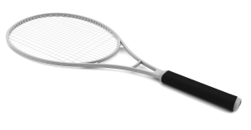 | 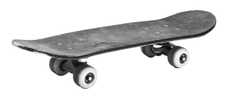 | 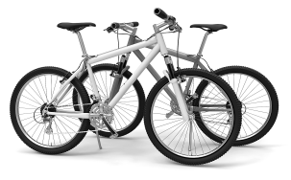 | 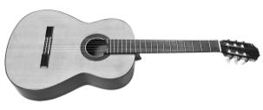

1. .Whose tennis racket is it?……………………… 3.
.It’s Thomas’s racket.………………………………
2. 4.

Write sentences. Follow the example.
C
1. (David / surf board) .Whose surfboard is it? It’s David’s surfboard. It’s his. ……….….……….….
2. (Miss Sullivan / ice skates)
3. (My cousins / boat)
4. (the little girl / puzzles)

Name |  | No. | Class
Date | Mark | Teacher

Complete the sentences. Use the possessive pronouns in the box.
Completa as frases. Usa os pronomes possessivos na caixa.
A
1. It’s Kelly’s doll. It’s __________.
mine
hers
his (2×)
ours
theirs
2. It’s Paul’s bike. It’s __________.
3. It’s my brother’s cap. It’s __________.
4. They’re my books. They’re __________.
5. It’s my parents’ car. It’s __________.
6. They’re our crayons. They’re __________.

Look at the table and complete the questions and the answers. Follow the example.
Observa a tabela e completa as perguntas e as respostas. Segue o exemplo.
B

1. Thomas | 2. Lucas | 3. My parents | 4. Helen
tennis racket | skateboard | bicycles | guitar

1. .Whose tennis racket is it?……………………… 3. .Whose………………………………………….………?
.It’s Thomas’s racket.……………………………… .They’re…………………………..………………………
2. .Whose skateboard ………..…………….………? 4. .Whose………………………………………….………?
.It’s………………………….……………………………… .It’s………………………….…………………………..…

Complete the sentences. Follow the example.
Completa as frases. Segue o exemplo.
C
1. .Whose surf board is it? It’s David’s surfboard. It’s his. ………..………………………….…….……….….
2. ……….………. ice skates are they? They’re Miss Sullivan’s ice skates. They’re ………...…….….….
3. …………….…. boat is it? It’s my cousins’ boat. It’s ………..……………_________.._____…...….…..
4. ……….………. puzzles are they? They’re the little girl’s puzzles. They’re ………..……….……..

Name |  | No. | Class
Date | Mark | Teacher

Use a, an or Ø (no article).
A

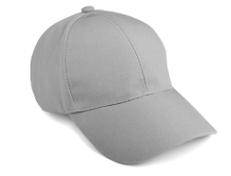 | 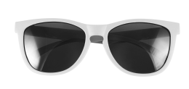 | 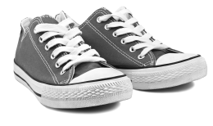 | 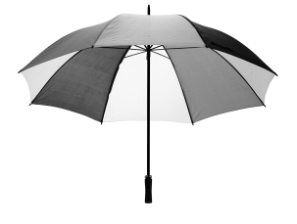
1. ______ cap | 2. ______ sunglasses | 3. ______ trainers | 4. ______ umbrella
5. ______ nurse | 6. ______ musicians | 7. ______ actress | 8. ______ ice skater
9. ______ babies | 10. ______ boy | 11. ______ girl | 12. ______ children

Fill in the blanks. Use a, Ø or the.
B
Sally is 1.______ little Irish girl.
She has got long wavy red hair, 2.______ big blue eyes, 3.______ small nose and 4.______ big mouth.
She has got 5.______ freckles around her nose and on her cheeks.
She is 6.______ very pretty girl.
She loves animals and she has got three pets: 7.______ dog, 8.______ hamster and 9.______ parrot.
10.______ dog is 11.______ Dalmatian.
Draw Sally’s portrait.
C

Name |  | No. | Class
Date | Mark | Teacher
Remember this!
a + consonant an + vowel Ø + plural nouns
Use a, an or Ø (no article).
Usa a, an ou Ø.
A
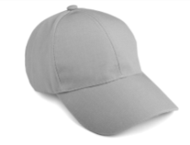 |  |  | 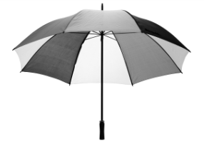
1. ______ cap | 2. ______ sunglasses | 3. ______ trainers | 4. ______ umbrella
5. ______ nurse | 6. ______ musicians | 7. ______ actress | 8. ______ ice skater
9. ______ babies | 10. ______ boy | 11. ______ girl | 12. ______ children

Circle the correct article.
Rodeia o artigo correto.
B
Sally is 1. a / an little Irish girl.
She has got long wavy red hair, 2. Ø / the big blue eyes, 3. a / an small nose and
4. a / the big mouth.
She has got 5. a / Ø freckles around her nose and on her cheeks.
She is 6. a / an very pretty girl.
She loves animals and she has got three pets: 7. an / a dog, 8. a / an hamster and 9. a / the parrot.
10. The / A dog is 11. a / an Dalmatian.
Draw Sally’s portrait.
Desenha o retrato da Sally.
C

