Name |  | No. | Class
Date | Mark | Teacher

Look at the city map and complete the sentences. Use prepositions of place.
A
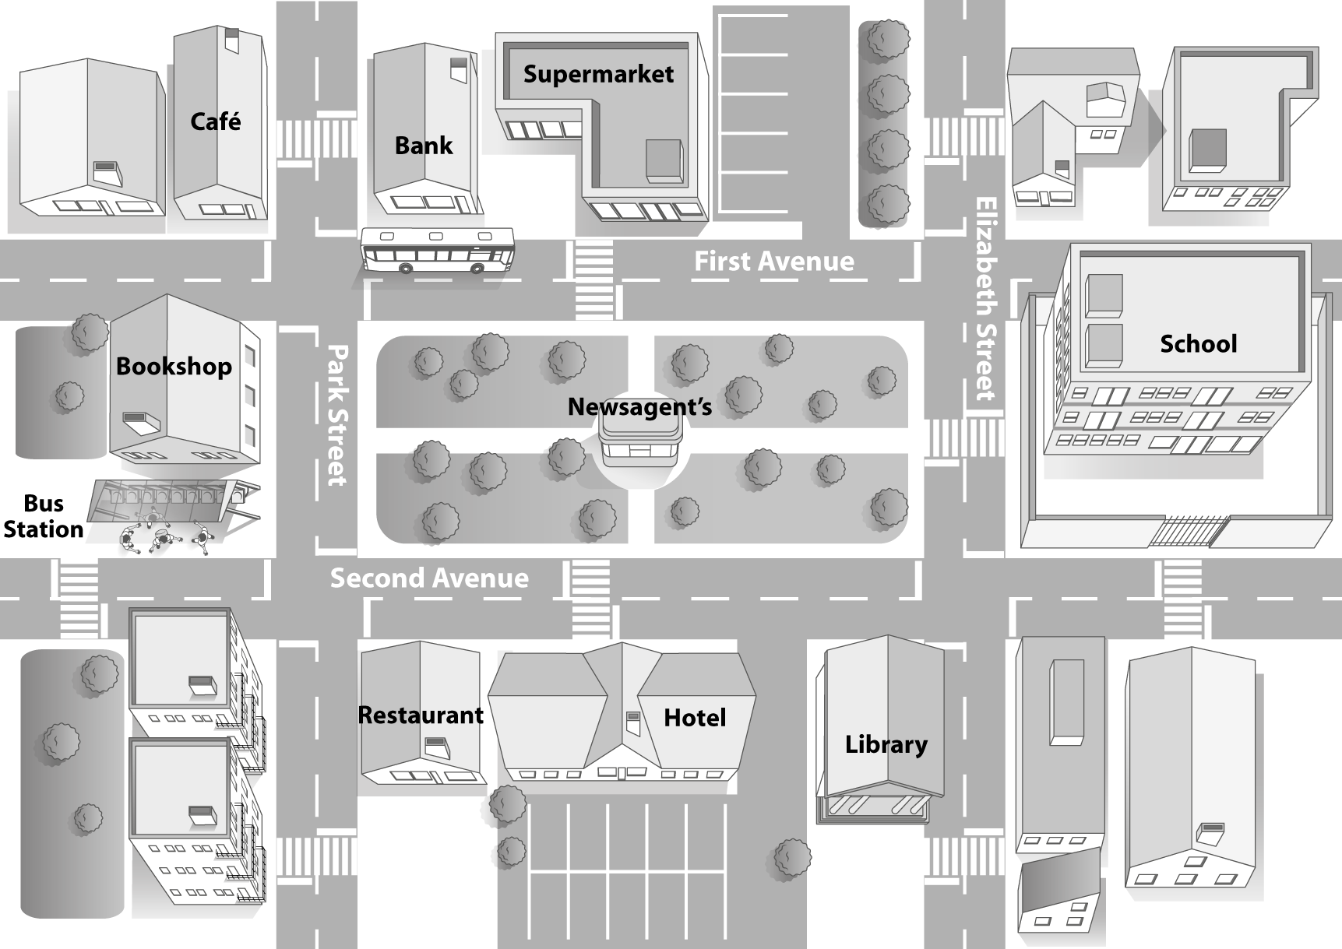

1. There’s a hotel ____________________ the restaurant and the library.
2. There’s a supermarket ____________________ the bank.
3. The bank is ____________________ the café.
4. There’s a newsagent’s ____________________ the park.
5. There’s a bus ____________________ the bank.

Complete the sentences with the prepositions of movement along, across, through or towards.
B
1. The train goes ____________________ the bridge to go to the city centre.
2. Go ____________________ this street to go to the hospital.
3. The girl is running ____________________ her dad in the park.
4. I’m going to school ____________________ the park because it’s the shortest way.

Name |  | No. | Class
Date | Mark | Teacher

Look at the city map and complete the sentences. Use prepositions of place in the box.
Observa o mapa da cidade e completa as frases. Usa as preposições de lugar na caixa.
A
between opposite next to in in front of

1. There’s a hotel ____________________ the restaurant and the library.
2. There’s a supermarket ____________________ the bank.
3. The bank is ____________________ the café.
4. There’s a newsagent’s ____________________ the park.
5. There’s a bus ____________________ the bank.

Circle the correct prepositions of movement.
Rodeia as preposições de movimento corretas.
B
1. The train goes across / through the bridge to go to the city centre.
2. Go along / across this street to go to the hospital.
3. The girl is running towards / along her dad in the park.
4. I’m going to school through / towards the park because it’s the shortest way.

