Name |  | No. | Class
Date | Mark | Teacher

 Listen to dialogues 1 and 2 to complete the city plan. Use the words in the box.
CD 3 Tracks 55 ● 56 / 57 ● 58
A
A
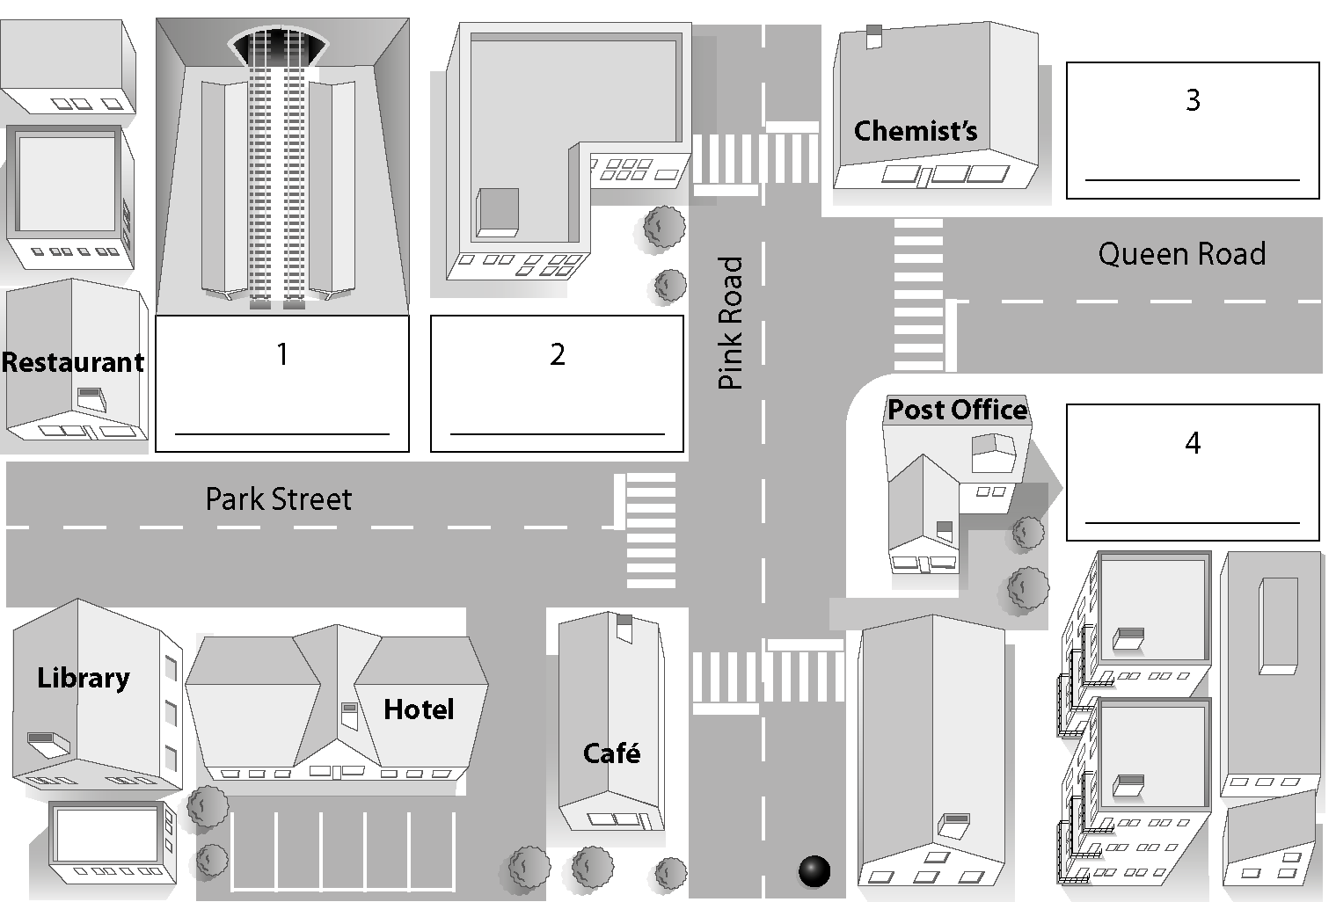
train station
shopping centre
cinema
fire station

Listen to Laura and Sophie. Tick (✓) the things Laura is showing her sister.
CD 3 Tracks 59 ● 60
B
1. |  | 2. |  | 3. |  | 4.
5. |  | 6. |  | 7.

Listen again and tick (✓) True (T) or False (F). CD 3 Tracks 59 ● 60
C
 | T | F
1. Laura has got a T-shirt for her brother.
2. There are some lovely clothes in the clothes shop.
3. The box of chocolates is from the supermarket.
4. There’s a new bookshop next to the restaurant.
5. There are some cute animals in the pet shop.

Name |  | No. | Class
Date | Mark | Teacher


I – Reading
Read the text.
A
 | My city
5  10 | My name is Charlotte and I’m from Brighton. It’s a beautiful city in the south of England. It’s great to live here! I’ve got lots of friends and I love my school. We always do really interesting stuff. I am in the Eating for Life school club and there was a fantastic school picnic on the beach last Friday. There was a fire and lots of delicious grilled fish. There were vegetarian sandwiches and fruit juices. There wasn’t any fast food but there was fruit salad and yoghurt for dessert.  There was a student, Josh, playing the guitar brilliantly. There were students and teachers dancing and singing.  We were all very happy because the picnic was awesome.

Complete the table.
B
1. Name
2. Country
3. Nationality
4. City
5. School club

Complete the sentences.
C
1. Charlotte lives in the south of England in a ____________ ____________.
2. There was a fantastic ____________ ____________ on the beach.
3. There wasn’t any ____________ ____________.
4. There was ____________ ____________ playing the guitar brilliantly.
5. The picnic was awesome, so they were all ____________ ____________.

Answer the questions.
D
1. Were there any teachers singing and dancing?
2. What was there for dessert?
3. Why were they very happy?

II – Vocabulary
Where were they yesterday? Write the places in the city.
A
1 | 2 | 3 | 4 |  | 5
1. My father was at the
2. Mum’s car was in the
3. They were at the
4. We were at the
5. I was at the

Where can you buy these things?
B
B
1. You can buy meat at the
2. You can buy bread at the
3. You can buy medicine at the
4. You can buy boots at the
5. You can buy magazines at the
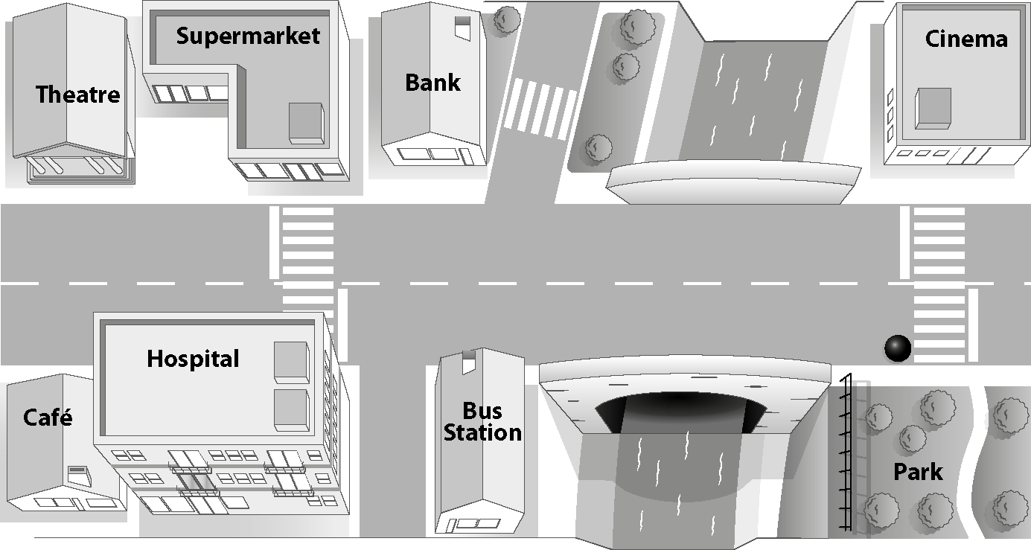
III – Grammar
Complete with the correct preposition of place or movement.
A
A
1. To get to the bus station
go _______________ the bridge.
2. The supermarket is ____________ the theatre and the bank.
3. To get to the café go _______________ this street. The café is _______________ the hospital.
4. The cinema is _______________ the park.

Complete with the correct adverb of manner.
B
B
1. Ann sings _______________ (beautiful).
2. He plays the guitar _______________ (horrible).
3. I play this game _______________ (easy).
4. The tourists listen to the guide _______________ (attentive).

Complete the dialogue with was, were, wasn’t or weren’t.
C
Lillian: Where 1. ________________ you last weekend?
Stuart: I 2. ________________ at the beach with my friends.
Lillian: 3. ________________ your brother there too?
Stuart: No, he 4. ________________ . He 5. ________________ at home.
What about you? Where 6. ________________ you?
Lillian: I 7. ________________ at my grandparents’ house with my cousins from France.
They 8. ________________ here last weekend.
Stuart: 9. ________________ your parents there too?
Lillian: No, they 10. ________________ .

Complete the sentences with there to be in the Past Simple.
D
1. Yesterday ________________ a school visit to the museum.
2. ________________ lots of people at the Zoo.
3. ________________ any kids singing? Yes, ________________.
4. ________________ (not) any balloons at the restaurant but ________________ music.
5. ________________ a rock concert last Saturday? No, ________________.
6. Last Saturday ________________ (not) a birthday party but ________________ a pyjama party.

IV – Writing
There was a special school lunch yesterday. Use the words in the box to write a text describing the school lunch.
• Yesterday / there to be / a cool activity at school
• There to be / a group of students / in the school kitchen / cooking a healthy lunch
• There to be (not) / any teachers in the kitchen
• There to be / lots of vegetables and fish
• There to be (not) / any wine / there to be only water
• The food / be fantastic
A special school lunch
Yesterday there was ................................................................
.......................................................................................................
.......................................................................................................
.......................................................................................................
.......................................................................................................
.......................................................................................................
.......................................................................................................
.......................................................................................................
.......................................................................................................
.......................................................................................................
.......................................................................................................
.......................................................................................................
.......................................................................................................

Name |  | No. | Class
Date | Mark | Teacher

I – Reading
Read the text.
A
 |  |  | My city
5  10 |  | My name is Charlotte and I’m from Brighton. It’s a beautiful city in the south of England. It’s great to live here! I’ve got lots of friends and I love my school. We always do really interesting stuff. I am in the Eating for Life school club and there was a fantastic school picnic on the beach last Friday. There was a fire and lots of delicious grilled fish. There were vegetarian sandwiches and fruit juices. There wasn’t any fast food but there was fruit salad and yoghurt for dessert.  There was a student, Josh, playing the guitar brilliantly. There were students and teachers dancing and singing.  We were all very happy because the picnic was awesome.

Complete the table.
B
1. Name
2. Country
3. Nationality
4. City
5. School club

Complete the sentences with the words in the box.
C
fast food a student beautiful city very happy school picnic
1. Charlotte lives in the south of England in a ____________________________ .
2. There was a fantastic ____________________________ on the beach.
3. There wasn’t any ____________________________.
4. There was ____________________________ playing the guitar brilliantly.
5. The picnic was awesome, so they were all ____________________________.

Answer the questions.
D
1. Were there any teachers singing and dancing?
2. What was there for dessert?
3. Why were they very happy?
II – Vocabulary
Where were they yesterday? Write the places in the city. Use the words / expressions in the box.
A
1 | 2 | 3 | train station  airport  theatre  car park  fire station  4 |  | 5
1. My father was at the
2. Mum’s car was in the
3. They were at the
4. We were at the
5. I was at the

Where can you buy these things? Use the words in the box.
chemist’s
butcher’s
shoe shop
newsagent’s
baker’s
B
1. You can buy meat at the
2. You can buy bread at the
3. You can buy medicine at the
4. You can buy boots at the
5. You can buy magazines at the

III – Grammar
Choose the correct preposition of place or movement.
A
A
1. To get to the bus stop, go along / across the bridge.
2. The supermarket is between / opposite the theatre and the bank.
3. To get to the café, go through / along this street. The café is next to / towards the hospital.
4. The cinema is opposite / behind the park.

Choose the correct adverb of manner.
B
1. Ann sings beautiful / beautifully.
2. He plays the guitar horribly / horrible.
3. I play this game easy / easily.
4. The tourists listen to the guide attentively / attentive.

Choose the correct form of the verb to be in the Past Simple.
C
Lillian: Where 1. was / were you last weekend?
Stuart: I 2. was / were at the beach with my friends.
Lillian: 3. Was / Were your brother there too?
Stuart: No, he 4. wasn’t / weren’t. He 5. was / were at home.
What about you? Where 6. was / were you?
Lillian: I 7. was / were at my grandparents’ house with my cousins from France.
They 8. was / were here last weekend.
Stuart: 9. Was / Were your parents there too?
Lillian: No, they 10. wasn’t / weren’t.

Complete the sentences with there was, there were, there wasn’t, there weren’t, was there or were there.
D
1. Yesterday ________________ a school visit to the museum.
2. ________________ lots of people at the Zoo.
3. ________________ any kids singing? Yes, ________________.
4. ________________ (not) any balloons at the restaurant but ________________ music.
5. ________________ a rock concert last Saturday? No, ________________.
6. Last Saturday ________________ (not) a birthday party but ________________ a pyjama party.

IV – Writing
There was a special school lunch yesterday. Use the words in the box to write a text describing the school lunch.
A special school lunch
• Yesterday / there to be / a cool activity at school
• There to be / a group of students / in the school kitchen / cooking a healthy lunch
• There to be (not) / any teachers in the kitchen
• There to be / lots of vegetables and fish
• There to be (not) / any wine / there to be only water
• The food / be fantastic
Yesterday there was at ...........
......................................................................................................
There......................................................................................
in the cooking .......................
lunch.............................................................................................
any .........................................
kitchen..........................................................................................
There lots of..............................................
wine. There .............
only ..............................................................................................
The food ...............................................................................
.....................................................................................................

Name |  | No. | Class
Date | Mark | Teacher

There was a birthday party last Saturday. Look at the picture and describe it to your friends.
Use the grammar and vocabulary help.

Grammar and Vocabulary help:
clowns cake
hats juice
presents fruit
kids kids very happy
balloons
There were some balloons on the wall.
There was a birthday cake.
Unit 3 – Listening Test
Instrumento de Avaliação – Compreensão Oral
Objetivos | Domínio Intercultural | Estrutura | Cotações | Critérios  de Correção
- Compreender discursos articulados de forma clara e pausada | - Conhecer o seu meio e o dos outros para comparar universos diferenciados: identificar edifícios públicos e lojas e seguir indicações | A. Preenchimento de espaços  B. Seleção de informação  C. Identificação de frases verdadeiras e falsas | 4 × 10 = 40  5 × 6 = 30  5 × 6 = 30 | Certo / Errado  Certo / Errado  Certo / Errado
- Compreender discursos articulados de forma clara e pausada |  |  | Total: 100 | Certo / Errado  Certo / Errado  Certo / Errado

Unit 3 – Progress Test A
Instrumento de Avaliação – Leitura e Produção Escrita
Objetivos | Domínio Intercultural | Estrutura | Cotações | Critérios  de Correção
- Ler textos breves sobre assuntos do seu interesse: identificar a ideia principal e a informação essencial em textos diversificados | - Conhecer o seu meio e o dos outros para comparar universos diferenciados: identificar edifícios públicos e lojas | I  B. Preenchimento de tabela  C. Preenchimento de espaços  D. Respostas a perguntas sobre o texto | 5 × 1 = 5  5 × 2 = 10  3 × 4 = 12 | Certo / Errado  Certo / Errado  Certo / Parcialmente certo / Errado  (Conteúdo certo: 3 pontos  Conteúdo parcialmente certo: 1 ou 2 pontos  Conteúdo errado: 0 pontos
- Aplicar itens lexicais relacionados com as áreas temáticas (public places and shops) |  | II  A. Preenchimento de espaços  B. Preenchimento de espaços | 5 × 2 = 10  5 × 2 = 10 | Certo / Errado  Certo / Errado
- Aplicar estruturas frequentes do funcionamento da língua (prepositions of place and movement; adverbs of manner Past Simple of the verbs to be and there to be) |  | III  A. Preenchimento  de espaços  B. Preenchimento  de espaços  C. Preenchimento  de espaços  D. Preenchimento  de espaços | 5 × 1 = 5  4 × 2 = 8  10 × 1 = 10  10 × 1 = 10 | Certo / Errado  Certo / Errado  Certo / Errado  Certo / Errado
- Produzir um texto simples (descrever um acontecimento com a ajuda de tópicos) |  | IV  Produção de texto | 20 | Competência pragmática: 12 Competência linguística: 8  (ver níveis de desempenho na  página 328)
 |  | IV  Produção de texto | Total: 100

Unit 3 – Progress Test B
Instrumento de Avaliação – Leitura e Produção Escrita
Objetivos | Domínio Intercultural | Estrutura | Cotações | Critérios  de Correção
- Ler textos breves sobre assuntos do seu interesse: identificar a ideia principal e a informação essencial em textos diversificados | - Conhecer o seu meio e o dos outros para comparar universos diferenciados: identificar edifícios públicos e lojas | I  B. Preenchimento de tabela  C. Preenchimento de espaços  D. Respostas a perguntas sobre o texto | 5 × 1 = 5  5 × 2 = 10  3 × 4 = 12 | Certo/ Errado  Certo/ Errado  Certo/Parcialmente certo /Errado  (Conteúdo certo: 3 pontos  Conteúdo parcialmente certo: 1 ou 2  Conteúdo errado: 0)
- Aplicar itens lexicais relacionados com as áreas temáticas (public places and shops) |  | II  A. Preenchimento de espaços  B. Preenchimento de espaços | 5 × 2 = 10  5 × 2 = 10 | Certo / Errado  Certo / Errado
- Aplicar estruturas frequentes do funcionamento da língua (prepositions of place and movement; adverbs of manner Past Simple of the verbs to be and there to be) |  | III  A. Seleção de informação  B. Seleção de informação  C. Seleção de informação  D. Preenchimento de espaços | 5 × 1 = 5  4 × 2 = 8  10 × 1 = 10  10 × 1 = 10 | Certo / Errado  Certo / Errado  Certo / Errado  Certo / Errado
- Produzir um texto simples (descrever um acontecimento com a ajuda de tópicos) |  | IV  Produção de texto | 20 | Competência pragmática: 12 Competência linguística: 8  (ver níveis de desempenho na  página 328)
 |  | IV  Produção de texto | Total: 100

