Name |  | No. | Class
Date | Mark | Teacher

Read Robert’s email about his new school.
A

________________ @ myemail.com
My new school

Greeting |  | Hello,
Name of school,  size and location |  | I hope you’re OK. I want to tell you all about my new school! I’m a student at King James’s School. It’s a big school in England.
Rooms and places |  | There are two floors. The computer rooms and the labs are downstairs. There is a comfortable library next to the canteen. Our classroom is upstairs. There is and an interactive board. There are three large windows and there are lots of posters and maps on the walls. My school is great for sports. There are nine tennis courts, two gyms and a football field outside.
What he likes about his school |  | I really like my school because I’ve got lots of new friends and we usually meet after classes.  What about your school? Do you like it?
Closing  (name) |  | Bye,  Robert

Imagine you are Robert’s friend. Use the information in the table to write an email describing your school.
B

Name of school | Dorchester Middle School
Size and location | small / Dorset (England)
Rooms and places | downstairs: canteen, music rooms, computer rooms, library
Rooms and places | upstairs: classrooms
Rooms and places | outside: 3 football fields, 2 rugby fields
What I like about school | very friendly and helpful teachers

robert@myemail.com
My new school

Greeting |  | …..Hello, Robert
Name of school,  size and location |  | …..Thank you for your email. Your school is great! I want to tell you....................  …………………………………..! I’m a student at...............................................................  ………………………………………………….…………………………………………………..…………………...
Rooms and places |  | …..There are...........................................................................................................  ................................................downstairs..............................................................  .upstairs.…………………………………………………………..…..……………...……………………………….………..……..  ……………………………………………………………………………………………………...……….outside.
What he/she likes about  his/her school |  | …..I really like my school because……………………………………………………………………………………  ……………………………………………………………………………………………………………………….………………………..
Closing  (name) |  | …..See you soon,  …………………………………………

Name |  | No. | Class
Date | Mark | Teacher

Read Robert’s email about his new school.
Lê o email do Robert sobre a sua escola nova.
A

________________ @ myemail.com
My new school

Greeting |  | Hello,
Name of school,  size and location |  | I hope you’re OK. I want to tell you all about my new school! I’m a student at King James’s School. It’s a big school in England.
Rooms and places |  | There are two floors. The computer rooms and the labs are downstairs. There is a comfortable library next to the canteen. Our classroom is upstairs. There is an interactive board. There are three large windows and there are lots of posters and maps on the walls. My school is great for sports. There are nine tennis courts, two gyms and a football field outside.
What he likes about his school |  | I really like my school because I’ve got lots of new friends and we usually meet after classes.  What about your school? Do you like it?
Closing  (name) |  | Bye,  Robert

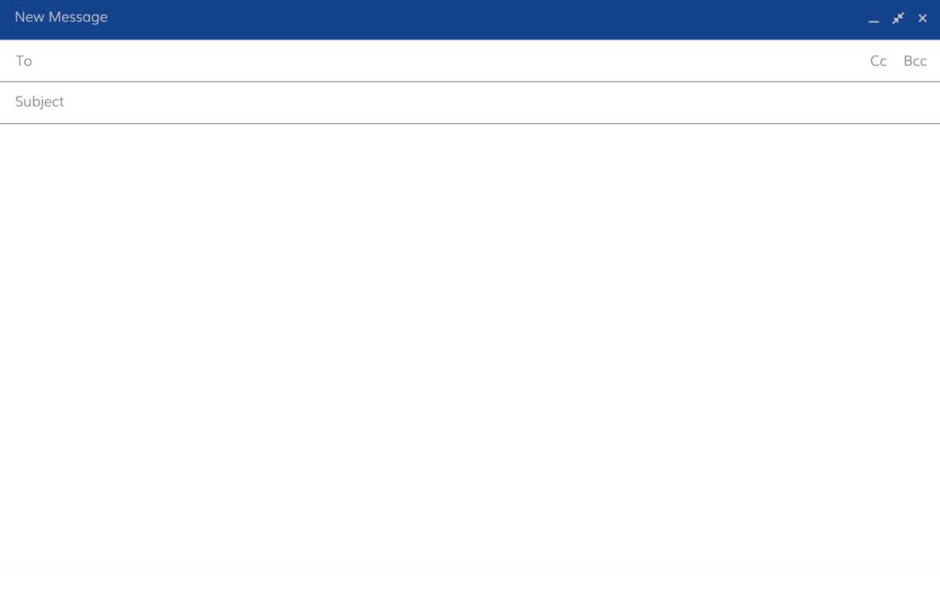

Imagine you are Robert’s friend. Use the information in the table to complete an email describing your school.
Imagina que és amigo/a do Robert. Usa a informação da tabela para completares um email a descrever a tua escola.
B

Name of school | Dorchester Middle School
Size and location | small / Dorset (England)
Rooms and places | downstairs: canteen, music rooms, computer rooms, library
Rooms and places | upstairs: classrooms
Rooms and places | outside: 3 football fields, 2 rugby fields
What I like about school | very friendly and helpful teachers

__________________@ myemail.com
My new school

Greeting |  | …..Hello, Robert.
Name of school,  size and location |  | …..Thank you for your email. Your school is great! I want to tell you…………………………  ……………………………………….……..! I’m a student at..........................................................  ……………………………………………………………………………………………………………………………………………………....
Rooms and places |  | …..There are……………………………floors. The…………………………………, the…………………………………...,  .the……………………………………………………and the……………………………..…….…………..are downstairs.  .The……………………………………………………are upstairs. There are…………………………………………………  ……………………………………………………and………………………………………….…………….…………………..outside.
What he/she likes about  his/her school |  | …..I really like my school because the teachers are……………………………………….…………….and  ……………………………………………………………………………………………………………………………………………………....
Closing  (name) |  | .See you soon, …..…..….. .  ………………………………………………

