Name |  | No. | Class
Date | Mark | Teacher

Look at the poster and read Leonard and Stuart’s WhatsApp conversation. Then complete the sentence below.
A
AFTER-SCHOOL CLUBS
Tuesdays and Wednesdays after school
Sports club  3 p.m.  (gym) | Lego club  4 p.m. (room 108) | Chess club  3 p.m.  (cafeteria) | Maths club  4 p.m.  (maths room) | Music club  3 p.m.  (music room) | Cookery club  3 p.m. (canteen) | Dance club  4 p.m.  (dance room)
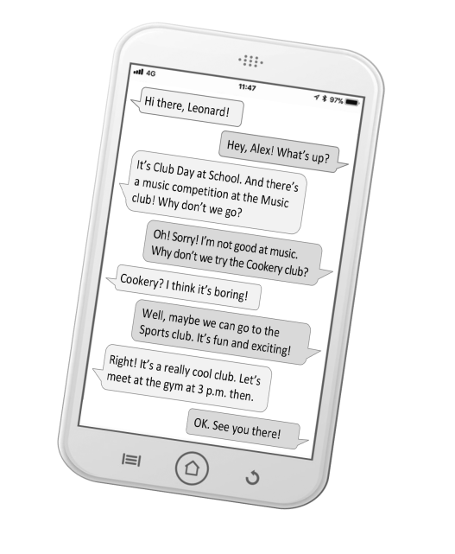
Hi there, Leonard!
Hey, Alex! What’s up?
It’s club day at school. And there’s a music competition at the music club! Why don’t we go?
Oh! Sorry! I’m not good at music. Why don’t we try the cookery club?
Cookery? I think it’s boring!
Well, maybe we can go to the sports club. It’s fun and exciting!
Right! It’s a really cool club. Let’s meet at the gym at 3 p.m. then.
OK. See you there!
● They choose to go to the __________________ club.

Work in pairs. Look at the poster again and complete the WhatsApp conversation with your ideas.
B
Here is some help:
Different club activities: football match, lego workshop, chess competition, problem solving competition, concert, biscuit baking workshop, hip hop workshop
Adjectives: exciting, boring, fun, cool, great, awesome, amazing, tiring, difficult
Hi there, __________________!
Hey, .
?
It’s .
And
.
Why don’t we go?
Oh! Sorry!
.
Why don’t we try
?
? I think
!
Well, maybe me can
.
It’s !
Right! It’s
. Let’s meet

.
OK. !

Name |  | No. | Class
Date | Mark | Teacher

Look at the poster and read Leonard and Stuart’s WhatsApp conversation. Then complete the sentence below.
Observa o poster e lê a conversa no WhatsApp entre o Leonard e o Stuart. De seguida completa a frase abaixo.
A
AFTER-SCHOOL CLUBS
Tuesdays and Wednesdays after school
Sports club  3 p.m.  (gym) | Lego club  4 p.m. (room 108) | Chess club  3 p.m.  (cafeteria) | Maths club  4 p.m.  (maths room) | Music club  3 p.m.  (music room) | Cookery club  3 p.m. (canteen) | Dance club  4 p.m.  (dance room)
Hi there, Leonard!
Hey, Alex! What’s up?
It’s club day at school. And there’s a music competition at the music club! Why don’t we go?
Oh! Sorry! I’m not good at music. Why don’t we try the cookery club?
Cookery? I think it’s boring!
Well, maybe we can go to the sports club. It’s fun and exciting!
Right! It’s a really cool club. Let’s meet at the gym at 3 p.m. then.
OK. See you there!
● They choose to go to the __________________ club.
Work in pairs. Complete the WhatsApp conversation with the expressions from the box.
Trabalha em pares. Completa a conversa no WhatsApp com as expressões na caixa.
B

dancing club day awesome lego club maths club hip hop workshop

Hi there, ! (name)
Hey, (name).
What’s up?
It’s at School.
And there’s a
at the Dance club. Why don’t we go?
Oh! No way! I’m not good at
.
Why don't we try the
?
Maths? I think it's difficult.
Well, maybe we can go to the
.
It's fun and exciting!
Right! It's an club.
Let's meet at room 108 at 4 p.m.
OK. See you there!

