Name |  | No. | Class
Date | Mark | Teacher

Look at the city plan and read Jane and Liam’s text messages.
A
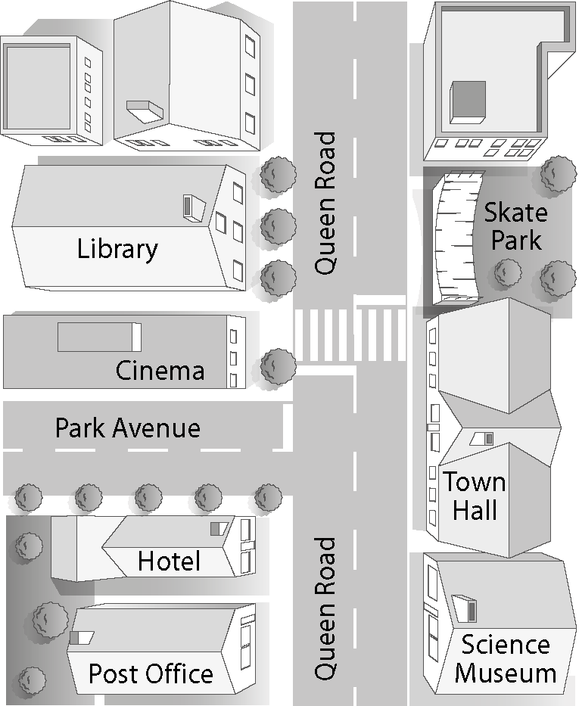
Hello, Jane! Where are you?
Hey, Liam! I’m at home. What’s up?
I’ve got a new skateboard and I want to try it out. Why don’t you come with me?
I love skateboarding! I’d love to!
Cool! Why don’t we meet at the skate park?
Well, I don’t know where it is. How do I get there?
Go along Park Avenue and turn left into Queen Road. The skate park is opposite the library.
OK. See you there! Bye!

Work in pairs. You want to go to the shopping centre. Look at the city plan and write text messages in your notebook according to the instructions.
B
Greet and ask where he/she is |  | Greet back and say you're at home  Ask “what’s up”
Tell your friend the new shopping centre is open and invite him/her to go there with you |  | Agree
Suggest meeting at the post office |  | Say you don’t know where it is and  ask for directions
Give directions |  | Say goodbye

Name |  | No. | Class
Date | Mark | Teacher

Look at the city plan and read Jane and Liam’s text messages.
Observa o mapa da cidade e lê as mensagens da Jane e do Liam.
A
Hello, Jane! Where are you?
Hey, Liam! I’m at home. What’s up?
I’ve got a new skateboard and I want to try it out. Why don’t you come with me?
I love skateboarding! I’d love to!
Cool! Why don’t we meet at the skate park?
Well, I don’t know where it is. How do I get there?
Go along Park Avenue and turn left into Queen Road. The skate park is opposite the library.
OK. See you there! Bye!

Work in pairs. You want to go to the shopping centre. Look at the city plan and complete the text messages.
Trabalha a pares. Queres ir ao centro comercial. Observa o mapa da cidade e completa as mensagens escritas.
B
Hi, _____________! Where are ________________?
Hey, _______________. I’m at ___________ . ___________?
The new shopping centre is open. Do you want to _________________________________ there with me?
I ____________ shopping. ____________________ !
_________________________________________

Cool! Why don’t we _______________________
at the post office?
I don’t know where it is. How __________________?
Go along Park Avenue and __________________
____________________________________. The post office is _______________ the Science Museum.
OK. See you there! Bye!

