Name |  | No. | Class
Date | Mark | Teacher

Read the dialogue and fill in the box.
A
Jane: Good afternoon!  Shop assistant: Good afternoon! Can I help you?  Jane: Yes, please. I’d like to buy a dress.  Shop assistant: Well, we've got some very nice dresses.  What’s your size?  Jane: Medium, please.  Shop assistant: Do you like this blue one?  Jane: Well, blue is not my favourite colour. Do you have it in green?  Shop assistant: Yes, sure. Here you are!  Jane: Can I try it on, please?  Shop assistant: Of course. The changing rooms are over there.  Jane: It’s great! How much is it?  Shop assistant: It’s £45.  Jane: I’ll take it. Here you are.  Shop assistant: Here’s your change. Thank you.  Jane: Thanks. | 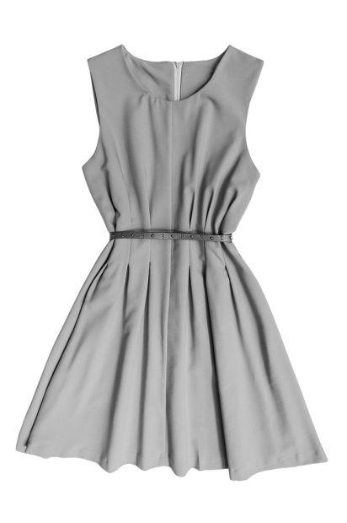  Item:  Size:  Colour:  Price:

Write a similar dialogue. Use the information in the box.
B
You: Good afternoon!
Item: jacket
Size: small
Colour: brown
Price: £53
Price: £53
Shop assistant: Good afternoon! ?
You: .
Shop assistant: ?
You: .
Shop assistant: ?
You: ?
Shop assistant: .
You: ?
Shop assistant: .
You: ?
Shop assistant: .
You: .
Shop assistant: Here’s your change. Thank you.
You: Thanks.

Name |  | No. | Class
Date | Mark | Teacher

Read the dialogue and circle the correct option.
Lê o diálogo e rodeia a opção correta.
A
Jane: Good afternoon!  Shop assistant: Good afternoon! Can I help you?  Jane: Yes, please. I’d like to buy a dress.  Shop assistant: Well, we've got some very nice dresses.  What’s your size?  Jane: Medium, please.  Shop assistant: Do you like this blue one?  Jane: Well, blue is not my favourite colour. Do you have it in green?  Shop assistant: Yes, sure. Here you are!  Jane: Can I try it on, please?  Shop assistant: Of course. The changing rooms are over there.  Jane: It’s great! How much is it?  Shop assistant: It’s £45.  Jane: I’ll take it. Here you are.  Shop assistant: Here’s your change. Thank you.  Jane: Thanks. | jeans / dress  small / medium  green / blue  £45 / £ 54

Complete the dialogue with the words in the box.
Completa o diálogo com as palavras na caixa.
B
jacket much small here try help size take black changing £53 favourite
You: Good afternoon!
Shop assistant: Good afternoon! Can I 1. ____________________ you?
You: Yes, please. I’d like to buy a 2. ________________________________________.
Shop assistant: Well' we've got some very nice jackets. What’s your 3.____________________?
You: 4. ____________________, please.
Shop assistant: Do you like this 5.____________________ one?
You: Well, black is not my 6.____________________ colour. Do you have it in brown?
Shop assistant: Yes, sure. 7. ____________________ you are.
You: Can I 8. ____________________ it on, please?
Shop assistant: Of course. The 9. ______________________________ rooms are over there.
You: It’s great! How 10. ____________________________ is it?
Shop assistant: It’s 11. ________________________________________.
You: I’ll 12. ____________________ it. Here you are.
Shop assistant: Here’s your change. Thank you.
Jane: Thanks.

