Name |  | No. | Class
Date | Mark | Teacher

Read the student's post about his/her holidays and fill in the table.
A
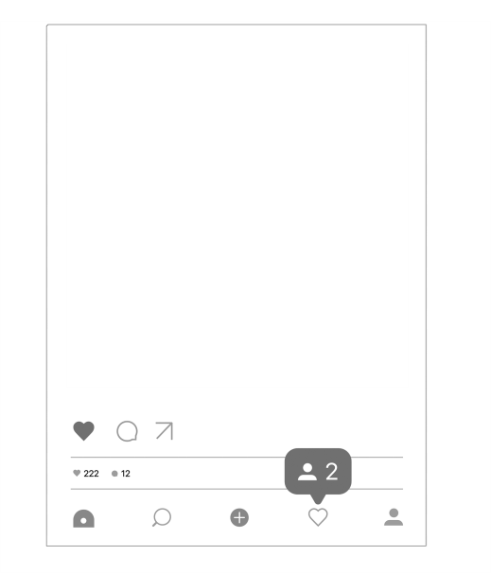 | Last winter I went to Switzerland by plane. The weather was cold and there was a lot of snow.  I went snowboarding with my parents. I had a great time! | Date
 |  | Place
 |  | Transport
 |  | Weather
 |  | Activities
 |  | Go with
Write a similar text with the information from the table.
B
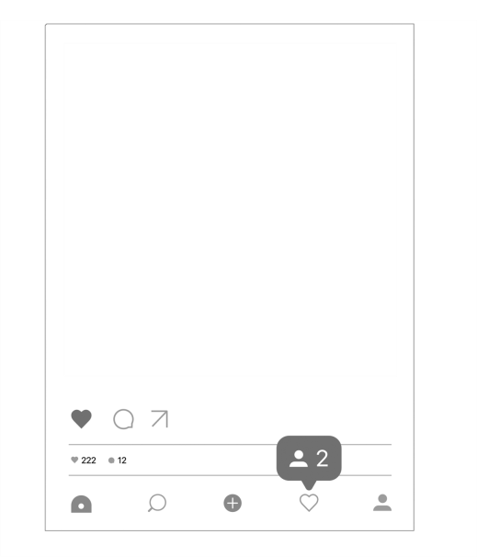 | _Last  _I enjoyed myself very much! | Date | last month
 | _Last  _I enjoyed myself very much! | Place | seaside
 | _Last  _I enjoyed myself very much! | Transport | car
 | _Last  _I enjoyed myself very much! | Weather | sunny and hot
 | _Last  _I enjoyed myself very much! | Activities | swimming and camping
 | _Last  _I enjoyed myself very much! | Go with | parents
Write about your last holidays.
C
Last  It was fantastic! | Date
Last  It was fantastic! | Place
Last  It was fantastic! | Transport
Last  It was fantastic! | Weather
Last  It was fantastic! | Activities
Last  It was fantastic! | Go with

Name |  | No. | Class
Date | Mark | Teacher

Read the student's post about his/her holidays and fill in the table.
Lê o post do/a aluno/a sobre as suas férias e preenche a tabela.
A
 | Last winter I went to Switzerland by plane. The weather was cold and there was a lot of snow.  I went snowboarding with my parents. I had a great time! | Date | Last
 |  | Place
 |  | Transport
 |  | Weather | and snowy
 |  | Activities
 |  | Go with
Complete a similar text with the information from the table.
Completa um texto semelhante com a informação da tabela.
B
 | ..Last.................... I went to the  ……………………………… by.................  ..The weather was.....................  and................. I went................  ……………………… and .....................  with...........................................  ..I enjoyed myself very much!.... | Date | last month
 |  | Place | seaside
 |  | Transport | car
 |  | Weather | sunny and hot
 |  | Activities | swimming and camping
 |  | Go with | parents
Write about your last holidays.
Escreve sobre as tuas últimas férias.
C
..Last....................................................................................  ………………………………………………………………………………………………………  ..The weather.......................................................................  ………………………………………………………………………………………………………  …………………………….…………………………………..I went..............  ………………………………………………………………………………………………………  ..It was fantastic!................................................................ | Date
 | Place
 | Transport
 | Weather
 | Activities
 | Go with

