“Apoio ao estudo”
Grammar
Present simple 78
Adverbs of frequency 80
Connectors 81
Present continuous 82
Adjectives + prepositions 84
Modal verb should 85
Comparative and superlative 86
Adverbs: adjectives + -ly 88
Past simple – verb to be 89
Past simple – verb there + to be 90
Past simple – regular verbs 91
Past simple – irregular verbs 92
Prepositions of movement 93
Be going to 94
Reflexive pronouns 96
Answer key 97
Answer key 97
Available in editable format at | 


1
2
3
4
5
6
7
8
9
10
11
12
13
14
15


STUDY TIPS
O present simple usa-se para exprimir hábitos ou rotinas (ex.: I drink milk for breakfast.), horários (ex.: The lesson starts at 8:30 a.m.) ou factos gerais (ex.: The Earth is round.)
Na forma afirmativa, todas as formas do verbo são iguais ao infinitivo (exs.: I like; you drink), exceto na 3.ª pessoa do singular, à qual, regra geral, se acrescenta um -s (exs.: She loves; He talks; It
rains). Se os verbos terminarem em -s, -x, -z, -sh, -ch e -o acrescenta-se -es (exs.: miss – misses; fix – fixes; buz – buzzes; finish – finishes; catch – catches; go – goes). Nos verbos terminados em consoante + -y, altera-se o -y para -i e acrescenta-se -es (exs.: study – studies; cry – cries.)
Nas formas negativa e interrogativa, usa-se o auxiliar do (exs.: She doesn’t speak Chinese; Do they play tennis?).
Nas respostas curtas, utiliza-se do/does ou don’t/doesn’t (ex.: Do you like football? Yes, I do. / No. I don’t.)

Bom estudo!

A. Tick (✔) the correct form of the verb to complete the sentences.
(Escolhe a forma correta do verbo para completares as frases.)
1. We sometimes ..___________________ books.
a) read  b) reads
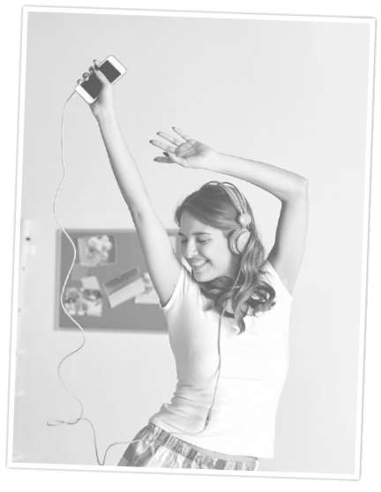
2. Emily ..___________________ dancing.
a) like b) likes
3. It often ..___________________ in April.
a) rain b) rains
4. My sister and I ..___________________ TV every day.
a) watch b) watches
5. I always ..___________________ to the bus stop.
a) run b) runs
6. He ..___________________ to school by bus.
a) go b) goes

B. Make negative sentences. (Faz frases negativas.)
1. They play football in the park. ..___________________
2. Dad makes breakfast. ..___________________
3. You write letters. ..___________________
4. He speaks German. ..___________________

C. Put the words in order. Use the correct form of the present simple to make sentences.
(Coloca as palavras por ordem. Usa a forma correta do present simple para escrever as frases.)
1. for breakfast / we / cereal / eat / .
..___________________
2. on foot / Laura / go / to school / .
..___________________
3. to the cinema / they / go / don’t / in the evening / .
..___________________
4. like / do / chocolate / you / ?
..___________________

D. Ask questions. Match them with answers.
(Faz perguntas. Associa-as às respostas.)
1. you / speak / English
..___________________ ?
a) By car.
b) In the park.
c) Yes, I do.
d) At the weekend.
2. how / she / go / home
..___________________ ?
3. when / they / tidy / their bedroom
..___________________ ?
4. where / he / ride / his bike
..___________________ ?

E. The words underlined are the answers. Write the questions.

(As palavras sublinhadas são as respostas. Escreve as perguntas.)
1. ..___________________ ?
Jane lives in Oxford.
2. ..___________________ ?
He gets up at seven o’clock.
3. ..___________________ ?
Yes, he does. Peter drinks orange juice for breakfast.
4. ..___________________ ?
Yes, I do. I listen to Mia Rose’s songs.

STUDY TIPS

Os adverbs of frequency usam-se para falar sobre rotinas e indicam a frequência de um acontecimento. Eles são geralmente colocados antes de um verbo conjugado no present simple
(ex.: She often plays tennis.). Mas, atenção: os adverbs of frequency colocam-se depois do verb to be (ex.: He is always tired).
Lembra-te de que never é sempre acompanhado de um verbo na forma afirmativa (ex.: We never go to bed late).
Observa atentamente esta tabela que te mostra os adverbs of frequency, organizados do mais frequente (always – sempre) para o menos frequente (never – nunca).
always | usually | often | sometimes | hardly ever | never
100% | 80% | 60% | 40% | 20% | 0%
Bom estudo!
1

A. Look at the table below and complete the sentences with the correct adverb.
(Observa a tabela abaixo e completa as frases com o advérbio correto.)


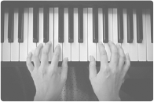


always |  |  | ✔
usually | ✔
sometimes |  | ✔
never |  |  |  | ✔

1. Paul ..___________________ wakes up with his alarm clock.
2. Mary is ..___________________ late for school.
3. The boys ..___________________ play football after school.
4. John ..___________________ plays the piano at the weekend.

B. Put the adverbs of frequency in the correct position. There is one example.
(Coloca os adverbs of frequency na posição correta. Segue o exemplo.)
• I get up at 7:30 a.m. (usually) …I usually get up at 7:30 a.m... .
1. Anne drinks milk in the morning. (never)
..___________________
2. You have lunch in the school canteen. (always)
..___________________
3. Paul and John are late. (sometimes)
..___________________


STUDY TIPS
Os connectors são usados para unir frases, ligando ideias. Ajudam por isso a clarificar
a sequência das ações e tornam um texto mais compreensível.
While (enquanto) usa-se para falar de duas coisas que acontecem ao mesmo tempo (ex.: The phone always rings while she's having a shower!) e when (quando) usa-se para indicar uma sequência de eventos (ex.: I do my English homework when I get home.).
Then (depois), later (mais tarde) e after that (depois disso) indicam uma sequência de diferentes ações.
Bom estudo!

A. Complete the sentences with when or while. (Completa as frases com when ou while.)
1. On Sundays my dad washes the car ..___________________ my mum prepares lunch.
2. Cathy watches TV ..___________________ she doesn’t have homework.
3. My father always sets the table ..___________________ he’s at home.
4. Do you listen to music ..___________________ you study?

B. Match the connectors on the left with the correct sentence on the right. Then write the sentences.

(Liga os conetores à esquerda com a frase correta à direita. Depois, escreve as frases.)
1. John arrives at school at 8:15.
Then • • he has lunch at the school canteen.
Later • • he goes to the drama club.
After that • • he has his morning lessons.
..___________________
..___________________

2. Paul is in front of the cinema and he is looking at the film posters.
Then • • he buys some popcorn.
Later • • he gets the tickets from the ticket office.
After that • • he goes to his seat and enjoys the film.
..___________________
..___________________

3. The school bell is ringing. All students go to the classroom.
Then • • they sit at their desks.
Later • • they answer.
After that • • the teacher asks them questions.
..___________________
..___________________

