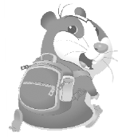
STUDY TIPS
Usa-se o comparativo para comparar duas (ou mais) coisas ou pessoas.
• No comparativo de superioridade, para adjetivos de uma sílaba, acrescenta-se -er ao adjetivo + than
(ex.: The cat is faster than the mouse). Nota que se o adjetivo terminar em -y, deve-se substituir por -i e só depois acrescentar -er (ex.: happy – happier).
Para adjetivos com duas ou mais sílabas, coloca-se more antes do adjetivo no comparativo (ex.: Paul is more intelligent than Gary.)
• Se quiseres dizer que duas coisas são (ou não) iguais ou semelhantes, usas as… as, sem alterar o adjetivo (exs.: Louis is as strong as John.).
Usa-se o superlativo para destacar características de uma coisa/pessoa em relação a outra(s), num grupo.
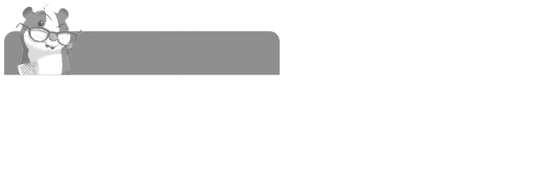
Para adjetivos de uma sílaba, acrescenta-se the + -est ao adjetivo (ex.: Mary is the smallest girl in the class.); para adjetivos com duas ou mais sílabas, coloca-se the most antes do adjetivo (ex.: Christmas is the most beautiful time of the year.).

Keep in Mind!

Os adjetivos good and bad têm formas especiais.
good – better than – the best (bom – melhor do que – o melhor) Bom estudo!
bad – worse than – the worst (mau – pior do que – o pior)

A. Tick (✔) the correct option. (Escolhe a opção correta.)
1. The comparative of superiority of tall is
a) more tall than  b) taller than c) the tallest
2. The comparative of superiority of bad is
a) more bad than b) worse than c) the worse
3. The comparative of superiority of intelligent is
a) more intelligent than b) the most intelligent c) the more intelligent
4. The comparative of superiority of lazy is
a) more lazy than b) lazier than c) the most laziest

B. Write the comparative of superiority. (Escreve o comparativo de superioridade.)
1. thin ______________... 4. small ______________...
2. long ______________... 5. interesting ______________...
3. fast ______________... 6. beautiful ______________...

C. Complete the sentences with the adjectives from exercise B.
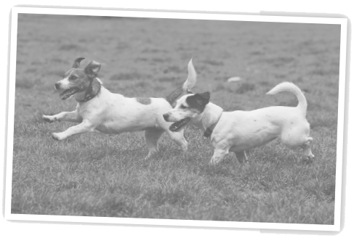
(Completa as frases com os adjetivos do exercício B.)
1. This flower is ______________... (beautiful) that one.
2. Their house is ______________... (small) mine.
3. My hair is ______________... (long) yours.
4. Your dog runs ______________... (fast) Paul’s.
5. Susan is ______________... (thin) her sister.
6. Your book is ______________... (interesting) John’s.

D. Write sentences with the comparative of superiority.
(Constrói frases com o comparativo de superioridade.)
• Jennifer Lawrence / Kate Winslet / famous – …Jennifer Lawrence is more famous than Kate Winslet....
1. Kevin Hart / Adam Sandler / funny ______________...
2. Spider-Man / Superman / strong ______________.. .
3. The Smurfs / the Minions / tall ______________.. .

E. Complete the sentences with the superlative of the adjectives in brackets.
(Completa as frases usando o superlativo dos adjetivos entre parêntesis.)
1. Which is ____________________________... (dangerous) animal in the world?
2. Five-star hotels are ____________________________... (expensive) in the country.
3. This exercise is ____________________________... (easy) in the test.
4. Who is ____________________________... (famous) actress in your country?

F. Look at the pictures and make sentences using the comparative (pictures 1-3) or the superlative (picture 4). (Observa as imagens e faz frases usando o comparativo – imagens 1-3 – e o superlativo – imagem 4.)
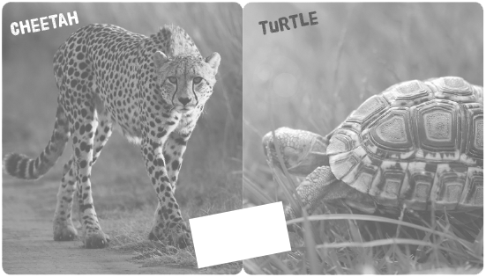

HIGH

FAST

1. _____________________________... 2. ____________________________...

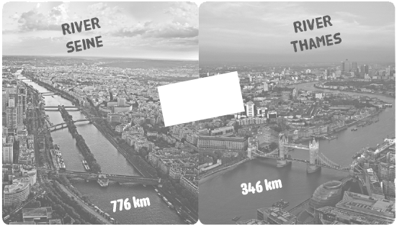
HIGH

LONG

3. ______________._______________. 4. _____________________________...


STUDY TIPS
Quando queremos indicar a forma como alguma coisa acontece/aconteceu usamos advérbios (ex.: They play loudly.)
Estes advérbios são, normalmente, colocados depois do verbo principal (ex.: She sings badly.).
Para formar estes advérbios, tens apenas de acrescentar -ly ao adjetivo (exs.: quick – quickly; quiet – quietly; careful – carefully). Tem em atenção que se o adjetivo terminar em -y, deves transformá-lo em -i e só depois acrescentar -ly (ex.: angry – angrily). Quando o adjetivo terminar em -le, retiras o -e e acrescentas -y (terrible – terribly).
Bom estudo!

A. Circle the adverbs (adjective + -ly) in the following sentences.
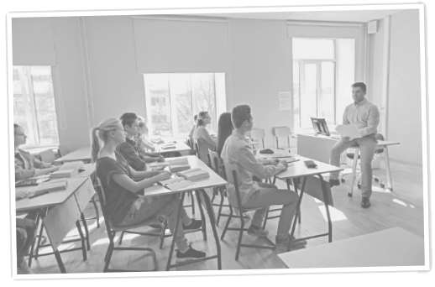
(Rodeia os advérbios (adjetivo + -ly) das seguintes frases.)
1. He studied everything quickly.
2. Anne is smiling happily at her friend.
3. The students listen attentively to their teacher.
4. We are sitting quietly at our desks.
5. My father always drives very carefully.
6. He speaks slowly.

B. Make adverbs with -ly from the adjectives.
(Forma advérbios com -ly a partir dos adjetivos.)
Adjective | Adverb
1. bad
2. easy
3. quick
4. lazy
5. elegant
6. kind
7. happy
8. careful
9. horrible

