STUDY TIPS

O past simple dos verbos irregulares, tal como o nome o indica, não segue a regra dos verbos regulares.
Ou seja, estes verbos na forma afirmativa não formam o passado acrescentando -ed (ex.: verb go – She went to school yesterday.)
Para mais facilmente memorizares os verbos irregulares no past simple, deverás consultar
a tabela dos Irregular Verbs que se encontra na badana do teu manual.

No entanto, as formas negativa e interrogativa continuam a formar-se com didn’t ou did + verbo principal no infinitivo (exs.: She didn’t go to school yesterday.; Did she go to school yesterday? Yes, she did. / No, she didn’t.)
Bom estudo!

A. Complete with the past simple of the irregular verbs.
(Completa com o past simple dos verbos irregulares.)
1. run ______________... 4. sleep ______________...
2. meet ______________... 5. eat ______________...
3. take ______________... 6. drink ______________...

B. Complete the table. (Completa a tabela.)
Affirmative | Negative | Interrogative
Paul wrote an email to his friends. | (1) __________________...  ______________...____ | (2) __________________...  ______________...____
(3) __________________... | She didn’t sing a song. | (4) __________________...
(5) __________________... | We didn’t eat pizza yesterday. | (6) __________________...
(7) __________________... | (8) __________________... | Did you have fun at the party?
(9) __________________... | (10) __________________... | Did they go to the cinema?

C. Here is a list of things Susan did and didn’t do yesterday. Write sentences.
(Aqui está uma lista das coisas que a Susan fez e não fez ontem. Escreve frases.)

✔ catch the school bus at 8:00 x see her friend Tina in the bus
✔ go to the Dance Club x buy her best friend’s present
✔ write her history essay x read her book before going to bed

• …Yesterday, Susan caught the school bus at eight o’clock, but she didn’t see her friend Tina
in the bus. ..
____

STUDY TIPS

As preposições de movimento são usadas para indicar movimento de pessoas ou de coisas.
Across significa “através de” (ex.: He swam across the river.), towards significa “em direção a”
(ex.: He ran towards his sister.) e through significa “por ou através de” (ex.: My father drove through the tunnel.).
Bom estudo!

A. Find three prepositions of movement in the word snake. Then complete the sentences.
(Descobre três preposições de movimento. Depois, completa as frases.)
e n m l s a f a c r o s s s m d o k l f n f t h r o u g h n v c h g r o t y p j u l j z v x t o w a r d s h d j d k f k k
1. There are a lot of bridges __________________... the River Thames.
2. The girl is looking __________________... her bedroom window.
3. I’m walking __________________... the bus stop to catch the bus.

B. Choose the right preposition according to the picture.
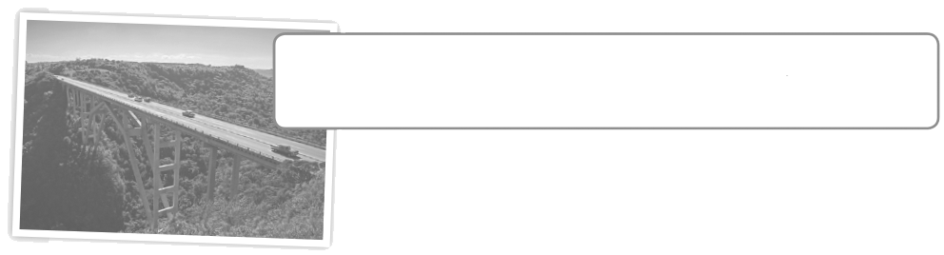
(Escolhe a preposição correta de acordo com a imagem.)
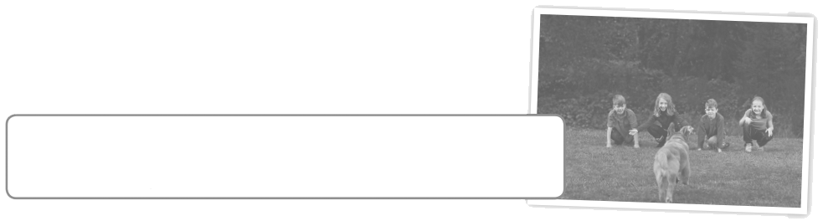
1. The cars are going through / across / towards
the bridge.

2. When we get home, our dog runs across /
towards / through us.
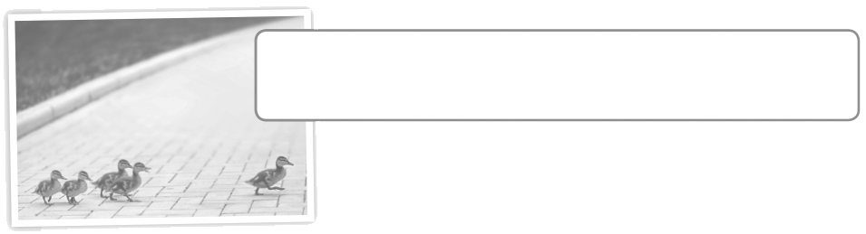
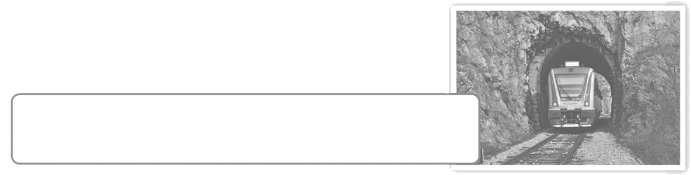
3. The ducks are going towards / across /
through the road.

4. The train is going across / through / towards
the tunnel.
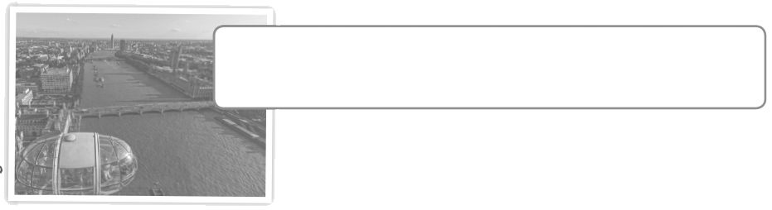

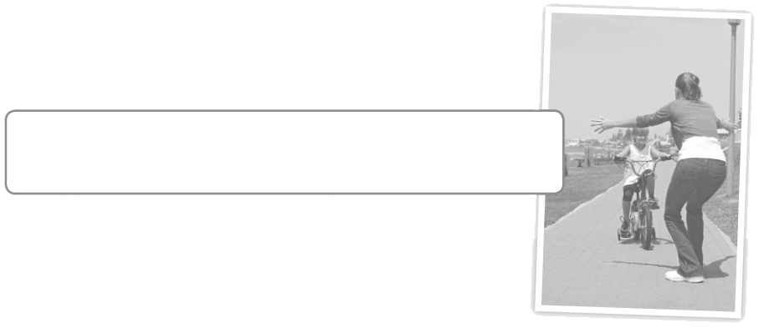
5. The River Thames flows through / across /
towards London.

6. He’s riding across / through / towards
his mother.

