
STUDY TIPS
Be going to pode ser usado para se exprimir planos ou intenções para o futuro (ex.: I’m going to visit London next year.).
Constrói-se com o present simple do verb to be (am / is / are) + going to + infinitivo do verbo principal
(exs.: We are going to play video games; She isn’t going to swim; Are they going to travel?).

Nas respostas curtas usa-se o present simple do verb to be (ex.: Is he going to surf the net? Yes, he is;
No, he isn’t.).
Bom estudo!

A. Complete the sentence. (Completa a frase.)
You use am/is/are + (1) ______________... + verb when you talk about (2) ______________...
or predictions for the future.

B. Write the sentences below in the correct column.
(Escreve as frases abaixo na coluna correta.)


I’m going to swim. Are we going to study? He’s going to eat.
They aren’t going to travel. We aren’t going to watch TV.
You’re going to read. Are you going to have a shower?
She isn’t going to sing. Yes, I am. No, she isn’t.
Yes, we are. Is she going to take photos?

Affirmative | ______________...__________________...______________...  ______________...__________________...______________...
Negative | ______________...__________________...______________...  ______________...__________________...______________...
Interrogative | ______________...__________________...______________...  ______________...__________________...______________...
Short answers | ______________...__________________...______________...  ______________...__________________...______________...

C. What is going to happen? Look at the pictures and write sentences using the following clues.
(O que vai acontecer? Observa as imagens e escreve frases usando as pistas.)
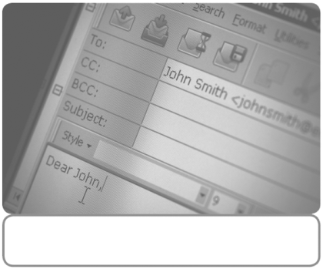
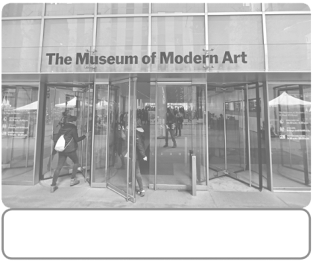


• they / catch the bus 1. they / visit a museum 2. he / write an email
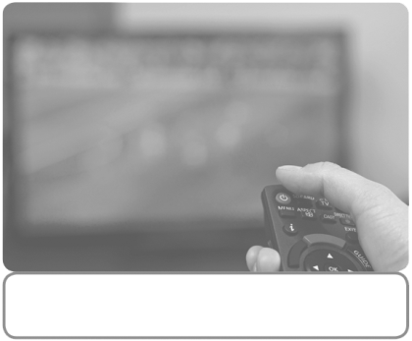
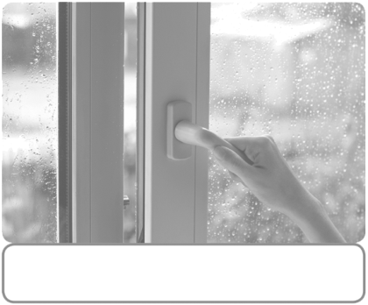


3. he / turn on the TV 4. she / close the window 5. she / eat the sandwich

• …They are going to catch the bus....
1. ...
2. ...
3.
4. ...
5. ...

D. Write sentences and say what is NOT going to happen.
(Escreve frases e diz o que NÃO vai acontecer.)
• He / visit London.
He is not going to visit London....
1. We / spend the summer at the beach.
…....
2. They / travel by boat.
…....
3. She / buy new clothes.
…
4. I / spend much money / next summer holidays.
…

STUDY TIPS
Os reflexive pronouns são usados para indicar que uma determinada ação recai sobre o próprio sujeito.
O pronome vem imediatamente após o verbo e concorda com o sujeito.
Os reflexive pronouns têm a terminação self (no singular) e selves (no plural).

Personal pronouns | Reflexive pronoun
I | myself
you | yourself
he | himself
she | herself
it | itself
we | ourselves
you | yourselves
they | themselves


Bom estudo!

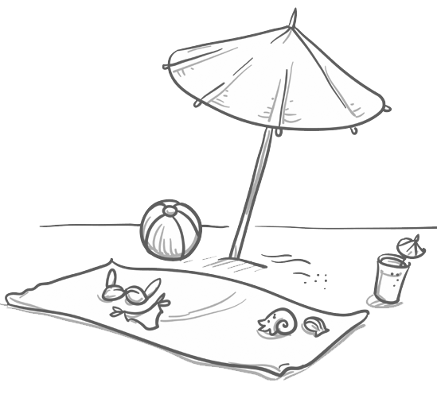
A. Circle the correct reflexive pronoun.
(Rodeia o reflexive pronoun correto.)
1. My mother cut herself / himself with a knife.
2. They enjoyed yourselves / themselves at the beach.
3. I can’t help you now. You have to do it by himself / yourself.
4. We burn yourselves / ourselves in the oven a lot.

B. Complete the sentences with the correct reflexive pronoun.
(Completa as frases com o reflexive pronoun correto.)
1. In the morning, Mary is taking a photo of ______________________....
2. Last week my father was alone talking to ______________________.._.
3. The students enjoy ______________________.. in the English class.
4. We hurt ______________________... in the garden fence.
5. I introduce ______________________.. to the new teacher every year.
6. Before leaving her room, she looks at ______________________.. in the mirror.
7. The pupils in this class don’t behave ______________________...
8. Be careful! Don’t hurt ______________________....

