“Apoio ao estudo”
Vocabulary
Countries and nationalities 64
Types of houses 65
Daily routine 66
Household chores 67
School subjects | School facilities | After-school clubs 68
Physical features | Personality 70
Clothes, footwear and accessories 71
Places in a city 72
Things to do in the city 73
Means of transport 74
Free time activities| Beach activities 75
Grammar
Present simple 78
Adverbs of frequency 80
Connectors 81
Present continuous 82
Adjectives + prepositions 84
Modal verb should 85
Comparative and superlative 86
Adverbs: adjectives + -ly 88
Past simple – verb to be 89
Past simple – verb there + to be 90
Past simple – regular verbs 91
Past simple – irregular verbs 92
Prepositions of movement 93
Be going to 94
Reflexive pronouns 96
Answer key 97
Available in editable format at | 


1
2
3
4
5
6
7
8
9
10
11
12
13
14
15
1
2
3
4
5
6
7
8
9
10
11


STUDY TIPS

Para responderes à pergunta “Where are you from?” (De onde és?), deves usar sempre o verbo to be (que significa “ser” ou “estar”) seguido da palavra from e do nome do país (ex.: I am from Portugal.).
À pergunta What’s your nationality? (Qual é a tua nacionalidade?) deves responder usando o verbo to be
(ex.: We are Portuguese.). Não te esqueças de que, em inglês, os países e as nacionalidades são sempre com maiúsculas!
Tem ainda em atenção que em inglês se diz “Eu sou + nacionalidade” (ex.: I am Portuguese – Eu sou português.) e não que “A minha nacionalidade é…” (ex.: My nationality is Portuguese.)
Singular | Plural
country | countries
nationality | nationalities

Bom estudo!

A. Complete the gaps to answer the questions about YOU.
(Preenche os espaços para responderes às questões acerca de TI.)
Where are you from? What’s your nationality?
1. I .._________ + 2. .._________ + 3. .._________ 4. I .._________ + 5. .._________
(verb to be) + (from) + (country) (verb to be) + (nationality)

B. Complete the tables with the correct countries and nationalities.
(Completa as tabelas com os países e as nacionalidades corretas.)
Ending in -an Ending in -ish
Country | Nationality |  | Country | Nationality
Australia | (1) ..____________ |  | (4) ..____________ | Irish
Canada | (2) ..____________ |  | The UK | (5) ..____________
The USA | (3) ..____________ |  | (6) ..____________ | Scottish

Ending in -ese Other
Country | Nationality |  | Country | Nationality
(7) ..____________ | Chinese |  | France | (9) ..____________
(8) ..____________ | Portuguese |  | (10) ..____________ | Welsh

C. Read the information and write sentences. There is one example.
(Lê a informação e escreve frases. Segue o exemplo.)
• Gianluca / Italy Gianluca is from Italy. He is Italian...
1. Lin / China ___
2. Mark / the USA ___
3. Oliver / the UK ___
4. Graham / Scotland ___

STUDY TIPS
Em diferentes partes do mundo, há tipos únicos e diferentes de casas que variam devido ao clima, a fatores históricos e geográficos e às condições de vida do meio onde estão inseridas.

Nos exercícios desta ficha encontrarás o nome de alguns tipos de casa existentes em Inglaterra. Tenta memorizá-los escrevendo no teu caderno diário frases onde incluas este vocabulário (ex.: I live in a flat.)
Deves ainda rever as question words Where? e What (type of)? para perguntares “onde” e “em que tipo de casa” alguém habita.
Bom estudo!

A. Label the pictures. Use the words from the box.
(Legenda as imagens. Usa as palavras da caixa.)
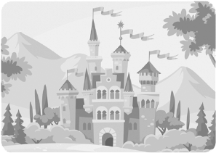
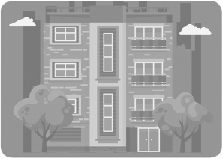

detached house
semi-detached house
block of flats
cottage
terraced house
castle

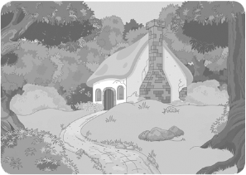
1. .._____________ 2. .._____________ 3. .._____________

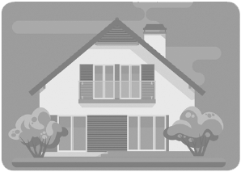
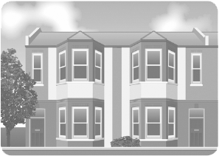

4. .._____________ 5. .._____________ 6. .._____________

B. Where do they live? Answer the question with the words from exercise A.
(Onde é que eles vivem? Responde à pergunta com as palavras do exercício A.)
1. James is a prince. He lives in a ___ .
2. The Smiths love the countryside. They live in a lovely ___ .
3. Lucy lives in a house joined to another house on one side.
She lives in a ___ .
4. Grace needs a big garden for her ten cats, so she now lives in a ___ .
5. Andrew lives on the 4th floor in a ___ .
6. Paul lives in a house that is a part of a line of houses.
It is a ___ .


STUDY TIPS
Para descreveres a tua rotina diária em inglês, precisas de saber alguns verbos e expressões correspondentes às atividades que compõem o teu dia, como por exemplo: wake up, get dressed, do your homework, etc.
Para melhorar a tua descrição, deverás indicar as horas: nas horas certas utilizas a expressão o’clock
(ex.: 7 o’clock); half significa “meia hora” e a quarter “um quarto de hora”.
Em inglês, dizes primeiro os minutos, seguidos de:
“past”, até à meia hora “to”, depois da meia hora
Só depois dizes as horas. Ora repara: 8:20 – It’s twenty past eight; 6:50 – It’s ten to seven.
Se for antes do meio-dia, deves incluir a.m. (ex.: 11:00 a.m. – 11:00 da manhã) e, se for depois do meio-dia, deves incluir p.m. (ex.: 2:00 p.m. – 2:00 da tarde).
Bom estudo!

A. What time is it? It’s… Tick (✔) the correct option.
(Que horas são? São… Assinala a opção correta.)
1
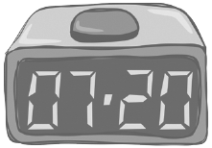
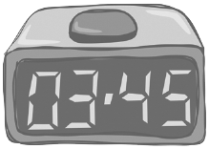

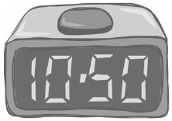
3
2
1
1
a) ... ten past ten  a) ... a quarter past three. a) ... twenty to seven.
b) … ten to ten. b) … a quarter to three. b) … twenty past seven.
c) … ten to eleven. c) … a quarter to four. c) … twenty to eight.

B. Match the pictures to the actions. (Associa as imagens às ações que elas representam.)


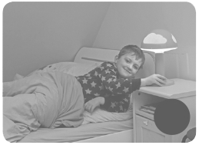



a) b) c) d) e)

1. go to bed 2. get up 3. go to school
4. have breakfast 5. do my homework

C. Complete the sentences with the correct word/expression from exercise B.
(Completa as frases com a palavra/expressão correta do exercício B.)
1. I usually ..___________________ at seven o’clock in the morning.
2. My parents and I ..___________________ in the kitchen.
3. At 8:15 a.m. my brother and I ..___________________ in my father’s car.
4. After school I ..___________________ in my bedroom.
5. At 10:00 p.m. we all ..___________________ to get some sleep.

STUDY TIPS

Nesta ficha, encontras vocabulário que te será útil, por exemplo, para melhor descreveres tarefas associadas à tua rotina diária.
Não te esqueças: para falares corretamente das tuas tarefas domésticas, deves rever o present simple.
Bom estudo!

A. Match the chores to the pictures.
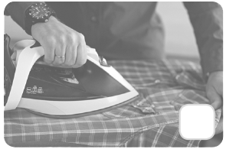
(Liga as tarefas às imagens.)
1. do the ironing 4. set the table
2. do the washing up 5. take out the rubbish
3. make the bed d)

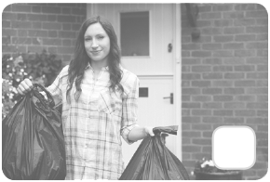

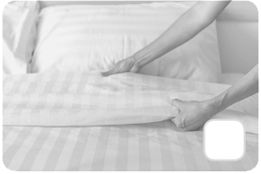
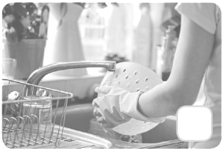

a) b) c) e)

B. Complete the sentences with the verbs in the present simple. Then do the crossword puzzle.
(Completa as frases com os verbos no present simple. Depois, faz as palavras cruzadas.)
1. My mother always ..___________________ the ironing.
2. My sister always helps at home. Every morning she ..___________________ her bed.
3. On Saturdays my father usually ..___________________ the car.
4. When dinner is ready, my little brother ..___________________ the table.
5. My father ..___________________ the rubbish out in the evening.
6. I always ..___________________ the bathroom after having my morning shower.
 |  |  | 3
 |  |  |  |  |  | 4 |  |  | 6
 | 2
 |  |  |  |  | 5
1
