NEE Worksheets
Grammar
Present simple 114
Adverbs of frequency 116
Connectors 117
Present continuous 118
Adjectives + prepositions 120
Modal verb should 121
Comparative 122
Superlative 123
Adverbs: adjectives + -ly 124
Past simple – verb to be 125
Past simple – verb there + to be 126
Past simple – regular verbs 127
Past simple – irregular verbs 128
Prepositions of movement 129
Want / Would like 130
Be going to 131
Reflexive pronouns 133
Answer key 134
Available in editable format at | 


1
2
3
4
5
6
7
8
9
10
11
12
13
14
15
16
17

A. Complete the table with the words from the box.
(Completa a tabela com as palavras da caixa.)
Verb like
I | like
You | (1) ______________
He | likes
She | (2) ______________
It | (3) ______________
We | like
You | (4) ______________
They | (5) ______________

likes
like
like
likes
like



AFFIRMATIVE
I, you, we, they + verb
he, she, it + verb + -s/-es

B. Circle the correct option. (Rodeia a opção correta.)
1. He play / plays football. 4. Julie and I read / reads magazines.
2. I like / likes chocolate cake. 5. The cat drink / drinks milk.
3. Jonas listen / listens to music. 6. They surf / surfs the net.

C. Complete the table with the words from the box.
(Completa a tabela com as palavras da caixa.)
Verb play
I | don’t play
You | (1) ______________
He | doesn’t play
She | (2) ______________
It | (3) ______________
We | We don’t play
You | (4) ______________
They | (5) ______________


don’t play
doesn’t play
don’t play
don’t play
doesn’t play

NEGATIVE
I, you, we, they + don’t + verb
he, she, it + doesn’t + verb

D. Circle the correct option. (Rodeia a opção correta.)
1. You don’t like / doesn’t like pink.
2. Sarah don’t play / doesn’t play basketball.
3. My friends don’t go / doesn’t go to school by bus.
4. Tom don’t do / doesn’t do his homework.

C. Complete the table with the words from the box.
(Completa a tabela com as palavras da caixa.)
Verb read
Do I read…?
(1) ______________…?
Does he read…?
(2) ______________…?
(3) ______________…?
Do we read…?
(4) ______________…?
(5) ______________…?


Do you read
Do they read
Do you read
Does she read
Does it read

INTERROGATIVE
Do + I, you, we, they + verb…?
Does + he, she, it + verb…?

F. Circle the correct option. (Rodeia a opção correta.)
1. Do / Does you like baseball?
2. Do they play / plays the piano?
3. Do / Does your sister go to school by car?
4. Do your friends eat / eats in the school canteen?
5. Do / Does he play football in the park?

G. Complete the sentences with the correct form of the verbs. There is one example.
(Completa as frases com a forma correta dos verbos. Segue o exemplo.)
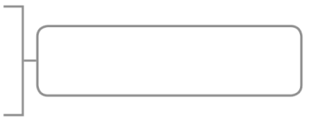
• I _____chat_____ (chat) with my friends online.
1. Martha ______________ (like) orange juice. AFFIRMATIVE
2. Sean and Frank ______________ (play) rugby.
• My brother _____doesn’t eat _____ (eat) fruit every day.
3. You ______________ (wash) the car. NEGATIVE
4. Sophie ______________ (go) to school on foot.
• __Do__ you _____help _____ (help) your parents?
5. _ _____ Sarah ______________ (watch) TV in the evening? INTERROGATIVE
6. _ _____ the dog ______________ (play) with the ball?

H. Write the sentence in the negative and interrogative.
(Escreve a frase na negativa e na interrogativa.)
They play video games in the afternoon.
Negative: _ _____
Interrogative: _ _____


A. Complete with the adverbs of frequency.
(Completa com os adverbs of frequency.)

ADVERBS OF FREQUENCY
always = sempre
usually = normalmente
often = frequentemente
sometimes = às vezes
rarely = raramente
hardly ever = quase nunca
never = nunca
1. ________________________
2. ________________________
3. ________________________
4. ________________________
5. ___________ /____________
6. ________________________

B. Look at George’s timetable and complete with always / often / rarely / never.

(Observa o horário do George e completa com always / often / rarely / never.)
 | Monday | Tuesday | Wednesday | Thursday | Friday
play football | ☺ | X | ☺ | X | ☺
watch TV | X | ☺ | X | X | X
read a book | X | X | X | X | X
go to school | ☺ | ☺ | ☺ | ☺ | ☺

1. George ________________________ plays football.
2. George ________________________ watches TV.
3. George ________________________ reads a book.
4. George ________________________ goes to school.

C. Look at Harold’s timetable and complete with always / never / once / twice.

(Observa o horário do Harold e completa com always / never / once / twice.)
 | Monday | Tuesday | Wednesday | Thursday | Friday
have breakfast | ☺ | ☺ | ☺ | ☺ | ☺
play basquetball | X | ☺ | X | ☺ | X
drink coffee | X | X | X | X | X
go to the cinema | X | X | ☺ | X | X

1. Harold ________________________ has breakfast.

2. Harold plays basquetball ________________________ a week.
once = uma vez
twice = duas vezes
3. Harold ________________________ drinks coffee.
4. Harold goes to the cinema ________________________ a week.


A. Read the sentences and underline the connectors.
(Lê as frases e sublinha os connectors.)

1. I wake up early when I go to school.
CONNECTORS
then = de seguida
after that = depois disso
later = mais tarde
when = quando
while = enquanto
2. I wake up at 8:00. Then I have a shower.
3. In the afternoon we do our homework.
Later we watch TV.
4. I have breakfast. After that I brush my teeth.
5. I listen to music while I study.

B. Circle the correct option. (Rodeia a opção correta.)

What do you do on Mondays, Greg?


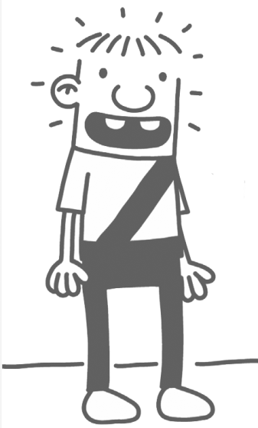
I get up and have a shower. (1) After that / When I have breakfast
(2) later / while I watch TV and (3) then / when I brush my teeth.
(4) After that / While I go to school. What classes do we have on
Monday, Rowley?

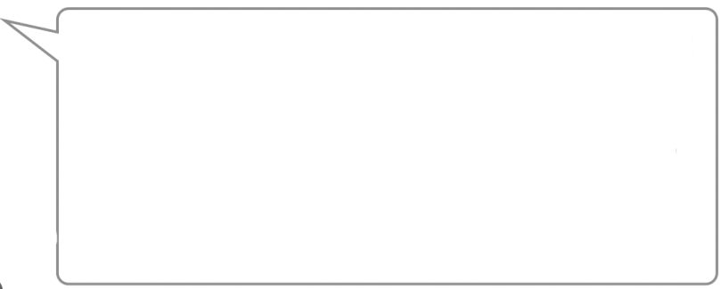

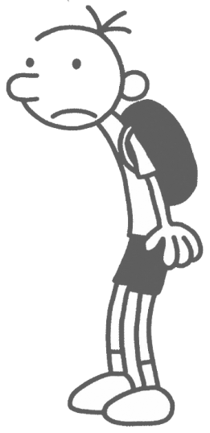
In the morning, we have history, (5) while / then
we have maths and (6) after that / when we
have music. (7) While / Later, in the afternoon,
we have science and physical education.
What do you do (8) when / then you go home?


(9) Later / When I go home, I do my homework.
(10) When / After that, I have a snack (11) while /
when I listen to music. (12) Later / when, I have
dinner with my family and (13) while / then I go
to bed. And you?

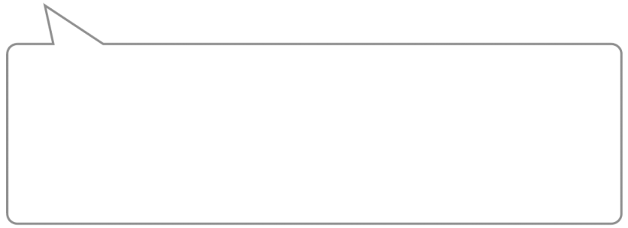

(14) When / Then I go home, I always watch TV and
(15) then / when I study. (16) While / After that I have
dinner and I read comic books. I love comic books!
Zoo-wee mama!

