A. Complete the table with the words from the box.
Verb wash
I | am washing
You | are washing
He | is washing
She | (1) ______________
It | (2) ______________
We | are washing
You | (4) ______________
They | (5) ______________
(Completa a tabela com as palavras da caixa.)


is washing
are washing
is washing
are washing


AFFIRMATIVE
I + am + verb -ing
he, she, it + is + verb -ing
we, you, they + are + verb -ing

B. Circle the correct option. (Rodeia a opção correta.)
1. He is playing / are playing football. 4. They is reading / are reading a book.
2. I am washing / are washing the car. 5. Rita am cooking / is cooking dinner.
3. John are listening / is listening to music. 6. We are surfing / is surfing the net.

C. Complete the table with the words from the box.
(Completa a tabela com as palavras da caixa.)
Verb cook
I | ’m not cooking
You | aren’t cooking
He | isn’t cooking
She | (1) ______________
It | (2) ______________
We | aren’t cooking
You | (3) ______________
They | (4) ______________


aren’t cooking
isn’t cooking
aren’t cooking
isn’t cooking

NEGATIVE
I + ’m not + verb -ing
he, she, it + isn’t + verb -ing
we, you, they + aren’t + verb -ing

D. Circle the correct option. (Rodeia a opção correta.)
1. You isn’t doing / aren’t doing your homework.
2. Sarah isn’t tidying / aren’t tidying her bedroom.
3. My parents am not having / aren’t having dinner.
4. I isn’t watching / am not watching TV at the moment.

E. Complete the table with the words from the box.
(Completa a tabela com as palavras da caixa.)
Verb clean
(1) ______________ …?
Are you cleaning…?
Is he cleaning…?
(2) ______________…?
(3) ______________…?
Are we cleaning…?
(4) ______________…?
(5) ______________…?


Are you cleaning
Are they cleaning
Is she cleaning
Am I cleaning
Is it cleaning

INTERROGATIVE
Am + I + verb -ing… ?
Is + he, she, it + verb -ing… ?
Are + we, you, they + verb -ing… ?

F. Circle the correct option. (Rodeia a opção correta.)
1. Are / Is you reading a book?
2. Am / Is she playing the piano?
3. Is / are my sister going to school?
4. Are / Am I doing this right?

G. Write the sentences in the negative and interrogative. There is one example.
(Escreve as frases na negativa e na interrogativa. Segue o exemplo.)
• They are washing the car.
Negative: …They are washing the car..
Interrogative: …Are they washing the car?.
1. She is playing video games at the moment.
Negative: …..
Interrogative: …..
2. You are watching TV now.
Negative: …. .
Interrogative: …..

H. Complete the sentences with the correct form of the verbs.
(Completa as frases com a forma correta dos verbos.)
1. I ___________________________ (do) my homework in my bedroom.
2. Mike ___________________________ (not surf) the net.
3. ___________ they ___________________________ (do) the ironing?
4. My brother ___________________________ (help) our parents.
5. You ___________________________ (not listen) to music at the moment.
6. ___________ Kate ___________________________ (read) a book now?


A. Complete the sentences with the prepositions from the box.
(Completa as frases com as preposições da caixa.)
for for in of at with

ADJECTIVES + PREPOSITIONS
late + for = atrasado/a para
afraid + of = receoso (com medo) de
angry + with = zangado/a com
good + at = bom em
famous + for = famoso/a por
fond + of = apaixonado por
interested + in = interessado/a em
brilliant + at = brilhante em

1. He is always late _________ school.
2. I’m interested _________ comic books.
3. My sister is very fond _________ music.
4. Charles is very good _________ English.
5. The teacher is very angry _________ the students.
6. Beethoven is famous _________ his symphonies.

B. Choose the correct expression to label the pictures.
(Escolhe a opção correta para legendar as imagens.)
famous for her music good at football
late for work brilliant at maths afraid of spiders
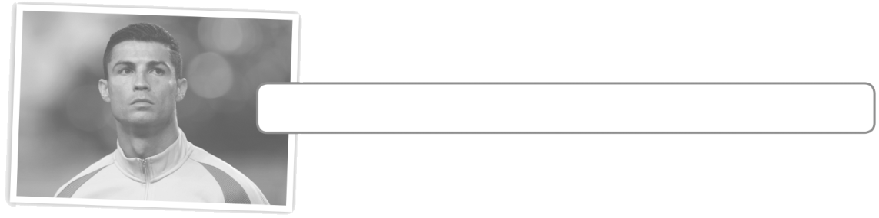

1. Cristiano Ronaldo is _________ .



2. Kevin is ________________________ .



3. Lucas is _____________________ .


4. Beyoncé is _____________________ .



5. Tom is _____________________ .

A. Complete with should/shouldn’t. There is one example.
Completa com should/shouldn’t. Segue o exemplo.)
Usamos should/shouldn’t para
dar conselhos:
should = dever (fazer algo)
shouldn’t = não dever (fazer algo)

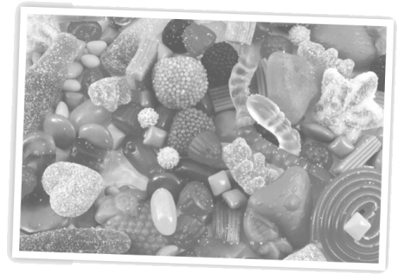

• I want to be healthy.
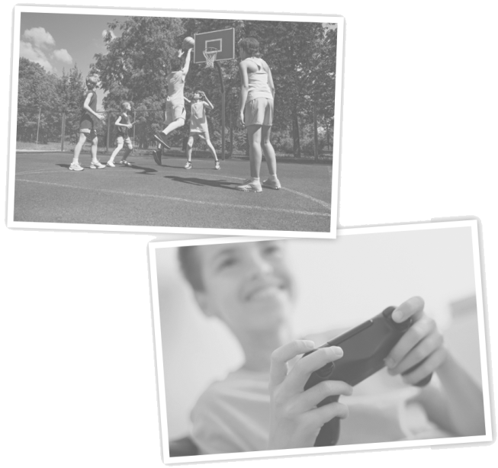
(Eu quero ser saudável.)
I …shouldn’t.. eat sweets.
I …should.. do sports.



1. I want to be a football player.
(Eu quero ser jogador de futebol.)
I …__________ practise every day.
I …__________ play video games all day.




2. I want to have good marks.
(Eu quero ter boas notas.)
I …__________ study a lot.
I …__________ be lazy.

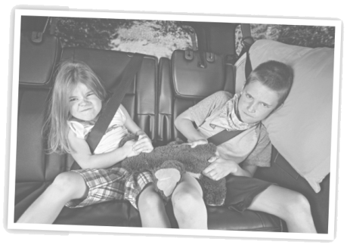
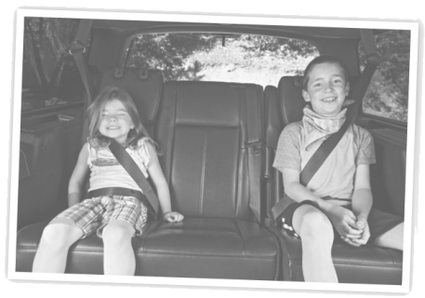

3. I want to be a happy person.
(Eu quero ser uma pessoa feliz.)
I …__________ be rude.
I …__________ smile more.




4. I want to help the environment.
(Eu quero ajudar o ambiente.)
I …__________ recycle.
I …__________ throw rubbish on the street.

