
A. Complete with the comparative of superiority.
(Completa com o comparative of superiority.

• Amelia is …taller than.. (tall) her mother.
1. My sister is …_____________________ (old) me.
COMPARATIVE OF SUPERIORITY
short adjectives = adjetivos curtos
adjective + -er + than (= mais… do que)
2. Jason is …_____________________ (short) his father.
3. The pencil is …_____________________ (cheap) the pen.
4. Allison is …_____________________ (young) Evie.
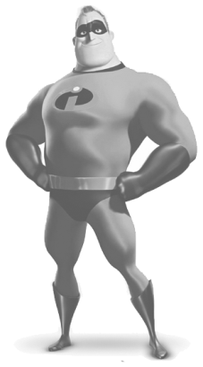
B. Look at the pictures and complete.
(Observa as imagens e completa.)
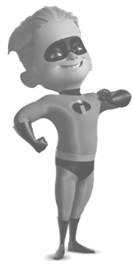
1. Bob is …____________________ (old) Dash.
2. Dash is …____________________ (young) Bob.
3. Dash is …_____________________ (short) Bob.
4. Bob is …______________________ (tall) Dash.
5. Dash is …____________________ (fast) Bob.
6. Bob is …____________________ (strong) Dash. BOB DASH

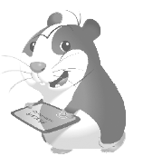
C. Complete with the comparative of superiority.
COMPARATIVE OF SUPERIORITY
long adjectives = adjetivos longos
more + adjective + than
(Completa com o comparative of superiority.)
• Trevor is …more intelligent than.. (intelligent) Luca.
1. The book is …__________________ (interesting) the film.
2. My cat is …___________________ (beautiful) your dog.
3. Cristiano Ronaldo is …__________________ (famous) me.
4. The car is …__________________ (expensive) the bike.


D. Complete with the comparative of superiority.
(Completa com o comparative of superiority.)
1. Playing football is …____________ (good) watching TV.
COMPARATIVE OF SUPERIORITY
Irregular adjectives
good (= bom) → better than
bad (= mau) → worse than
2. John is …____________ (bad) Peter at playing basketball.
3. Eating chocolate is …____________ (good) eating soup.
4. A rainy day is …____________ (bad) a sunny day.


A. Complete with the superlative of superiority.
(Completa com o superlative of superiority.

• Harvey is …____the tallest_____ (tall) of his class.
1. My grandfather is …______________________ (old) of my family.
SUPERLATIVE
short adjectives
the + adjective + -est
(= o/a mais…)
2. Jasper is …______________________ (short) person I know.
3. This book is …______________________ (cheap).
4. Duncan is …______________________ (young) of my friends.
5. My uncle has got …______________________ (fast) car of the family.
6. Winter is …______________________ (cold) season of the year.


B. Complete with the superlative of superiority.
SUPERLATIVE
long adjectives
the + most + adjective
(Completa com o superlative of superiority.)
• Trevor is …_the most intelligent__ (intelligent) of his class.
1. This film is …_______________________ (interesting) one.
2. My girlfriend is …______________________ (beautiful)
girl in the world.
3. I want to be …______________________ (famous) football
player in the world.
4. This car is …______________________ (expensive) of all.
5. I think New York is …______________________ (amazing) city in the world.
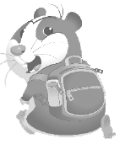
C. Complete with the superlative of superiority.
(Completa com o superlative of superiority.)
1. My sister is great. She is …___________________ (good)!
SUPERLATIVE
irregular adjectives
good → the best
bad → the worst
2. This salad is …___________________ (bad) part of my lunch.
3. I don’t like bananas. It’s …___________________ (bad) fruit!
4. My English teacher is …___________________ (good) teacher
at school!


A. Match the adjectives to the adverbs. Draw lines.
(Associa os adjetivos aos advérbios. Traça as linhas.)
slow 1. • • a) quickly (rapidamente)

careful 2. • • b) carefully (cuidadosamente)
Adjective + -ly = adverb
normal 3. • • c) slowly (lentamente)
quick 4. • • d) happily (alegremente)
happy 5. • • e) easily (facilmente)
easy 6. • • f) normally (normalmente)
quiet 7. • • g) dangerously (perigosamente)
dangerous 8. • • h) quietly (silenciosamente)
beautiful 9. • • i) badly (mal)
bad 10. • • j) beautifully (lindamente)

B. Look at the pictures and circle the correct adverb.
(Observa as imagens e rodeia o advérbio correto.)

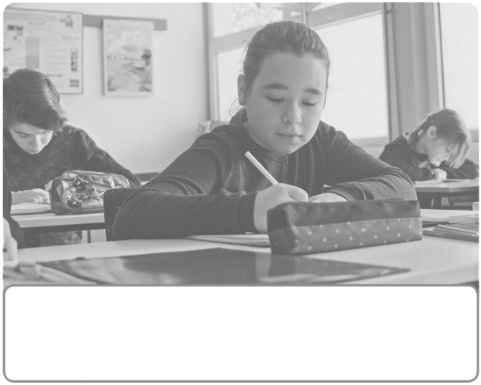

1. The students do the test 2. Jane does her homework
quietly / dangerously. normally / happily.

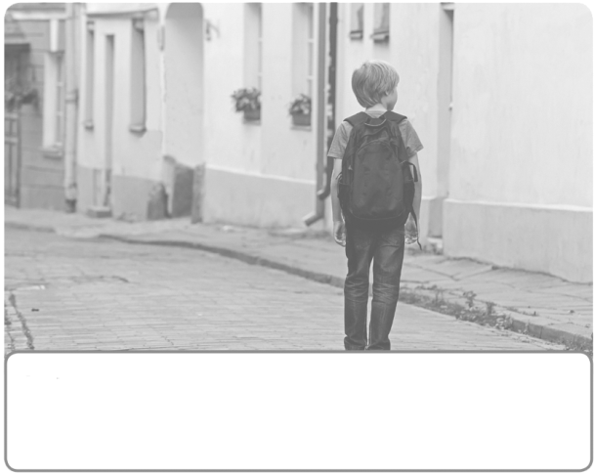
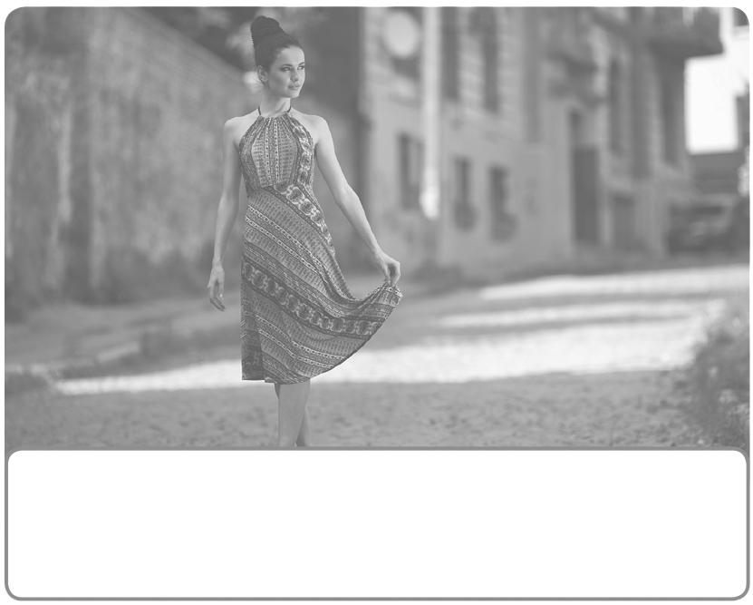

3. She is beautifully / dangerously 4. I go to school quickly / slowly
dressed. because I go on foot.

