A. Complete the table with the words in the box.

(Completa a tabela com as palavras da caixa.)
weren’t was weren’t Was wasn’t wasn’t
was were Was were Were wasn’t

AFFIRMATIVE
I, he, she, it + was
we, you, they + were
NEGATIVE
I, he, she, it + wasn’t
we, you, they + weren’t
INTERROGATIVE
Was + I, he, she, it… ?
Were + we, you, they… ?

Affirmative |  |  | Negative |  |  | Interrogative
I | was |  | I | (5) _______ |  |  | Was I…?
You | were |  | You | weren’t |  |  | Were you…?
He | (1) _____ |  | He | wasn’t |  |  | (10) ______ he…?
She | was |  | She | (6) _______ |  |  | Was she…?
It | (2) _____ |  | It | (7) _______ |  |  | (11) ______ it…?
We | were |  | We | (8) _______ |  |  | Were we…?
You | (3) _____ |  | You | weren’t |  |  | (12) _____ you…?
They | (4) _____ |  | They | (9) _______ |  |  | Were they…?

B. Complete with was or were.
(Completa com was ou were).
1. I _______ born in April. 4. My friends and I _______ in the city.
2. Joshua and Peter _______ at the park. 5. My sister _______ born last year.
3. The cat _______ on the sofa. 6. You _______ at the cinema yesterday.


C. Complete with wasn’t or weren’t.
(Completa com wasn’t ou weren’t).
1. David and Kelly …____________ at the zoo yesterday.
2. I …____________ at the library.
3. Ed Sheeran …____________ born in 1990. He was born in 1991.
4. My friends …____________ at the party last night.

D. Complete with was, wasn’t, were or weren’t.
(Completa com was, wasn’t, were ou weren’t).
1. Yesterday I …____________ at home with my family.
2. The cinema …____________ (not) open last night.
3. …____________ you at the party last week?
4. My classmates …____________ (not) at the zoo. They were at the theatre.
5. Rebecca …____________ at school yesterday.



There + to be = haver / existir

 | Affirmative | Negative | Interrogative
Singular (1) | There was… | There wasn’t… | Was there…?
Plural (+1) | There were… | There weren’t… | Were there…?

A. Complete with there was or there were. (Completa com there was ou there were.)
1. Twenty years ago …_____________________ two shops in the city.
2. …_____________________ a small post office.
3. …_____________________ a police station.
4. …_____________________ three bridges.

B. Complete with there wasn’t or there weren’t.
(Completa com there wasn’t ou there weren’t.)
1. …_____________________ any tablets when I was born.
2. Fifty years ago, …_____________________ any mobile phones.
3. …_____________________ a fire station in my city.
4. When I was 5 years old, …_____________________ a computer in my house.

C. Complete with Was there or Were there. (Completa com Was there ou Were there.)
1. …_____________________ any dogs at the park yesterday?
2. …_____________________ a theatre in your city?
3. …_____________________ a police station in your city ten years ago?
4. …_____________________ any mobile phones when you were born?

D. Look at the picture. Circle the correct option.
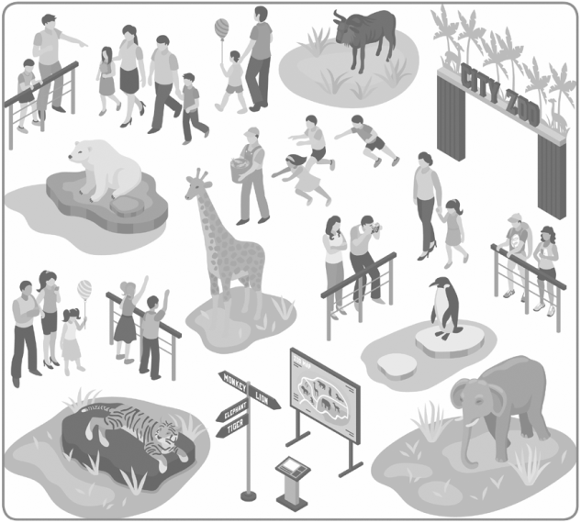
(Observa a figura. Rodeia a opção correta.)

This was the city zoo ten years ago.
1. There was / There wasn’t an elephant.
2. There were / There weren’t any snakes.
3. There was / There wasn’t a zebra.
4. There were / There weren’t many children.
5. There was / There wasn’t a giraffe.
6. There were / There weren’t any lions.


A. Complete the table. (Completa a tabela.)
Verb play
I | played | We | played
You | (1) …__________ | You | (3) …__________
He / she / it | (2) …__________ | They | (4) …__________


AFFIRMATIVE
verb + -ed

B. Complete the sentences with the affirmative form of the verbs.
(Completa as frases com a afirmativa dos verbos.)
1. I …____________ (visit) my cousins. 3. My friends and I …____________ (watch) the film.
2. Alice …____________ (finish) the test. 4. My sister …____________ (listen) to music.


C. Complete the table. (Completa a tabela.)
Verb travel
I | (1) …__________ | We | (3) …__________
You | didn’t travel | You | (4) …__________
He / she / it | (2) …__________ | They | didn’t travel

NEGATIVE
didn’t + verb

D. Complete the sentences with the negative form of the verbs.
(Completa as frases com a negativa dos verbos.)
1. Suri …____________ (organise) the party.
2. They …____________ (watch) TV last night.
3. The dog …____________ (cross) the road.


E. Complete the table. (Completa a tabela.)
Verb study
Did I study…? | (2) …_________________
(1) …_________________ | (3) …_________________
Did he / she / it study…? | (4) …_________________

INTERROGATIVE
Did + subject + verb… ?

F. Complete the sentences with the interrogative form of the verbs.
(Completa as frases com a interrogativa dos verbos.)
1. …____________ you …____________ (have) piano lessons?
2. …____________ your sister …____________ (arrive) late?
3. …____________ they …____________ (finish) the book?

