

AFFIRMATIVE
Infinitive | Past simple |  | Infinitive | Past simple |  | Infinitive | Past simple
go → went |  |  | buy → bought |  |  | drink → drank
see → saw |  |  | have → had |  |  | eat → ate
take → took |  |  | swim → swam |  |  | read → read

A. Look at the table and complete the sentences. Use the past simple.
(Observa a tabela e completa as frases. Usa o past simple.)
1. Stephen …____________ (drink) coffee. 3. Mary and I …____________ (buy) a book.
2. I …____________ (go) to school yesterday. 4. Jane …____________ (have) lunch with me.



B. Complete the sentences with the past simple in the negative.
(Completa as frases com o past simple na negativa.)
NEGATIVE
didn’t + verb
1. I …___________________ (see) my friends yesterday.
2. We …__________________ (eat) pizza. We ate soup.
3. My grandparents …__________________ (go) to Paris last week.
4. Peter …___________________ (swim) last week.


C. Complete the sentences with the past simple in the interrogative.
(Completa as frases com o past simple na interrogativa.)
1. …____________ George …____________ (take) the bus?
INTERROGATIVE
Did + subject + verb... ?
2. …____________ my father …____________ (swim) in the sea?
3. …____________ you …____________ (read) that book?
4. …____________ they …____________ (drink) a cup of tea?

D. Put the sentences in the negative and interrogative forms.
(Coloca as frases na negativa e na interrogativa.)
• Nelly bought a train ticket.
Negative: …Nelly didn’t buy a train ticket...
Interrogative: …Did Nelly buy a train ticket?..
1. I ate different food.
Negative: …____________ .
Interrogative: …____________ ?
2. Martin wrote an email.
Negative: …____________ .
Interrogative: …____________ ?

A. Look at the pictures and tick (✔) the correct option.

(Observa as imagens e seleciona a opção correta.)
across = através de (atravessar)
towards = em direção a
through = por, através de (passar por dentro)
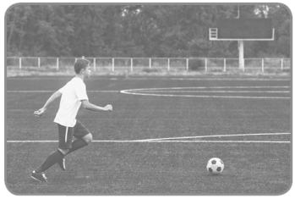
1.
a) Joseph is running across the field. 
b) Joseph is running towards the field.


2.
a) David is running through his mother.
b) David is running towards his mother.

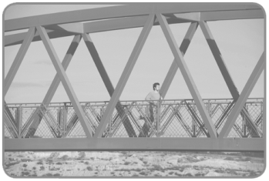
3.
a) Peter is running across the bridge.
b) Peter is running through the bridge.


4.
a) The bird is flying towards the flower.
b) The bird is flying through the flower.

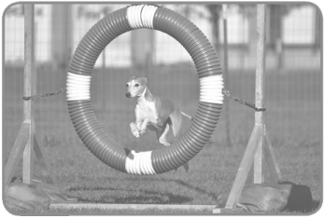
5.
a) The dog is passing towards the hoop.
b) The dog is passing through the hoop.


6.
a) Alice is going across the street.
b) Alice is going towards the street.

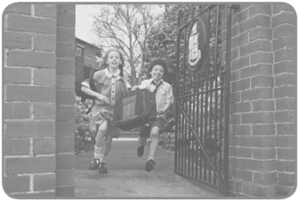
7.
a) They are running through the exit.
b) They are running towards the exit.

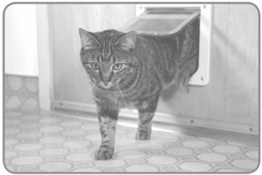
8.
a) The cat is going through the door.
b) The cat is going towards the door.




I want/would like… = Eu quero/queria…
(Would like é mais formal)

A. Complete the dialogues with the expressions in the boxes.
(Completa os diálogos com as expressões nas caixas.)
Buying a train ticket
Clerk: Good morning! (1) …____________ ?
I want four tickets
Can I help you?
Thank you
I would like some tickets
Sandra: Yes, please. I would like some information. What time is the
next train to Lisbon?
Clerk: The next train to Lisbon is in ten minutes, at 11:45.
Sandra: Thank you. (2) …____________

for that train.
Clerk: How many tickets do you want?
Sandra: (3) …____________ .
Clerk: Here you are.
Sandra: (4) …____________ !
Clerk: You’re welcome!

Ordering a meal at the restaurant
Waitress: Good evening! Would you like to order?
I want orange juice
No, thank you.
I would like some cheesecake
I want chicken and salad
Molly: Yes, please. (5) …____________ .
Dave: I would like grilled fish and potatoes.
Waitress: And to drink?
Molly: (6) …____________ , please.

Dave: I would like some water.
Waitress: And for dessert?
Molly: (7) …____________ .
Dave: Nothing for me. I’m on a diet.
Waitress: Anything else?
Dave: (8) …____________ .

