A. Complete the table with the words from the box.
(Completa a tabela com as palavras da caixa.)
Verb play
I am (1) _________ play
You are going to play
He is going to play
She (2) _________ going to play
It is going to (3) _________
We are going to play
You are (4) _________ play
They (5) _________ going to play



going to
are
going to
play
is
AFFIRMATIVE
I + am + going to + verb
he, she, it + is + going to + verb
we, you, they + are + going to + verb

B. Circle the correct option. (Rodeia a opção correta.)
1. He is going to / are going to play cards with his friends.
2. I are going to / am going to send text messages to my classmates.
3. Harry is going to / am going to visit his family.
4. My parents am going to / are going to take photos.

C. Complete the table with the words from the box.
(Completa a tabela com as palavras da caixa.)
Verb cook
I’m (1) _________ going to cook
You aren’t going to cook
He isn’t (2) _________ cook
She isn’t going to cook
It (3) _________ going to cook
We aren’t going to (4) _________
You (5) _________ going to cook
They aren’t (6) _________ cook


isn’t
cook
aren’t
not
going to
going to
NEGATIVE
I + ’m not + going to + verb
he, she, it + isn’t + going to + verb
we, you, they + aren’t + going to + verb

D. Circle the correct option. (Rodeia a opção correta.)
1. You isn’t going to / aren’t going to arrive late at school tomorrow.
2. Sarah isn’t going to / aren’t going to surf the net.
3. My parents ’m not going to / aren’t going to swim in the sea.
4. I isn’t going to / ’m not going to take photos at school.

E. Complete the table with the words from the box.
(Completa a tabela com as palavras da caixa.)
Verb swim
(1) ___________________ …?
Are you going to swim…?
Is he going to swim…?
(2) ___________________ …?
(3) ___________________ …?
Are we going to swim…?
(4) ___________________ …?
(5) ___________________ …?


Are you going to swim
Am I going to swim
Are they going to swim
Is she going to swim
Is it going to swim
INTERROGATIVE
Am + I + going to + verb... ?
Is + he, she, it + going to + verb... ?
Are + we, you, they + going to + verb... ?

F. Circle the correct option. (Rodeia a opção correta.)
1. Are / Is you going to read a book tomorrow?
2. Am / Is she going to play the piano?
3. Are / Am my friends going to hang out at the weekend?
4. Are / Is your sister going to surf at the beach?

G. Look at the pictures and complete the sentences with the affirmative or negative forms.
(Observa as imagens e completa as frases com a afirmativa ou negativa.)
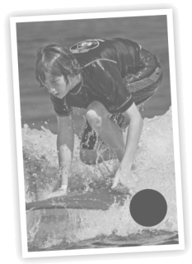
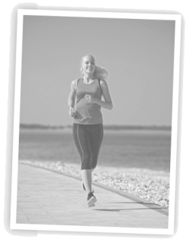
• Charlotte …__is going to run.__.. (run) in the beach.
1
1. Carlos ___________________ (surf) in the sea.

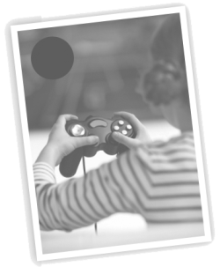
2
2. Rita ___________________ (play) volleyball.
3
3. My parents ___________________ (cook) dinner.
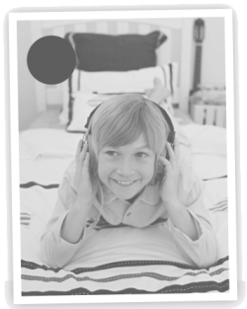
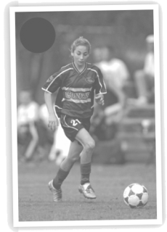
5
4
4. Martha ___________________ (play) basketball.

5. I ___________________ (watch) TV tonight.

A. Complete the table with the words from the box.
(Completa a tabela com as palavras da caixa.)
Personal pronouns | Reflexive  pronouns
I | myself  herself yourselves  yourself itself
you | (1) ___________________
he | himself
she | (2) ___________________
it | (3) ___________________
we | ourselves
you | (4) ___________________
they | themselves

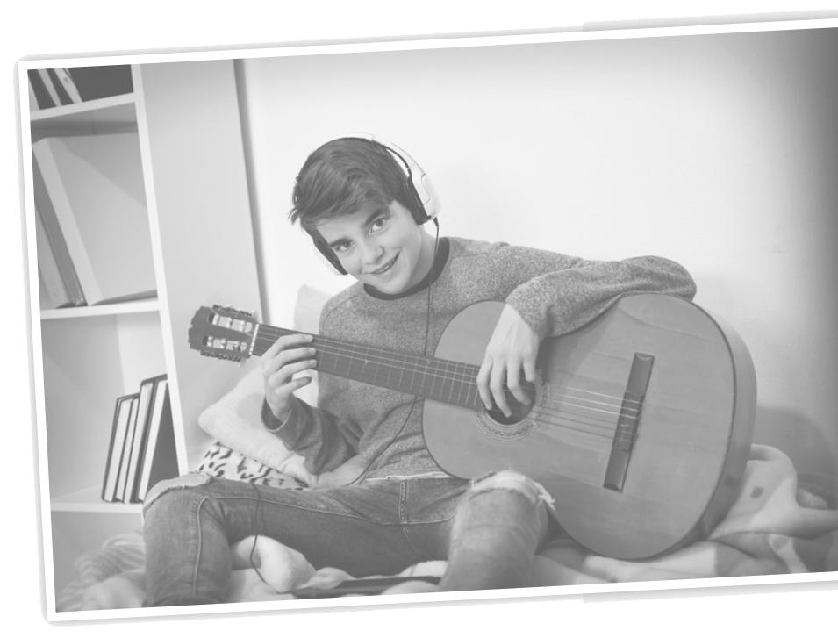
B. Complete with the correct reflexive pronoun.
(Completa com o reflexive pronoun correto.)
1. I draw a picture of ___________________.
2. You taught ___________________ how to play the guitar.
3. She hurt ___________________.
4. We enjoyed ___________________ at the party.
5. They looked at ___________________ in the mirror.
6. You cut ___________________ when you made dinner.
7. It cleans ___________________. Great machine!
8. I talk to ___________________ sometimes.

C. Circle the correct option.
(Rodeia a opção correta.)
1. Tom saw himself / themselves in the photo.
2. My friends prepared yourself / themselves for the party.
3. Julie and I enjoyed themselves / ourselves at the party.
4. Sarah cut herself / myself with a knife when she was cooking.
5. You and your sister were angry with yourselves / herself for forgetting my birthday?
6. I am enjoying myself / themselves a lot!
7. Sarah hurt yourself / herself playing football.
8. He is asking himself / ourselves some questions.

